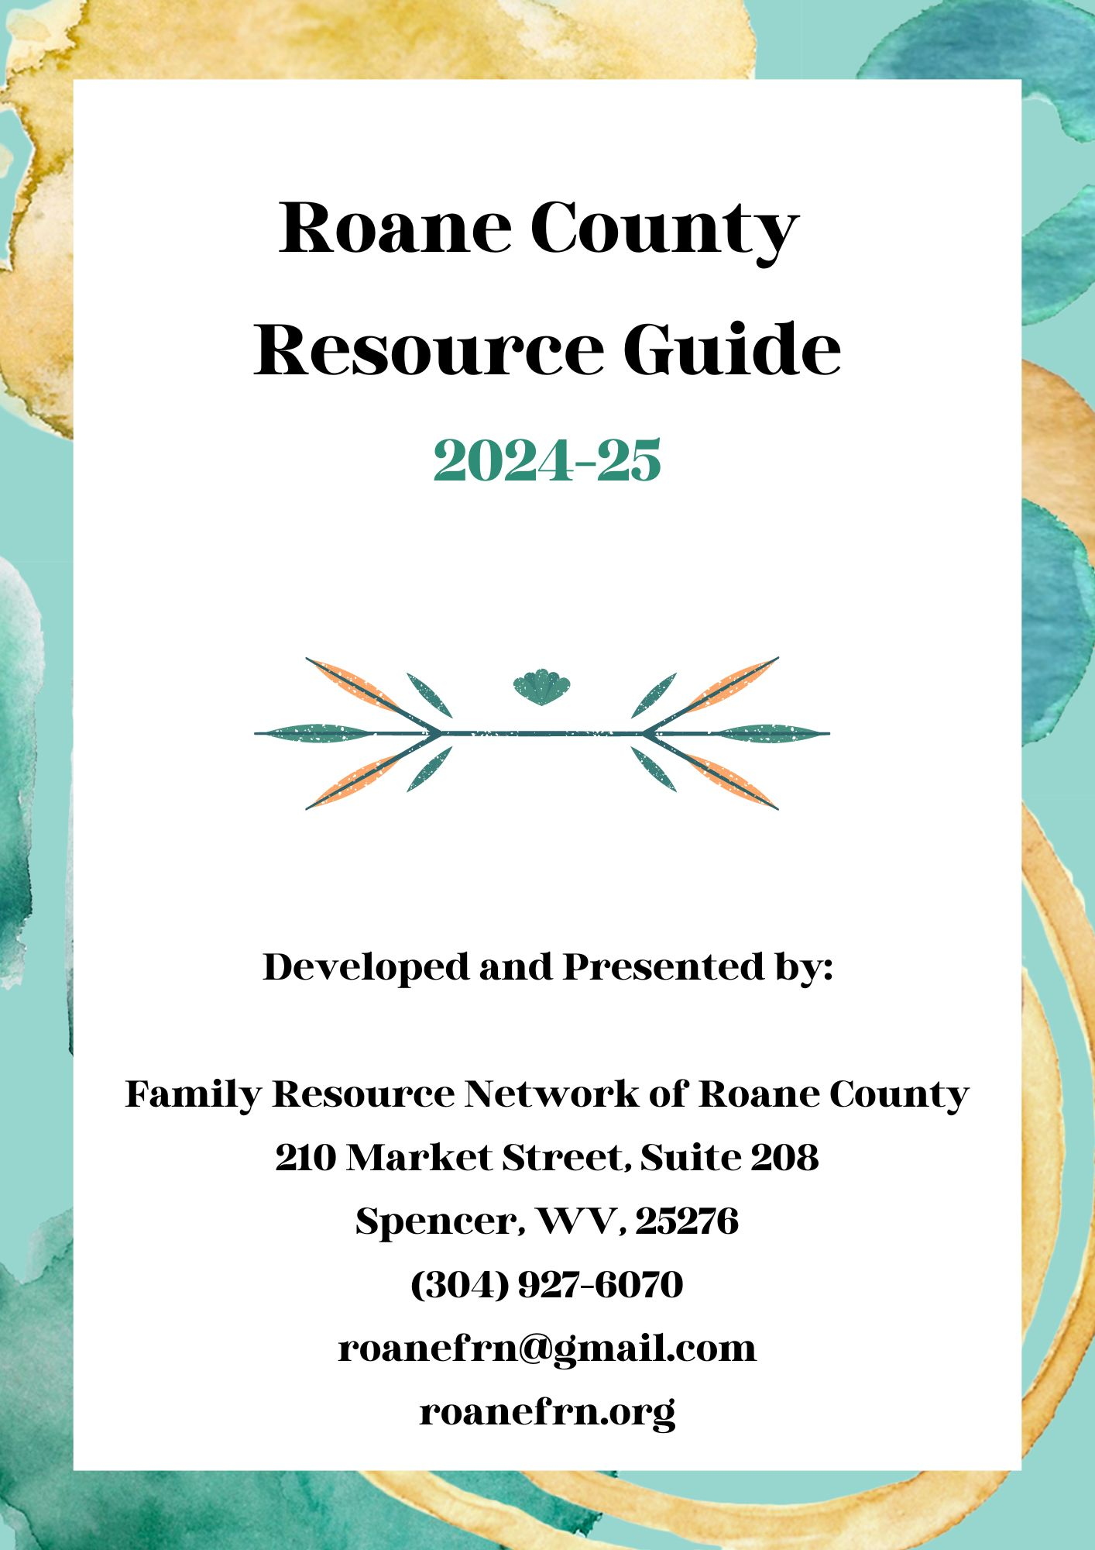
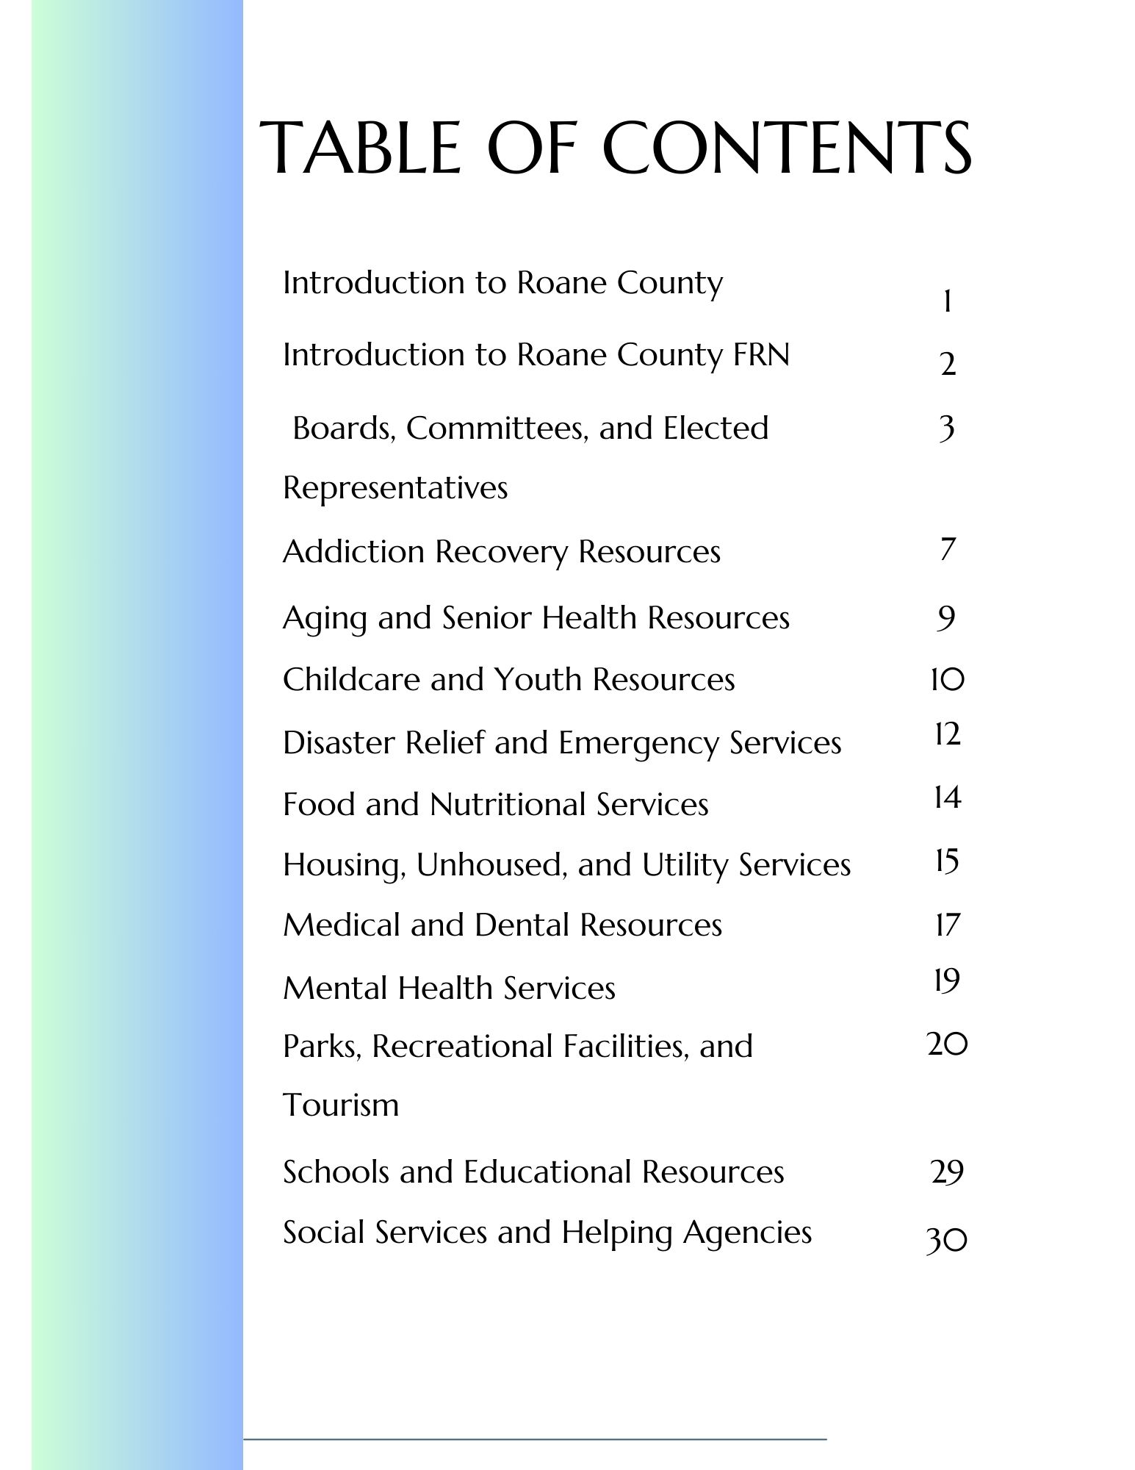
Welcome to Roane County, West Virginia!
Whether you be a resident or guest of Roane County, we are happy to welcome you to our slice of
Almost Heaven. We hope the information prepared in this guide will be helpful to you during your stay. Please enjoy some quick facts about our scenic and historic region.
Brief History of Roane County:
Roane County was founded on March 11, 1856, by act of the Virginia Legislature. The county is named after Judge Spencer Roane of Virginia, whose name was also lent to our county seat, Spencer (previously “New California”). On June 20, 1863, at the height of the American Civil War, Roane was one of the fifty counties admitted to the Union as the newly formed state of West Virginia. Roane County was then divided into seven districts: Curtis, Geary, Harper, Reedy, Smithfield, Spencer, and Walton. Aside from minor adjustments, these districts were largely unchanged for more than a century. In the 1980s, these regions were consolidated into three new magisterial districts: Northern, Eastern, and Western. A Southern district would be formally designated in the 1990s. We currently host six structures recognized on the National Register of Historic Places, as well as numerous locations that hosted action during the American Civil War.
Brief Demographic Profile of Roane County:
As of the 2022 census, the population of Roane County was 13,834. The US Census Bureau also reports that English is the primary spoken language of many residents. The economy of Roane County employs 4.32k individuals, with the largest employers falling under the Healthcare and Social Assistance and Retail Trades designations. As of 2021, the median household income was reportedly $38,608. The median property value was $107,200. 21.3% of the population for whom poverty status is determined in Roane County, WV (2.99k out of 14k people) live below the poverty line, a number that is higher than the national average of 12.6%.
Major Roadways Servicing Roane County:
Roane County is serviced by the following major roadways:
I-79/Interstate 79 US-119/ US Highway 119 WV-36/ West Virginia Route 36
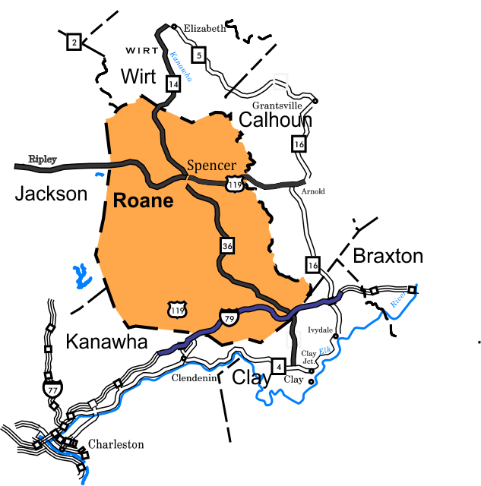
US-33/ US Highway 33 WV-14/ West Virginia Route 14

Family Resource Network of Roane County
The Family Resource Network of Roane County is a non-profit 501(c)(3) organization responsible for the research, development, and linkage of resources and services within Roane County. We are a grant-based entity funded by the WV Department of Human Services. We strive to increase community awareness of local, state, and federal resources available to assist Roane County
children and families. We proudly partner with community agencies and service providers to identify and address local concerns, promote impactful professional partnerships, and maximize
opportunities for families to succeed in Roane County. The Family Resource Network of Roane County is proud to develop and distribute this annual resource guide to our service population.
FRN Monthly Meetings:
Roane FRN conducts monthly meetings with interested citizens, helping agencies, businesses, and other community stakeholders. The purpose of these meetings is to inform the public on FRN activities, facilitate community problem-solving, share information helpful to those serving Roane County, and allow opportunities for meaningful networking and partnerships to be cultivated. We would be thrilled to have you join us every fourth Tuesday at noon in the Roane County Commission Chambers. Lunch is always provided. You may also participate via Zoom by contacting us at the addresses below.
FRN Contact Information:
We at Roane FRN are here to assist you! Please contact our office with the information below to arrange an appointment or join our email listserv. Additionally, follow us on Facebook to stay up to-date with our schedule and receive helpful information concerning all things Roane County.
Family Resource Network of Roane County
Corie Whiting, Executive Director
216 Market Street, Suite 208, Spencer, WV, 25276
(304) 927-6070
roanefrn@gmail.com
roanefrn.org
Facebook: Roane County Family Resource Network

Local Boards, Committees, and Elected Officials
Board/Committee Title | Brief Description/Meeting Times | Contact Information
911 Advisory Board | The 911 Advisory Committee is made up of up to nine members representing Fire Departments, the city, county and state police, emergency medical services, the Roane County Commission, and the public.  Meetings are generally held on the first Wednesday of even months at 6pm at the 9-1-1 Center on East Main Street in Spencer. | Current Board: Ray Dietz, Adam Smith, Steve Hughes, Randy Whited, Melissa Gilbert  For more information, contact the 911 Director at (304) 927-0918 or email: roaneco911@frontier.com
Airport Authority | The Roane County Airport Authority is made up of five members serving five-year terms appointed by the Roane County Commission. Meetings are generally held as needed with varied meeting locations, please contact for next meeting date and location. | Current Board: John Hill, Jon Hildreth, Terry Williams, Robert Smith, Randy Whited  For more information, contact the Chamber of Commerce at (304) 927-1780 or email: director@roanewvchamber.org
Building Commission | The Building Commission is made up of three to five residents who do not hold any office or employment under the US, State, County, Political subdivision or Political party. No more than 2/3 shall be from the same political party. Members are appointed by the Roane County Commission and serve five-year terms.  Meetings are held as needed in Spencer. | Current Board: Ron Whoolery, Ray Hawk, Jeremy Eastman, Richard Nash  Vacancy  For more information, contact the Building Commission at (304) 927-0078 or email: jenrand@commission.state.wv.us
Central Appalachia Empowerment Zone-WV Board | The CAEZ Board is made up of up representatives from each Census Tract elected by the residents of the Census Tract that it represents. In Roane County, two Census Tracts are represented, 9630 (Spencer) and 9631 (Newton). One additional member is appointed by the Roane County Commission. Other members are appointed by other counties covered by this agency. Terms are for three years. Meetings are generally held on the first Tuesday of each month at 6pm at the County Commission Room in the Clay County Courthouse. | Current Board representing Roane County: Vacancy (census tract 9630), Vacancy (census tract 9631), Merlin Shamblin, Commissioner  For more information, contact the CAEZ Director, Connie Lupardus at (304) 587-2034 or 1-800-935-3921
Camp Shepard Advisory Committee | The Camp Sheppard Advisory Committee is made up of eleven members representing Camp Sheppard, 4-H Leaders, WVU Extension Service, Roane County Schools, Farm Bureau, Master Gardeners, the Roane County Commission and the public. Members are appointed by the Roane County Commission and serve three-year terms. Meetings are generally held on the second Monday of each month at 6:00pm at Camp Sheppard, Gandeeville, WV | Current Board: Alvin Hunt, Kate Burbank – President, Peggy Heeter – Treasurer, Jim Dever - Vice President  Dr. Richard Duncan, Joe Ross, Chad Stricklin, Jerry Milliken  Andrew Corkrean, Aaron Simon  For more information, call (304) 577-9167  Visit our webpage: http://www.roanewv.com/cms.aspx?Name=CampSheppard
Civil Service Commission | The Roane County Civil Service Commission is made up of three members representing the Roane County Bar Association, the Deputy Sheriff's Association and the Roane County Commission. Members are appointed by the Roane County Commission and serve four-year terms. The Civil Service Commission shall make rules and regulations providing for both competitive and medical examinations for the position of Deputy Sheriff in Roane County, and other duties to carry out WV Code 7-14-6 & 7.  Meetings are held as needed in Spencer. | Current Board: Andrew Farmer (Bar Assn Appointee),  Harry B. Anderson (Deputy Sheriff's Assn Appointee),  Greg Castello (Commission Appointee)  For more information, contact the County Clerk at (304) 927-2860 or email: smcdonald@clerk.state.wv.us
Clay/Roane Public Service District (PSD) | The Clay/Roane Public Service District (PSD) is made up of six members representing the district they serve and includes two members appointed by the Roane County Commission. Members serve six-year terms. Meetings are generally held on the second Thursday each month at 6:30pm at the PSD Office in Procious, West Virginia. | Roane Representatives: Susan Beard, Linda Drennen, Commissioner Merlin Shamblin.  For more information, contact the Office at (304) 548-5209 or email: clayroanepsd@ntelos.net
Clover Public Service District (PSD) | The Clover Public Service District (PSD) is made up of three members representing the district they serve, appointed by the Roane County Commission. Members serve six-year terms. Meetings are generally held on the first Thursday each month at 6:00pm at the PSD Office in Clover, West Virginia | Current Board: Randy Starcher, Bobby Richards, Chuck Ricks, Commissioner Randy Whited  For more information, contact the Office at (304) 927-3323
Roane County Economic Development Authority | The Roane County Economic Development Authority (RCEDA) assists businesses start, expand or relocate in Roane County. Works to assist & promote business attraction, and economic and community development efforts both nationally and internationally. | Phone: 304-927-5189  Email: Kim.Davis@roanecountyeda.org  Website: www.roanecountyeda.org  Physical Address: 216 Market Street, Suite 100, Spencer, WV 25276
Roane County EMS Board | The Roane County EMS Board is made up of up to ten members representing different county entities. One member is appointed by the Roane County Commission; one member is a County Commissioner, and the remainder are elected by the Board. Members serve three-year terms. Meetings are generally held on the second Monday of each month at 5:30 pm at the EMS Office in Spencer | Current Board Appointed by the County Commission: Brad Nichols,  Melissa Gilbert, Merlin Shamblin  For more information, contact the EMS Director at (304) 927-3725.  Physical Address: 200 East Main Street Spencer, WV
Farmland Protection by Conservation Easement | The Roane County Farmland Protection Board is made up of seven members representing EDA, Farm Bureau, Conservation, non-farmers and the Roane County Commission. Members are appointed by the Roane County Commission and serve four-year terms.  Meetings are generally held on the third Thursday of each month at 9am in the Commission Room at the Roane County Courthouse. | Current Board:  Merlin Shamblin (non-voting), Mark Whitley, Jimmy Hays, Sam Sheets, Jim Workman, Holly Smith-Terrell, Dotty Hersman, Kim Davis (treasurer - nonvoting), Jennifer Randolph (secretary - nonvoting)  For more information, contact at (304) 927-0078 or email: jenrand@commission.state.wv.us
Roane County Humane Authority | The Humane Authority is made up of up to thirteen members appointed by the Roane County Commission. Terms are for three years. Meetings are generally held as needed, please use provided contact information for next meeting date. | Current Board: Sandy Bush, Reta Varda,  Morgan McCune, Tanya Hicks, Morgan Roberts, Meghan Sinclair, Nancy Sinclair, Sherri Copley, Libby Ballard  Michelle & Greg Weinhardt, Randy Whited  For more information, contact the Animal Shelter at (304) 927-2555 or  visit the Animal Shelter's Facebook page.
Roane County Library Board | The Roane County Library Board is made up of five members, the Roane County Commission and the Library Director. Members are appointed by the Roane County Commission and serve five-year terms.  Meetings are generally held on the third Monday of odd months at 2pm at the Roane County Main Library in Spencer. | Current Board Members Include:  Thelda Hughes, Sheena Ashley Hall  Mary Beth Tanner, Gary Mace, Mary Ann Wilson, Randy Whited  For more information, contact the Library Director at (304) 927-1130
Mid-Ohio Valley Health Department Board | The MOVHD is made up of up representatives from each county that it represents. In Roane County, two members are appointed by the County Commission, one a Republican, and the other a Democrat. Terms are for five years. Meetings are generally held on the fourth Thursdays of January, March, May, July, September and November each year at 6:30pm in Parkersburg. | Current Board representing Roane County:  Heather Downey - Republican  Dave Allen Goff - Democrat  For more information, contact the Mid-Ohio Valley Health Department  at (304) 485-7374
Mid-Ohio Valley Workforce Investment Board | The workforce Investment Board Mid-Ohio Valley coordinates a variety of federal, state and local employment and training resources in a nine-county area of West Virginia to ensure that efficient and effective workforce services are accessible to employers, current employees, job seekers and other citizens of the region. The skilled staff are ready to assist job seekers and employers and in doing so boost economic development in the region. | Roane County's Local Elected Official representative is Commissioner Randy Whited.  For more information about the WORKFORCE WV Centers, visit their website at www.workforcewv.org  For more information about the Workforce Investment Board, contact  304 424-7271 ext.102
Parks and Recreation Commission | The Parks & Recreation Commission is made up of ten members including the Roane County Commission and the public. Members are appointed by the Roane County Commission and serve three-year terms.  Meetings are generally held on the first Tuesday of each month at 7pm in the County Commission Courtroom in Spencer. | Current Members: Delmas Walker, Cathy Parsons, Quinton Keaton, Amy Downey, John Pena, Randy Whited  For more information, contact the Walkers at (304) 577-6162 or email: dswalker@frontier.com
Solid Waste Authority | The Solid Waste Authority is made up of five members representing the Public Service Commission, Little Kanawha Conservation District, Division of Environmental Protection and the County Commission. Two members are appointed by the Roane County Commission and serve four-year terms.  Meetings are generally held on the second Monday of each month at 2pm at the Recycling Center. | Current Authority Members: David Goff, Mark Bossert, Flora Waite, Andrew Corkrean, Vacancy  For more information, e-mail roaneswa@gmail.com or visit their Facebook page or contact the Recycling Center at 304-377-6103.
Roane County Chamber of Commerce | The Roane County Chamber of Commerce supports businesses, individuals, and the community through a variety of programs and initiatives. Available for technical assistance, the Chamber encourages economic and community development for all of Roane County. The Chamber of Commerce focuses on education, networking, advocacy and marketing to promote businesses. | Roane County Chamber of Commerce  (304) 927-1780  roanechamber@gmail.com  www.roanechamberwv.org  www.facebook.com/roanechamberwv  216 Market St, Spencer, WV 25276 on Mezzanine Level  Office Hours Vary
Walton Public Service District | The Walton Public Service District (PSD) is made up of three members representing the district they serve, appointed by the Roane County Commission. Members serve six-year terms. Meetings are generally held on the first Tuesday each month at 5pm at the PSD Office in Walton, West Virginia | Current Board: Carl Ashby Jr., Larry Harpold, Lawrence Looney, Andrew Corkrean, Commissioner  For more information, contact the Office at (304) 577-9118 or email: wvwatergirl@frontier.com
Walton Sewer PSD | Walton Sewer Public Service District  Meets 4th Monday @4pm at the Walton Community Building | Board: James Crowder, Linda Raines, Michael Jones, Commissioner Andrew Corkrean
WVU Extension Service | WVU Extension focuses on providing trusted and practical educational programs that improve health, education and prosperity. These programs help people, businesses and communities solve problems, develop skills and build a better future. | Meetings are held at the Roane County Extension Office as needed and in March each year.  County Commission Representative: Merlin Shamblin
Unsafe Structure and Property Enforcement Agency | Enforcement Agency Members  Litter Control Officer: Tanya Hicks  County Health Officer: Renee Metz  Fire Chief: Jason Conrad  Engineer: Jim Hildreth  Public Member: Dave Goff  Public Member: Mark Bossert  Ex Officio/Enforcement: Sheriff Dever | For more information, please contact Mark Bossert via e-mail at mark@roanegrown.com

Local Elected Officials as of June 2024
Assessor: Emily Westfall- (304) 927-3020 County Clerk: Sena McDonald- (304) 927-2860
County Commission: Andrew Corkrean, Randy Whited, Merlin Shamblin- (304) 927-0078
Prosecutor: Joshua Downey- (304) 927-2091 Sheriff: Phillip Dever- (304) 927-2540
City of Spencer Chief of Police: Todd Cole- (304)927-5616 Mayor: Terry Williams- (304) 927-1640
City Council: David Holland (Recorder), Steve Hughes, Daniel D'Agostino, Robin Stump, Toby Ford
Circuit Judge: Anita Harold Ashley

Addiction and Recovery Services
Name of Agency/Service | Brief Description of Services Provided | Contact Information
Westbrook Health Services | Westbrook helps all women and men suffering from substance use issues, as well as co-occurring substance use and mental health disorders. The treatment consists of the ASAM 3.1 level of care. This is a clinically managed low-intensity residential service that helps clients who have not been successful with outpatient level of care up to that point. The programs under this division are voluntary and they provide 24/7 care for the clients at the residential facilities. | P.O. Box 227  227 Clay Road Spencer, WV, 25276  304-927-5200 Fax: 304-927-5201  www.westbrookhealth.com
KVC Behavioral Healthcare | KVC West Virginia’s Intensive Outpatient Substance Use Treatment Program (IOP) gives individuals ages 18 and older, who are also insured by Medicaid, the support, resources and community they need to recover from substance use disorder. Clients will participate in individual and group therapy facilitated by trained mental health professionals. KVC will also work with individuals to get involved in local 12 step support programs such as Narcotics Anonymous (NA) and Alcoholics Anonymous (AA) to help them with their recovery. | 811 Madison Avenue Spencer, WV 25276 304-927-0015 www.kvc.org
Roane County Day Report Center | Roane County Day Report Center provides substance abuse treatment and random drug screening. | 325 Main Street Spencer, WV 25276 304-519-5898 www.facebook.com/pg/Roane-County-DayReport
OVP Healthcare Systems | OVP HEALTH has extensive experience and expertise in the treatment of people suffering from opioid dependency and other substance use disorders. Utilizing medication-assisted treatment (MAT) and counseling, our program’s strengths revolve around the ability of our highly trained staff to design a specific course of treatment based upon the client’s unique needs, beliefs, and personality traits, as well as their experience in treatment programs. | 303 Main Street, Spencer, WV, 25276  ovphealth.com
The Bomar Club | BoMar is a 501-C3 non-profit organization whose primary purpose is to support people in recovery from alcohol and drugs. BoMar is starting out the year on a positive note. We look forward to supporting people in recovery. The BoMar Club rents space for 3 AA meetings a week, 3 NA meetings a week. | 306 North Church Street Ripley, WV 25271 304-372-3722 www.thebomarclub.org Email: bomarclub@yahoo.com

WV Angel Initiative | The WV Angel Initiative is a confidential program by the West Virginia State Police (WVSP), in collaboration with the West Virginia Department of Human Services (DoHS), Office of Drug Control Policy (ODCP), that offers quick access to treatment for those struggling with substance use disorder (SUD).  Under this initiative, anyone with a SUD can go to a WVSP detachment to get help entering an addiction treatment center. No arrests, no prosecution, no questions asked. | WVSP Spencer Detachment  100 Triplett Rd, Spencer, WV 25276  Phone: (304) 927-0950

Substance Abuse Recovery Hotlines
SAMHSA (Substance Abuse and Mental Health Services Administration) | SAMHSA’s National Helpline, 1-800-662-HELP (4357) (also known as the Treatment Referral Routing Service), or TTY: 1-800-487-4889 is a confidential, free, 24-hour-a-day, 365-day-a-year, information service, in English and Spanish, for individuals and family members facing mental and/or substance use disorders. This service provides referrals to local treatment facilities, support groups, and community-based organizations. Also visit the online treatment locator or send your zip code via text message: 435748 (HELP4U) to find help near you. Read more about the HELP4U text messaging service.
HELP4WV | HELP4WV offers a 24/7 call, chat, and text line that provides immediate help for any West Virginian needing addiction treatment. We can be reached at 1-844-HELP-4WV (1-(304) 454-7196). Many of those answering our accredited helpline are peer-support specialists or recovery coaches. This means that they have personal experience in recovery from a mental health or substance abuse issue.
The National Drug Helpline | The National Drug Helpline at (844) 289-0879 is a free, confidential, 24/7 drug and alcohol hotline. Call today and start your journey towards a better future. Through this number, you can call to find support for yourself or a loved one.

Aging and Senior Health Services
Name of Agency/Service | Brief Description of Services Provided | Contact Information
Roane County Committee on Aging | The Roane County Committee on Aging, Inc provides a wide range of community services, such as meals, exercise classes, engagement opportunities, etc. designed to improve the quality of life for Roane County senior citizens (60+). Many of the services are provided free of any charge and other services are provided at a nominal cost. | 811 Madison Avenue Ste 2, Spencer, WV 25276  304-927-1997  jhaverty@rccoawv.org
Roane General Hospital-Long Term Care | RGH Long-Term Care offers a variety of services which meet both the medical and non-medical needs of those who cannot care for themselves. Long-Term Care is designed for residents who need extended hospital care or nursing home care, and the facility’s convenient location allows residents to stay in their community and to continue to interact with family and friends. | 200 Hospital Drive  Spencer, WV 25276  304-927-6250  304-927-6287  304-927-4444  www.roanegeneralhospital.com/long--termcare
Genesis Healthcare-Miletree Center | Miletree Center is a 62 bed Skilled Nursing Facility offering both short-term and long-term stay options to meet your skilled nursing and/or rehabilitation needs. 24- hour nursing services offer IV therapy, dementia and wound care. Miletree also takes pride in its excellent Rehabilitation Department which offers physical, occupational, and speech therapy services. Their recreations department offers a variety of activities daily for client and family enjoyment. | 825 Summit Street  Spencer, WV 25276  304-927-1007  www.genesishcc.com/Miletree
Marcap Manor | Marcap Manor is a low-rise building designed to accommodate our elderly and disabled residents. With 29, one-bedroom apartments, Marcap Manor is a great option for our ageing population. It features a laundry facility on each floor, a community room, and a gazebo outside to enjoy the beautiful WV weather. | Contact Spencer Housing Authority:  601 Market Street, Spencer WV 25276  (304) 927-4181  Fax: (304) 927-4186
Sunset Apartments | Sunset Apartments is a high-rise, three-story building designed to accommodate our elderly and disabled residents, including an accessible elevator. With 40 one-bedroom apartments and four handicapped accessible units, our community seniors will love living at Sunset Apartments. Sunset features a laundry facility, a large community room, and an outdoor gazebo to enjoy the beautiful WV weather. | Contact Spencer Housing Authority:  601 Market Street, Spencer WV 25276  (304) 927-4181  Fax: (304) 927-4186
Childcare and Youth Resources
Building Blocks Child Development Center | Building Blocks serves children aged six weeks to 12 years of age and work to provide educational enrichment for students with the very best facilities, excellent instructors, and a great learning environment. Facility accepts CONNECT Childcare. Sliding fee available to those applicable. Afterschool care available. | 532 Parkersburg Road  Spencer, WV 25276  304-927-4313
PATCH COA Preschool | PATCH preschools focus on learning and social, emotional, behavioral transition along with kindergarten preparation for our upper ages of students. Programs mix hands-on learning with fun and engaging activities for our students and focus on safety and integration, along with helping working parents with their childcare needs by providing a flexible daily schedule. All programs accept Connect Childcare. | 811 Madison Avenue  Spencer, WV 25276  304-927-8047  www.patch21.org
AFL-CIO Appalachian Council HeadStart | The Council’s Head Start program provides diverse services to meet the educational, health, parent, community, and social service needs of our children and families. We serve children between the ages of three and four, along with their families, all of whom are either at or below the federal poverty guidelines. | Roane Office and Spencer Classrooms  PO Box 106  811 Madison Ave, Suite 4  Spencer WV 25276  304-927-4981  FAX: 304-927-4206
Roane County Schools | Roane County Schools is a public school district that encompasses Roane County High School, Spencer Middle School, Spencer Elementary School, Walton Elementary/Middle School, and Geary Elementary/ Middle School. | Roane County Schools  813 Capitol Street  Spencer WV 25276  304-927-6400  FAX: 304-927-6440
PATCH 21st Century Youth Programs | PATCH offers a variety of 94 different educational enrichment programs on a rotational basis across the county for grades Pre K-12 and their families. PATCH also hosts youth soccer and basketball programs, as well as summer enrichment for students K-12. | 811 Madison Ave. Spencer, WV 25276  (304) 927 - 8047  Follow PATCH 21 on Facebook for program updates and visit their website at www.patch21.org
CONNECT Childcare | Community service organization that works with parents, childcare providers, businesses, and community organizations to help promote the availability of quality childcare services in the area. Provide parents with childcare referrals and information on evaluating quality childcare, plus resources on various parenting issues. Offer childcare providers access to valuable training, and supportive services for new or established programs. | 1701 5th Ave., Box 4  Charleston, WV 25387  304-414-4694  888-595-8290  www.connectccrr.org
Roane County Library System | Roane County Libraries offer a variety of programs for youth of all ages, including weekly summer literacy programs, story trails, and more. The library offers a wide variety of materials and activities, including wireless and eBooks free to patrons. Contact your local branch for an updated calendar of events. | Spencer Branch-  110 Parking Plaza, Spencer, WV, United States, West Virginia  1 (304) 927-1130  roanewvlib.com  Walton Branch-  2 Cunningham Lane, Walton, WV, United States, West Virginia  1 (304) 577-6071  waltonwvlibrary@gmail.com  Geary Branch-  1 Library Lane, Left Hand, WV, United States, West Virginia  1 (304) 565-4608  morton39@yahoo.com
4-H Youth Development | WV 4-H provides youth opportunities to develop life skills and knowledge, build self-esteem and positive values, become more active citizens through service and adopt healthy habits. Children between the ages of 9 and 21 can join 4-H with a parent or guardian’s permission. Younger kids, ages 5–7, who are interested in the practices of 4-H can start in the Cloverbud program, which focuses more on fun and social activities that set the stage for future learning. | WVU Extension Service Roane County Office  110 Parking Plaza Spencer, WV 25276  304-927-0975  304-927-0976  Fax: 304-927-0983  www.extension.wvu.edu/roane/4h
Boy/Cub Scouts of America | The Boy Scouts of America (BSA) provides the nation’s foremost youth program of character development and values-based leadership training, which helps young people be “Prepared. For Life. ®” The Scouting organization is composed of more than 1 million youth members between the ages of 5 and 21. | St. John’s United Methodist Church  335 Church Street Spencer, WV 25276  304-927-2197  304-610-0992  304-577-6303 www.stjohnsheights.org/scouting.html Email: jwoolweaver@frontier.com
Girl Scouts of Black Diamond | Girl Scouts of the Black Diamond Council provides girls grades K-12 opportunities for service learning, educational/developmental learning, and leadership training. | 321 Virginia Street West Charleston, WV 25302  304-345-7722  800-756-7616  www.bdgsc.org Email: info@bdgsc.org
The Busy Bee Academy | The Busy Bee Academy provides uniquely creative entrepreneurial education for children via in-person classes and special interest clubs. | 314 Market Street  Spencer, WV, 25276  (304) 519-5914
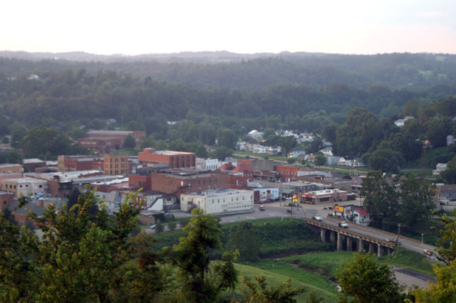
Disaster Relief Resources
Federal Disaster Assistance- US Department of Homeland Security | The Disaster Assistance Improvement Program’s (DAIP) mission is to provide disaster survivors with information, support, services, and a means to access and apply for disaster assistance through joint data-sharing efforts between federal, tribal, state, local, and private sector partners. | Check Eligibility: https://www.disasterassistance.gov/
American Red Cross | The purpose of the American Red Cross is to meet the immediate disaster-caused needs of individuals, families, and communities. The provide home fire, wildfire, hurricane, and flood relief. | Check Eligibility:  https://www.redcross.org/
FEMA (Federal Emergency Management Agency) | FEMA has information to help you prepare for, respond to, and recover from disasters specific to your location. Use this page to find local disaster recovery centers, flood maps, fact sheets, FEMA contacts, jobs and other resources. | West Virginia FEMA Resources:  https://www.fema.gov/locations/west%20virginia
Rise WV- WV Flood Recovery | RiseWV was developed in response to the 2016 flooding in West Virginia and assists residents with flooding disaster related services and recovery efforts. | https://wvfloodrecovery.com/


Emergency Services
PLEASE NOTE: Emergency personnel can be contacted at any time by simply dialing 911. However, should you need to contact these agencies and are not actively involved in an emergency, non-emergency lines are provided below.
Roane County 911 Dispatch Center | 205 East Main Street, Spencer, WV 25276  304-927-0911
Roane County Sheriff’s Department | Law Enforcement: 304-927-3410  Tax Inquiries: 304-927-2540
Spencer City Police Department | 116 Court Street, Spencer, WV 25276  304-927-2392
West Virginia State Police-Spencer Detachment | 100 Triplett Road, Spencer, WV, 25276  304-927-0950
Spencer-Roane County Fire Department  (General Office) | 154 East Main Street, Spencer, WV 25276  304-927-1099
Roane County EMS | 200 East Main Street, Spencer, WV  304- 927-3725
Roane County Humane Officer/Animal Shelter | 2550 Parkersburg Road, Spencer, WV 25276  304-927-2555
Clover/Roane Fire Department | 3909 Clay Road, Spencer, WV, 25265  304-927-1299
Walton Volunteer Fire Department | 7113 Charleston Road, Walton, WV, 25286  304-577-6229
Gandeeville/Harmony Volunteer Fire Department | 58 Civic Drive, Gandeeville, WV, 25243  304-577-6037
Reedy Volunteer Fire Department | 54 Main Street, Reedy, WV, 25270  304-927-3040
Newton Volunteer Fire Department | 12017 Clay Road, Newton, WV, 25266  304-565-4866
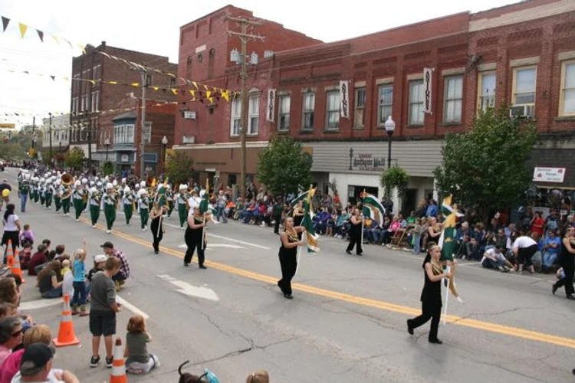

Food and Nutritional Services
WV DHHR- Roane County | Roane County DHHR can assist eligible individuals with grocery and infant items via WIC, SNAP Benefits, and other assistance programs. Please check online or call the local office for eligibility criteria. | 677 Ripley Road #3  Spencer, WV 25276  304-927-0956  www.dhhr.wv.gov
Helping Hands Food Pantry | Helping Hands Food Pantry provides food giveaways on Wednesdays from 10:00 a.m. – 2:00 p.m. Contact office for eligibility requirements. | 811 Madison Avenue Spencer, WV 25276  304-927-4966
Mountaineer Foodbank Mobile Unit | The Mountaineer Foodbank mobile unit provides food deliveries on a rotational basis at Roane County High School, located at 1 Raider Way, Spencer, WV, 25276. Please see Mountaineer Foodbank website for dates and times beyond Dec. 2024. | https://www.mountaineerfoodbank.org/mobile-pantry  Date(s): 2/10/24, 4/27/24, 6/18/24, 8/7/24, 10/12/24, 12/14/24  Time: 11am-12:30pm
Backpack Program- Spencer Memorial United Methodist Church | The Backpack Program provides weekend supplemental food bags to any student in Roane County who wishes to participate. | Contact Phillip McNemar:  Phil.ctf@gmail.com  Memorial UMC-  509 Market St.  Spencer, WV 25276  304-927-4427
Blessing Boxes | Several Blessing Boxes are situated throughout the county. These boxes may be filled with non-perishable donations and may be utilized by anyone at any time. | There are blessing boxes located in the parking areas of both First Baptist Church and Garden Fresh Market in Spencer, WV. Please see Roane FRN Facebook page for announcement of more blessing boxes.
*Please follow Roane FRN Facebook page for information on new services developing in this area.
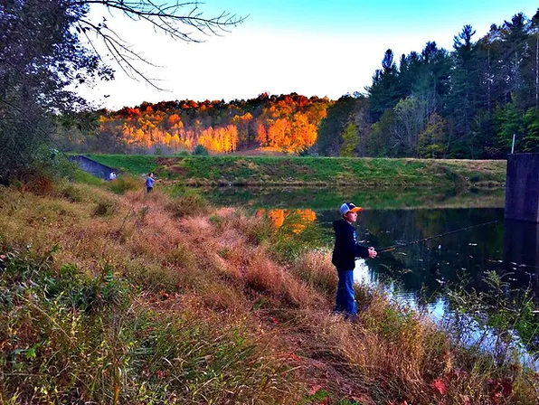
Housing and Unhoused Resources
This section concerns housing and residency within Roane County. For Airbnbs and other short-term rentals, please see the Parks and Recreation section.
Spencer Housing Authority | The Spencer Housing Authority team works hard to ensure that everyone in the city has a safe and affordable place to live. They manage many public and income-based housing developments within the community. | 601 Market Street, Spencer WV 25276  P: 304 927-4181 F: 304 927-4186  https://www.spencerhousingauthority.org/
USDA Rural Development Home Loan Program | Cost-effective service provider that strives to help homeowners and their families remain successful homeowners throughout the term of the loan. | 104 Miller Drive, Ripley, WV 25271  304-372-3441
Coalfield CAP Veterans Shelter Program | Coalfield CAP can administer SSV grant funding to veteran families in need of housing support. Please see their contacts to determine eligibility requirements. | P.O. Box 1406, 1626 West 3rd Avenue, Williamson, WV 25661  304-235-1701 800-234-1706 Fax: 304-235-1706  www.coalfieldcap.org
West Virginia Coalition to End Homelessness | Persons currently experiencing homelessness can be connected to emergency shelter and permanent housing resources. | 833-722-2014  https://www.wvceh.org
Habitat for Humanity of WV | Habitat for Humanity builds decent and affordable homes around the world in partnership with families in need of a decent place to live. Habitat homebuyers help build their own homes alongside volunteers and pay an affordable mortgage. | P.O. Box 70146, Charleston, WV 25311  304-720-7636  Please consult representative for eligibility terms.
Board-Depue Realty | Board-Depue realty offers a variety of services for both home buyers and sellers in the Roane County area. | Jennifer Board Nichols  Spencer, WV 25276  304-927-3250  jennifer@bdr1.com
Old Fences Realty | Old Fences realty offers a variety of services for both home buyers and sellers in the Roane County area. | David Mike Greenlee  820 Capitol Street, Spencer, West Virginia 25276  Office: 304-927-4400  Cell: 304-377-3758
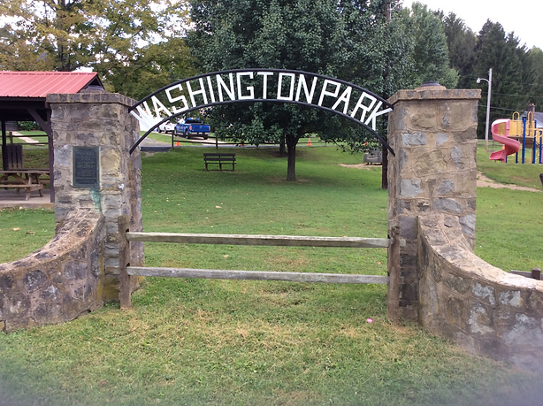
Home Utility Services
Waterworks Department – City of Spencer | 116 Court Street Spencer, WV 25276  304-927-2300
Waste Management (Trash Collection) | 866-909-4458  Bill Pay 866-964-2729  www.wm.com
Mountaineer Gas Company | 2401 Sissonville Drive Charleston, WV 25387  800-834-2070  www.mountaineergasonline.com
Frontier Communications (Internet) | 816 Lee St E, Charleston, WV 25301  Phone: (304) 807-9776  800-921-8101  www.frontier.com
Optimum (Phone and Internet) | 5707 MacCorkle Ave SE Ste 60, Charleston, WV 25304  Phone: (866) 950-3278
Community Resources INC. | Provide energy efficient upgrades to  homes, and aid families when they  struggle to pay their utility bills.  811 Madison Avenue, Room 22 Spencer, WV 25276  304-927-4632  www.cricap.org
Dollar Energy Fund | For more than 40 years, Dollar Energy Fund has been serving the limited-income community by providing utility assistance grants and other services.  Dollar Energy Fund, Inc.  P.O. Box 42329  Pittsburgh, PA 15203-0329  Utility Assistance: 1-888-282-6816

Medical Resources
Roane General Hospital | Roane General Hospital provides a variety of services to our community on both an inpatient and outpatient basis. Services include Acute Care,  Cardiac/Pulmonary Rehabilitation,  Cardiopulmonary, Cardiology,  Diabetes Management, Emergency Department, Fitness Complex  Interventional Pain Management,  Laboratory, Long Term Care, Oncology, Orthopedics, Outpatient Nursing/ Infusion Therapy, Physical Therapy, Radiology/Imaging, Swing Bed Services, and Surgery. | 200 Hospital Drive Spencer, WV 25276 304-927-4444 www.roanegeneralhospital.com
Roane General Medical Associates Walk-In Services | Roane General Medical Associates is a rural health clinic that provides acute walk-in services to the entire population of Roane County and the surrounding area. Acute Walk-in Services: Sunday-Saturday, 8:30am - 6:30pm | 200 Hospital Drive  Spencer, WV 25276  304-927-6246
Southern Roane Medical Clinic | Southern Roane Medical Clinic provides the following services and procedures:  Breast/cervical cancer screenings  EPSDT physicals (Early Periodic Screening and Development Testing)  Well-child exams  Well-male and female exams with routine screening tests  Employment physicals/WVMCD eligibility physicals  Sports physicals  Workers Compensation physicals | 1 Library Lane Left Hand, WV 25251 304-565-3151  Hours of Operation:  Monday, Wednesday, and Friday 8:00 a.m.-5:00 p.m.  Closed Tuesday, Thursday, Saturday, and Sunday
Roane County Family Health Care | Roane County Family Health Care, Inc. uses physicians, physician assistants and certified nurse midwives to offer a full range of health care for the entire family including geriatrics. | 146 Williams Drive  Spencer, WV 25276  304-927-1495  Administration: 304-927-2241  Women’s Health Direct: 304-927-1719  www.rcfhc.org  www.facebook.com/rcfhc

OVP Health Systems | OVP HEALTH has extensive experience and expertise in the treatment of people suffering from opioid dependency and other substance use disorders. Utilizing medication-assisted treatment (MAT) and counseling, our program’s strengths revolve around the ability of our highly trained staff to design a specific course of treatment based upon the client’s unique needs, beliefs, and personality traits, as well as their experience in treatment programs. | 303 Main Street, Spencer, WV, 25276  ovphealth.com
Brannon Dental Associates | Brannon Dental Associates is a family- owned general dentistry practice providing nearly 3 decades of excellent dental care to Central WV and beyond. | 350 Hospital Drive Spencer, WV 25276 304-927-2775 www.facebook.com/pg/Brannon-DentalAssociates
Gentle Dental Care | General Dental Care provides general dentistry services from Edward L. Moore, DDS. | 533 Ripley Road  Spencer, WV 25276  304-927-3550
WV Health Right – Mobile Dental Clinic | To qualify, patients must be uninsured or have Medicaid or Medicare coverage and household income must be at or below 250% of the Federal Poverty Level guidelines. A copy of your last tax return or proof of non-filing status must be provided prior to your appointment. | 304-414-5944 (Cindy)  www.wvhealthright.org/mobile-dental-clinic
Dr. Brett K. Radow, OD | Provides a vast array of services including comprehensive eye examinations, diagnosis and treatment of eye diseases and prescribing glasses, contact lenses, medicine and other needed therapy modalities for the improvement of vision and/or eye health. | 200 Hospital Drive Spencer, WV 25276 304-927-4444 www.roanegeneralhospital.com
Journey to Health Holistic Healthcare | Journey to Health is holistic health practice rooted in mind body spirit balance for optimal health. This practice is owned and operated by a certified holistic health coach and herbalist. | 304-373-9173  journeytohealth.beatenpath@gmail.com

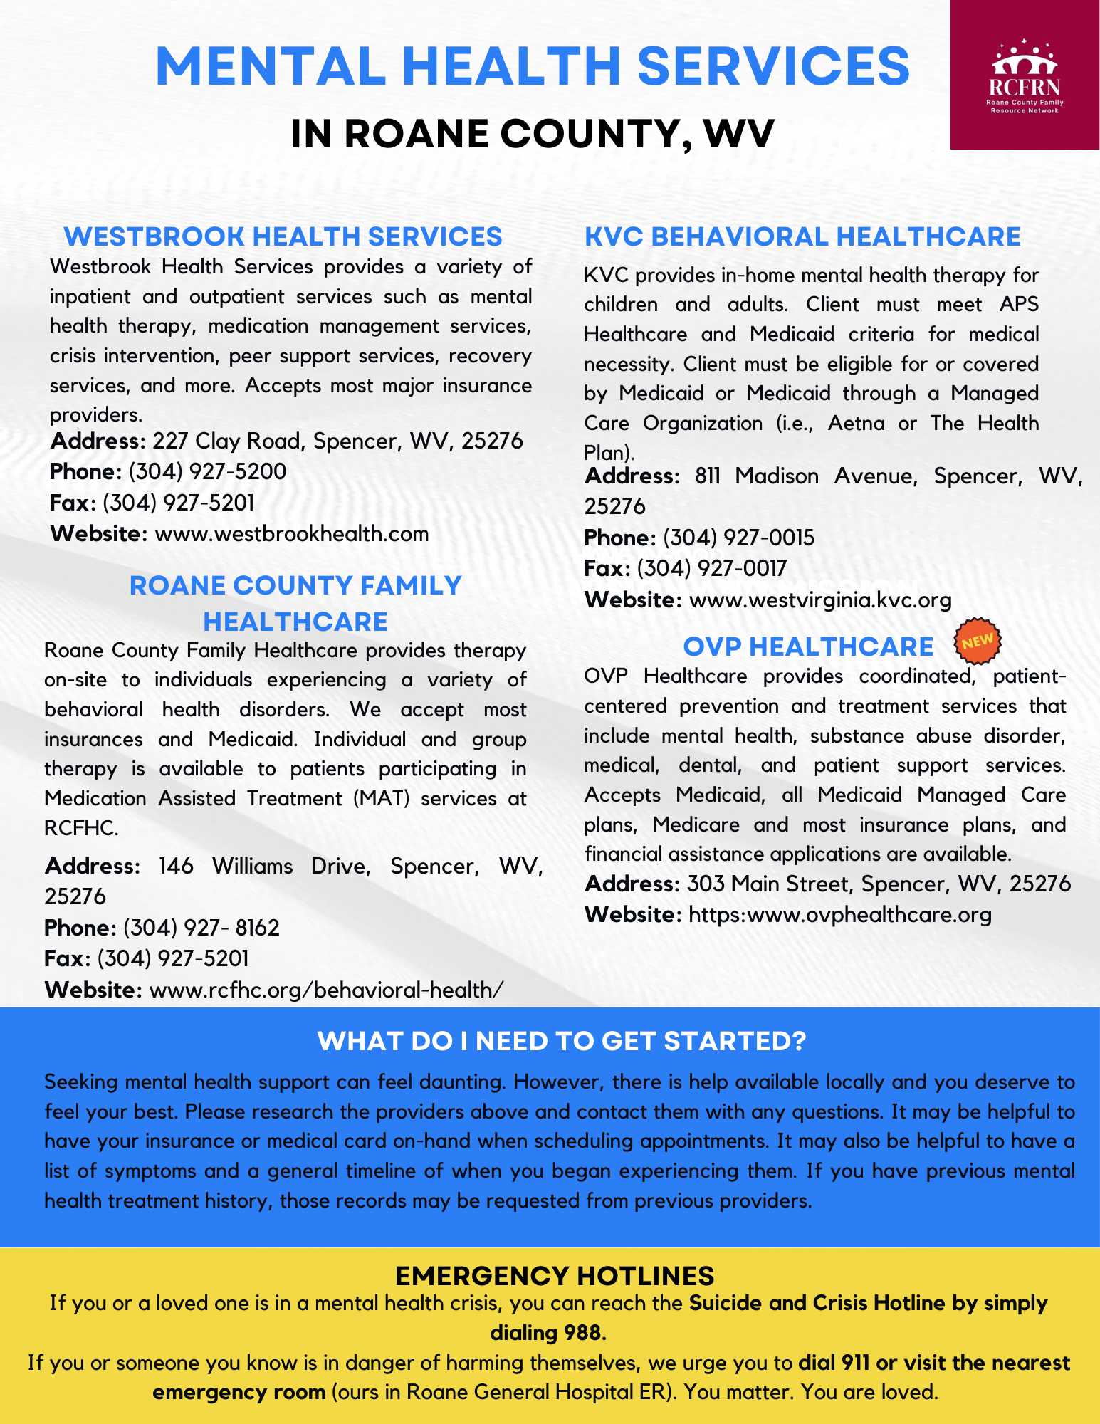
Parks, Recreational Facilities, and Tourism
Camp Sheppard | 78 Camp Sheppard Ln  Gandeeville, WV 25243  304-577-9167  www.facebook.com/pages/Camp-ShepardFour-H-Camp
Heritage Park Community Building | 116 Court Street Spencer, WV 25276  304-927-1640  www.facebook.com/pages/Heritage-ParkCommunity-Building
Charles Fork Lake | Rt. 36 Spencer, WV 25276  304-927-1640  www.cityofspencer.com/parks-recreation
Ben’s Run Trail | Spencer, WV 25276  304-927-1640  www.cityofspencer.com/parks-recreation
Washington Park | Located at the south entrance to the city on US 119 (Black Walnut Avenue)  304-927-1640  www.cityofspencer.com/parks-recreation
Spencer City Pool | 134 Park Avenue Spencer, WV 25276  304-927-3152
Miletree Lake | 304-927-1640  www.cityofspencer.com/parks-recreation  Miletree Lakes are located just off West Main Street near McDonalds
Goff Hill Civil War Park | Located at the former Spencer State Hospital farm  304-927-1640  www.cityofspencer.com/parks-recreation
Griffith Park a.k.a. Fifth Street Park | Located across from Spring Creek in the Alvord Community  304-927-1640  www.cityofspencer.com/parks-recreation
Spring Heights Education Center | 2067 Barrcutt Road Spencer, WV 25276  304-927-5865  Fax: 304-927-6540  www.springheights.org info@springheights.org www.facebook.com/springheightsFB Twitter: @spring heights www.instagram.com/springheights www.youtube.com/springheightscamp
Walton Community Building | 304-577-6063 www.facebook.com/WaltonCommunityBuilding
Reedy Community Building | 118 Main Street Reedy, WV 25270  304-927-3222  www.facebook.com/town.reedy/
Chestnut Ridge Winery | 15 Chestnut Ridge, Spencer, WV 25276  (304) 377-5721
Robey Theater | 318 Main St, Spencer, WV 25276  (304) 927-1390

Local Airbnbs

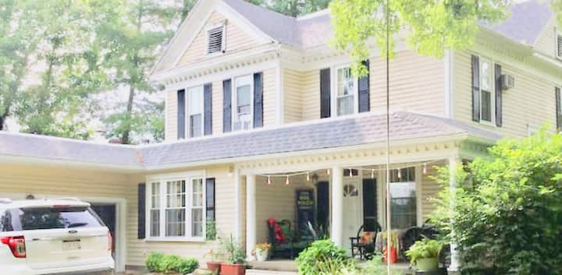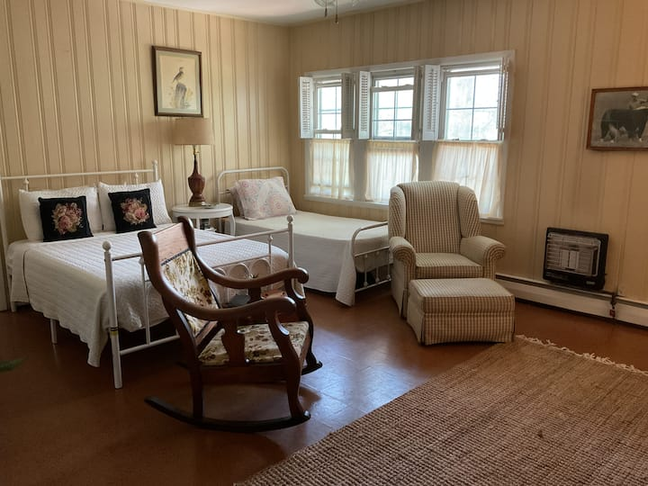

Guest suite in Spencer
Private entry w/laundry & bath, low fees. Sleeps 3
2 beds
$55 per night
4.94 out of 5 average rating, 121 reviews4.94 (121)

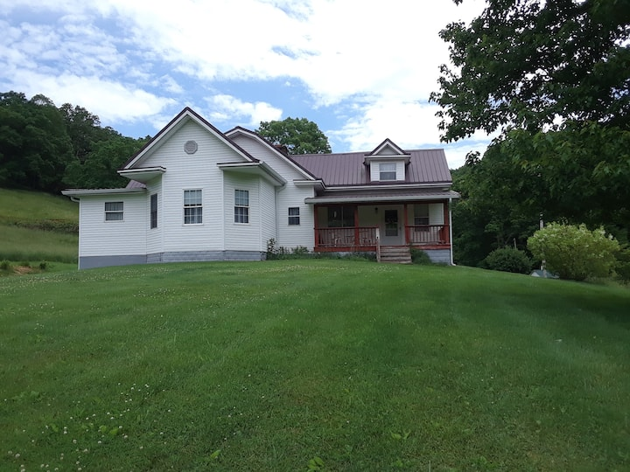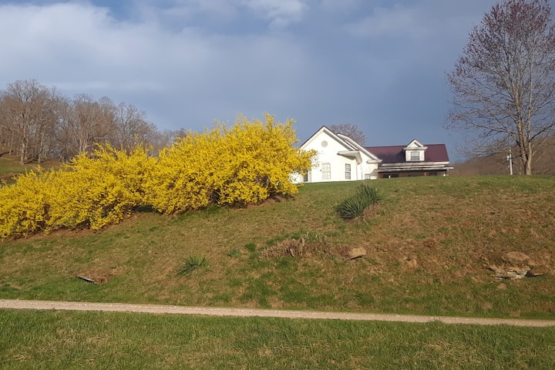

Farm stay in Spencer
Farm stay at West Hollow Farmhouse
2 beds
$100 per night
5.0 out of 5 average rating, 15 reviews5.0 (15)

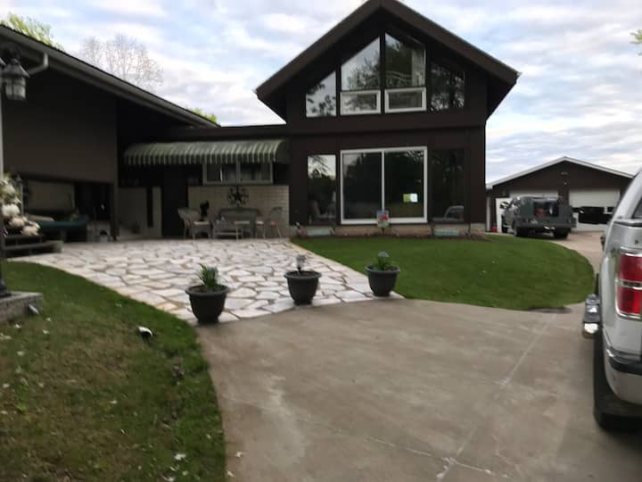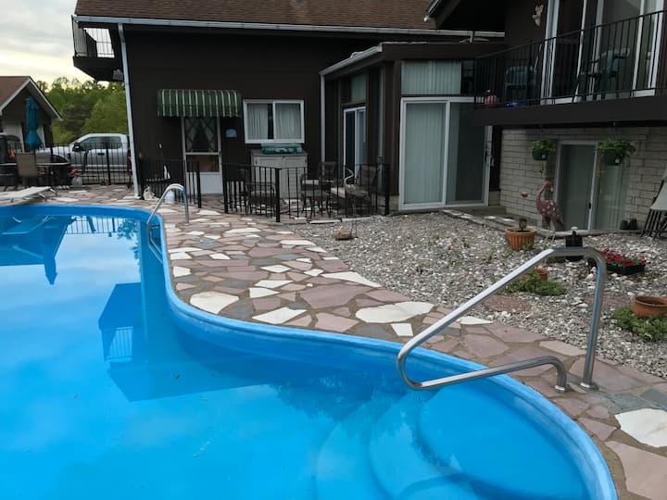

Home in Spencer
Almost heaven West Virginia
5 beds
$159 per night
5.0 out of 5 average rating, 31 reviews5.0 (31)



Cabin in Palestine
Emmy House nestled in the WV foothills
4 beds
$122 per night
4.96 out of 5 average rating, 289 reviews4.96 (289)

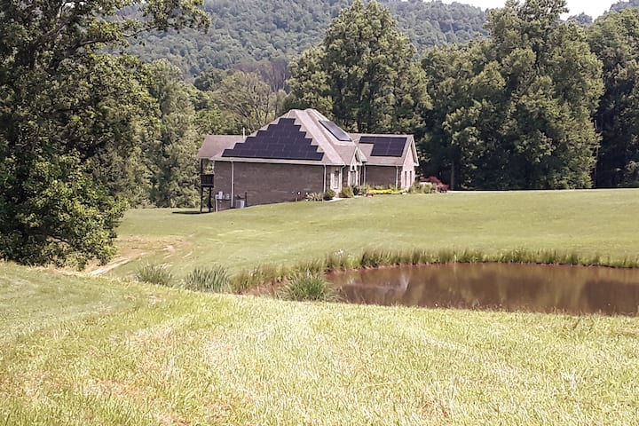

Apartment in Newton
The Looney Farm
3 beds3
$85 per night
4.91 out of 5 average rating, 342 reviews4.91 (342)

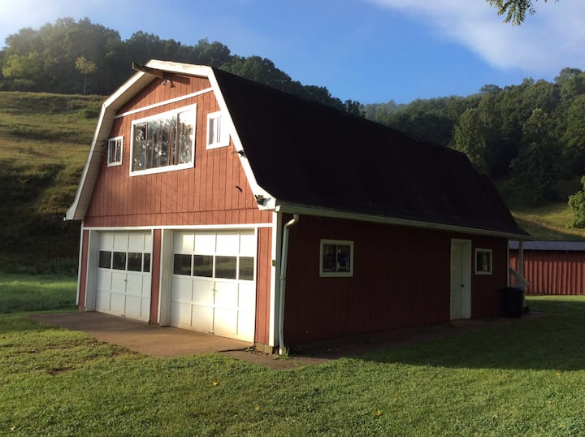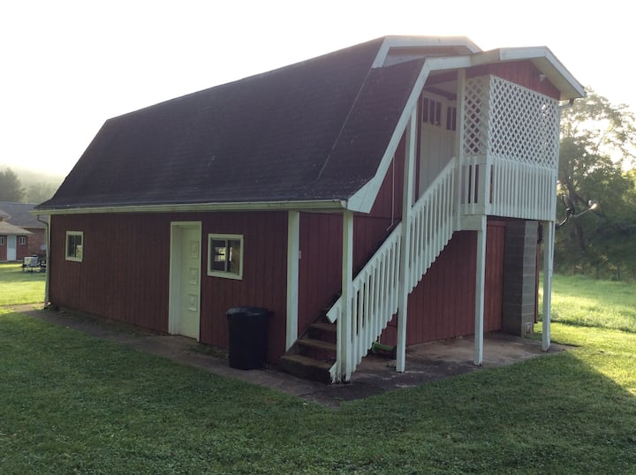

Apartment in LeRoy
Circle A Farm - “Barndominium”
3 beds
$75 per night
4.88 out of 5 average rating, 69 reviews4.88 (69)

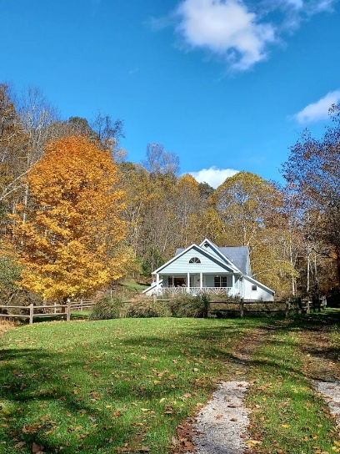

Bungalow in Walton
Secluded retreat with separate studio office
4 beds4 beds
$125 per night
4.91 out of 5 average rating, 56 reviews4.91 (56)

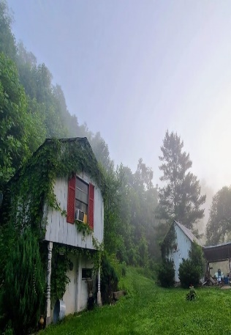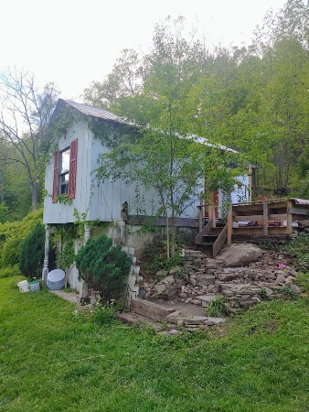 Farm stay in Walton
Romantic Rustic Roost in Woodland Paradise
1 queen bed
$120 per night
4.94 out of 5 average rating, 214 reviews4.94 (214)

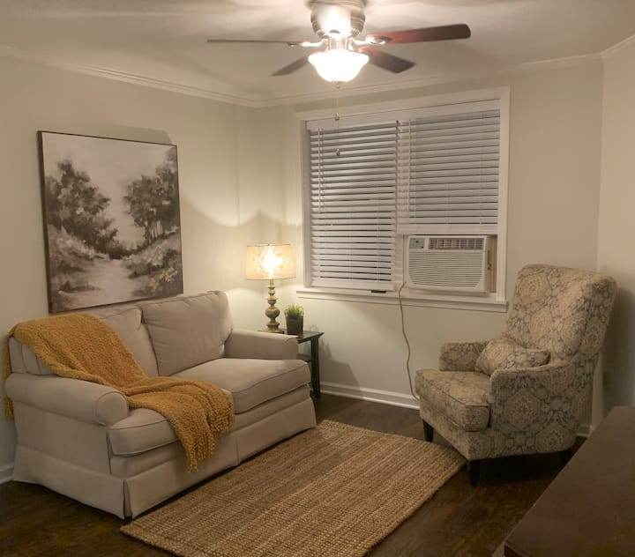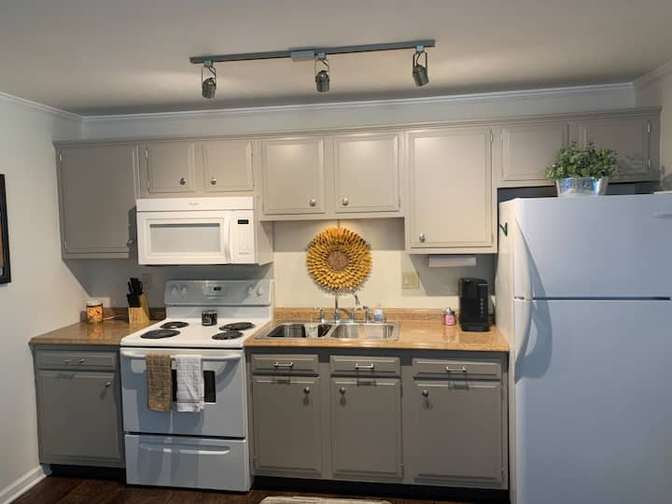

Apartment in Spencer
1 Bedroom Downtown Spencer (2nd Floor Walk-Up)
1 queen bed
$46 per night
5.0 out of 5 average rating, 12 reviews5.0 (12)

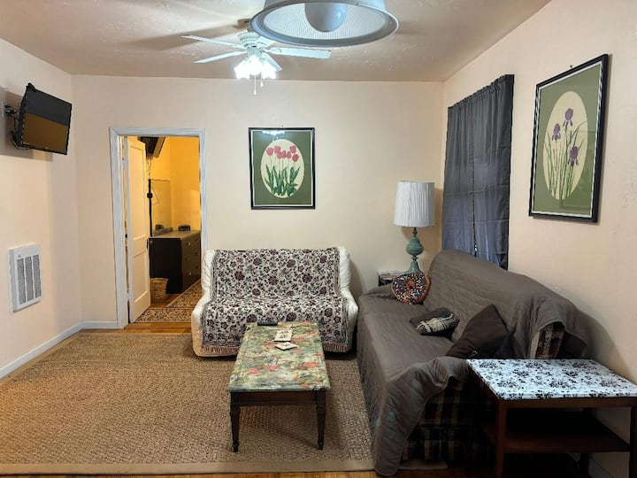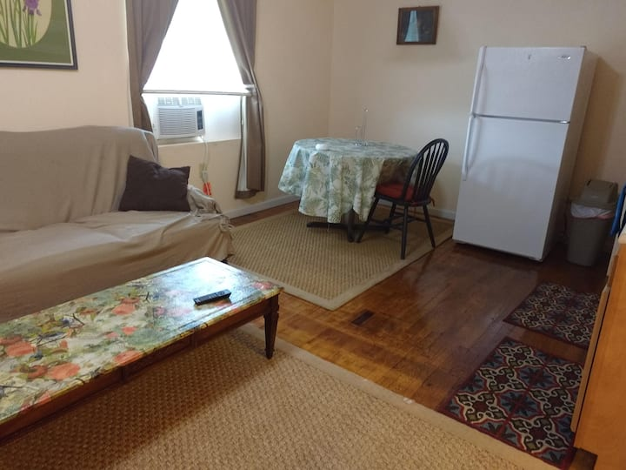

Apartment in Spencer
Cute and comfy apartment for 4(apartment 3)
1 queen bed
$89 per night
4.83 out of 5 average rating, 6 reviews4.83 (6)

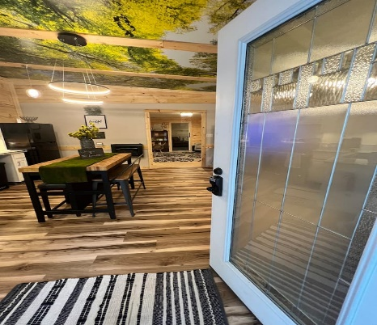

Townhouse in Spencer
New Listing! Hot tub, Unique stay, winery, hiking
4 beds
$99 per night
4.87 out of 5 average rating, 112 reviews4.87 (112)

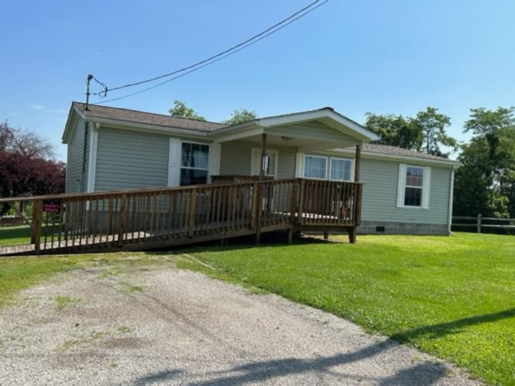

Home in Spencer
4 beds
$99 per night
4.97 out of 5 average rating, 30 reviews4.97 (30)

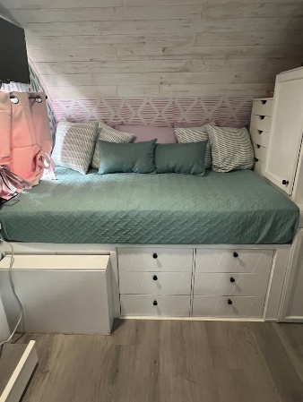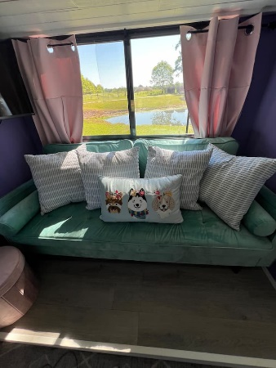

Camper/RV in Spencer
Colorful Glamper
3 beds
$75 per night
New Listing

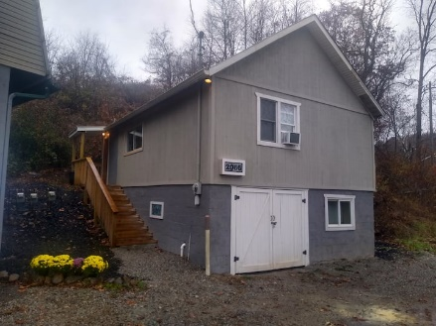

Vacation home in Spencer
The convenient yet comfy home
3 double beds
$90 per night
4.96 out of 5 average rating, 45 reviews4.96 (45)

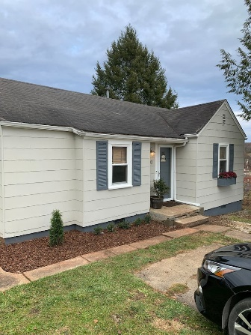

Home in Spencer
Beautiful 2-Bedroom Home in the Heart of Spencer
$79 per night
4.81 out of 5 average rating, 21 reviews4.81 (21)

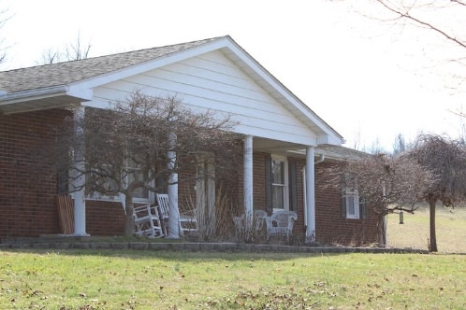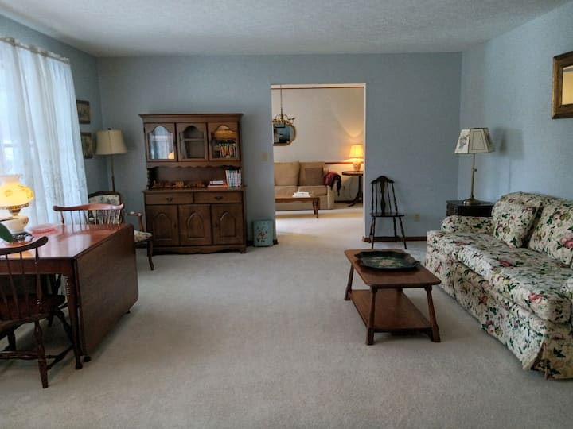

Home in Spencer
Bonnie’s Place
6 beds
$180 per night
5.0 out of 5 average rating, 6 reviews5.0 (6)

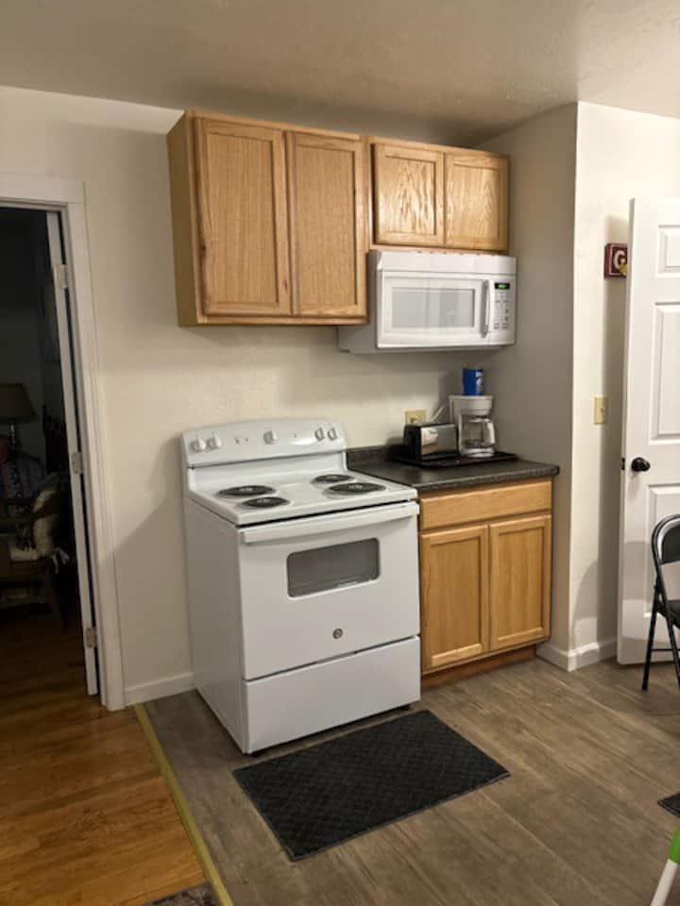

Apartment in Spencer
Cute and clean apartment for 3(apartment 2)
2 beds
$79 per night

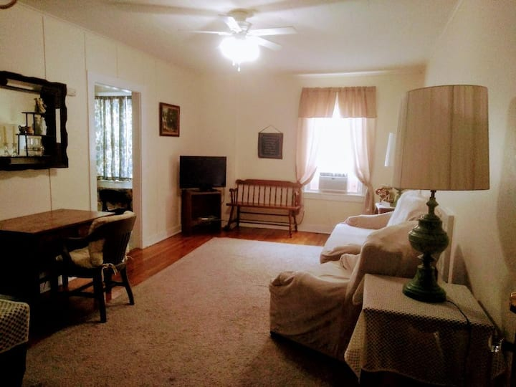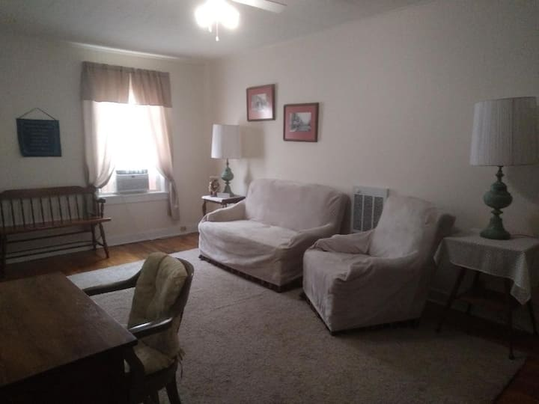

Apartment in Spencer
Clean one bedroom apartment for 3. (apartment 1)
2 beds
$89 per night
5.0 out of 5 average rating, 3 reviews5.0 (3)

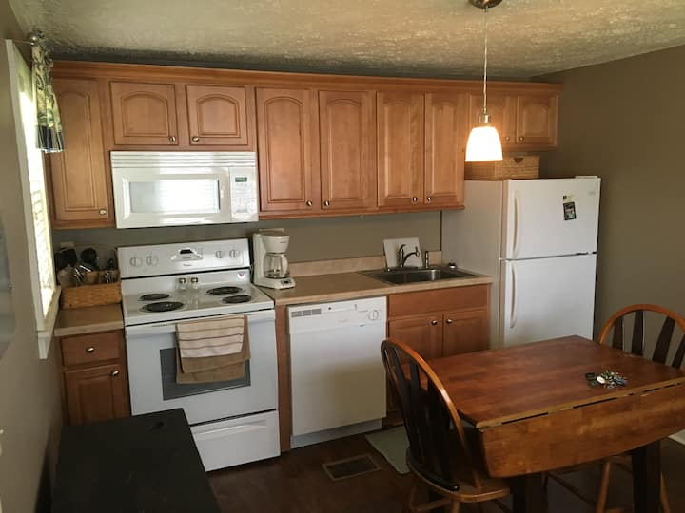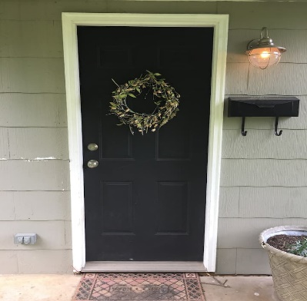

Guesthouse in Spencer
Quaint Cottage in the heart of Spencer
1 double bed
$55 per night
4.74 out of 5 average rating, 19 reviews4.74 (19)

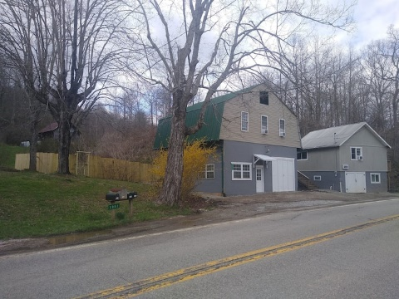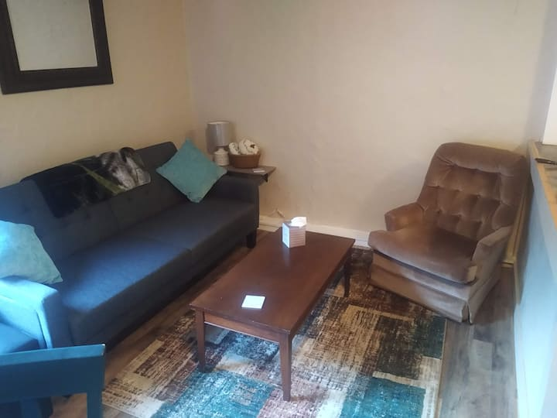

Vacation home in Spencer
Lovely 2 Bedroom Garage Apartment
3 beds
$95 per night
5.0 out of 5 average rating, 10 reviews5.0 (10)

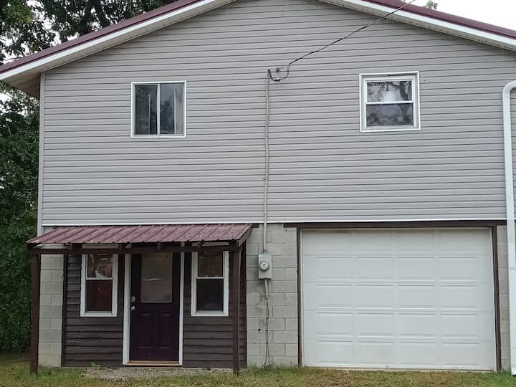

Home in Gandeeville
Corner timeout
4 beds
$80 night

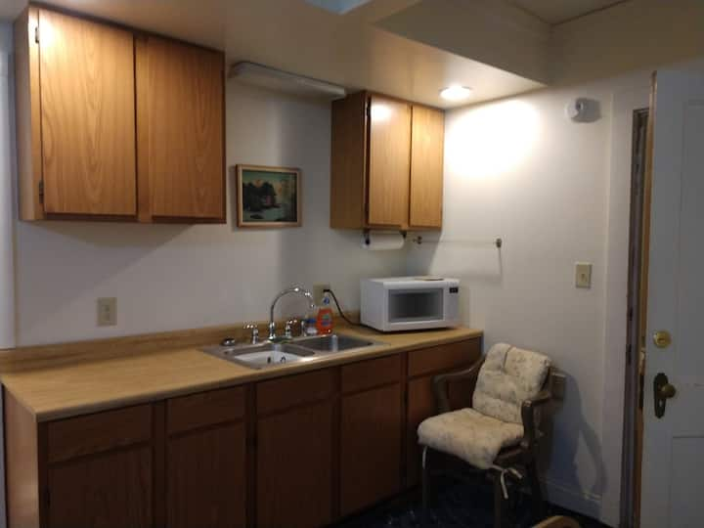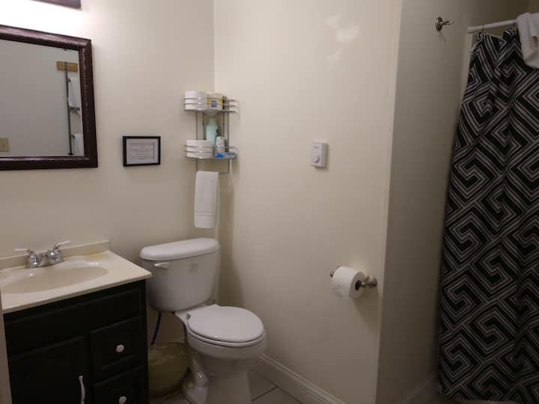

Apartment in Spencer
Clean efficiency apartment for 2(apartment 4)
1 queen bed
$65 night

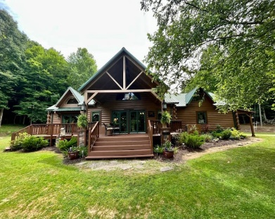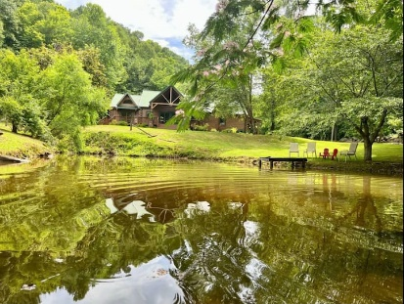

Cabin in Left Hand
Tranquil ridge-top cabin on over 172 acres
9 beds
$440 night

Schools and Educational Resources

Roane County Board of Education | 813 Capitol Street Spencer, WV 25276  304-927-6400  Fax: 304-927-6402  www.roanecountyschools.com
Roane County High School | 1 Raider Way Spencer, WV 25276  304-927-6420  www.rchs.roanecountyschools.com
Spencer Middle School | 2 Raider Way, Spencer, WV, 25276  www.sms.roanecountyschools.com
Spencer Elementary School | 85 Clay Road Spencer, WV 25276  (304) 927-6428  www.ses.roanecountyschools.com
Geary Elementary/Middle School | 9538 Clay Road Left Hand, WV 25251  304-565-3721  www.gems.roanecountyschools.com
Walton Elementary/Middle School | 90 School Drive Walton, WV 25286  304-577-6731  304-577-6734  www.wems.roanecountyschools.com
Faith Christian Academy | 237 Arnoldsburg Rd, Spencer, WV 25276  304-927-3320
Roane Adult Basic Education | 811 Madison Ave, Spencer, WV 25276  304-927-8292
Appalachian Regional Council Head Start | 811 Madison Ave, Spencer, WV 25276  304-927-4981  https://www.appcouncil.com/index.htm
Bus Garage (Spencer) | 167 East Main Street Spencer, WV 25276  304-927-6426
Patch 21st Century Learning Centers  (afterschool and summer programs, tutoring) | 811 Madison Avenue #3 Spencer, WV 25276  304-927-8047  Fax: 304-927-8084  www.patch21.org www.facebook.com/patch21 Email: info@patch21.org

Centered on West Virginia

Google map Showing 46 stays.

Social Services and Helping Agencies
WV DoHS – Roane County | DoHS is comprised of the Bureau for Behavioral Health and Health Facilities; Bureau for Child Support Enforcement; Bureau for Children and Families; Bureau for Medical Services; Bureau for Public Health; Office of Inspector General; and West Virginia Children’s Health Insurance Program (WV CHIP). DoHS provides services in all 55 counties. They can provide Birth Certificate, Medicaid Coverage or  temporary assistance, school clothing vouchers, TANIF, SNAP benefits, etc. | 677 Ripley Road #3  Spencer, WV 25276  304-927-0956  www.dhhr.wv.gov  Reports can also be made to the Abuse and Neglect Hotline ( 1-800-352-6513 ) 7 days a week, 24 hours a day.
Family Crisis Intervention Center | 24 Hour Hotline, Shelter, Individual Counseling, Legal Advocacy, Case Management, Support Group, Parenting Classes, Child Exchange, Monitored Visitation Center Eligibility Requirements:  -Be a victim of violence or abuse  -Be in need of a safe shelter from abuse  -Be 18 years of age or older; unless an emancipated youth | 24 Hour Hotline:  800-794-2335 or  304-428-2333  www.fcichaven.org
EVE (Eliminating Violent Environments) | Roane County Domestic Violence  Outreach Services  Providing Shelter, a 24-hour hotline,  crisis intervention, counseling, referrals and advocacy. A Child Exchange and Monitored  Visitation Center providing monitored visitation and child exchange in a safe, neutral, child-friendly environment putting the needs and interests of the children first | 304-927-3707  Hotline: 800-794-2335
WV Birth to Three | WV Birth to Three is a statewide system of services and support for children under age three who have a delay in their development, or may be at risk of having a delay, and their family. The Department of Health and Human Resources, through the Bureau for Public Health and the Office of Maternal, Child and Family Health, WV Birth to Three, as the lead agency for Part C of the Individuals | 866-321-4728  www.wvdhhr.org/birth23
Roane County Baby Connection | Roane Baby Connection has clothing Newborn -5T, infant formula, diapers, wipes, and many other baby items available.  They are open the 1st Monday of the month 10-12 and 3rd Thursday 4-6 | 754 Parkersburg Rd., Spencer, WV,  304-927-1535
Roane County Family Resource Network | Roane FRN strives to link citizens to resources, services, and relationships within Roane County to meet as many needs as possible locally. We provide social assistance, referral/linkage services, and public education opportunities, as well as coordinate key stakeholders in problem-solving within the community. | 216 Market Street, Suite 208, Spencer, WV, 25276  (304) 927-6070  roanefrn@gmail.com  roanefrn.org  Facebook: Roane County Family Resource Network

Helpful Websites
Roane County, WV Website: https://www.roanewv.com/
City of Spencer, WV Website: https://www.cityofspencer.com/
Roane FRN: https://roanefrn.org/