**“BJCC Dinner & Wine Walk”**

**Saturday April 13th 5:30pm-10:00pm**

**Location: Town Square, Las Vegas**

**Dinner: Yard House 5:30 to 6:45**

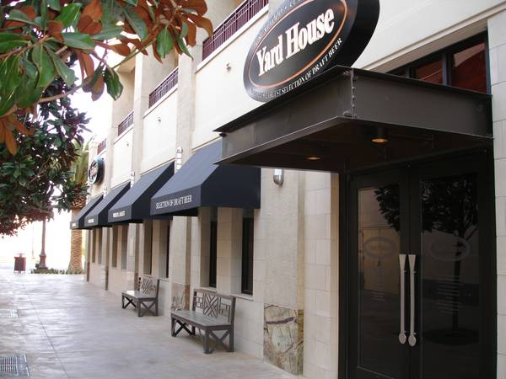

**Wine Walk: 7:00 to 10:00**

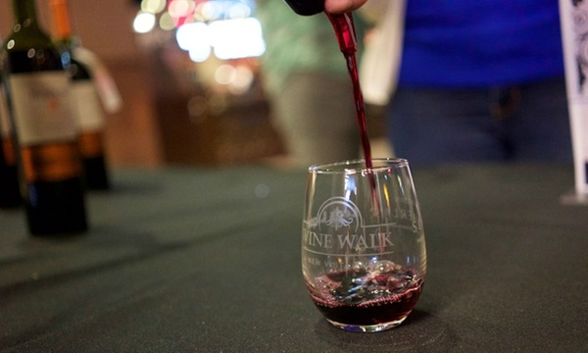

**NOTE: Tickets for the Wine Walk available on GROUPON. One for $24 or Two for $42. See website or Groupon App for details.**

***Lets get out before the heat of the summer & have some fun!***