December 25, 2003 (or shortly after)
Happy New Year!

It’s (just past) the time of year you’ve been waiting for. The time of year when you glance at the return address, make a painful expression, and say to your spouse or other significant person who stands next to you during mail call “I wonder if he’ll go on and on about his kids and dog again?” Probably, but more importantly, it is the time of year when we learn that one small person can save us all, that somebody willing to make the greatest sacrifice can change the world—yes, I’m talking about the next movie in the Lord of the Rings series! As the annual Schrobilgen family holiday letter has gotten bigger and in more demand each year (as in “I demand to be removed from your address book!”), it has become more difficult to find a theme to pull things together. Due to technical difficulties, chiefly being that I waited until December 22 to get started on this, I’ve decided to instead share my list of themes for 2003 that were rejected by my editorial staff, along with reasons for their rejection. So without further ado:

The Theme of "Bigger and Better Things": So many things were bigger, like the new house we bought in August. We only moved one block, due east, so if you've already sent gifts or money to our old address, don't worry. The new owners will hand it across the street to our former across-the-street neighbors, who will pass it across the alley to us since they are now our alley neighbors. One of the best things from this past year was watching Imal and Katie get married in May. In a touching ceremony in a small church in Wisconsin, Kathleen and I were parents of the groom, also parents of the ringbearer, flower bearer, and the picture carrier boy. We were very proud of them all, especially the picture carrier boy, who kept his hands in his pockets the whole time he was at the front of the church and didn’t pick his nose, not even once. Also bigger this year (or longer, at least) is my title at Worknet: Manager of Network Engineering. Time will tell if I’m any better at it than my last position

The “Using Every Letter of the Alphabet to Start a Line of a Poem” Theme: I came up with
“O” is for Oso. We’re afraid that he might
“P” on the carpet. Our dog’s not too bright. Rejected because 2003 was a very good year for Oso, accident-wise.

The “Wait Until Next Year” Theme: Erin’s T-ball team was defeated in the league championship series, when a guy in the left field stands interfered with a foul ball that Moises Alou would've caught… Wait a minute, wrong championship, but no less heart-breaking. The kids are young, they’ve got many, many years of optimism ahead of them before they accept the fact that destiny is inevitable in Chicago baseball. Erin just can’t wait to get outside to practice catching “divers” again.

The Numerical Theme: Important numbers from 2003 included 30 (the number of jumping jacks Kathleen makes Rory do when he has so much energy that he’s spinning out of control--he has done as many as 120 without stopping), 737 (our new street address on Highland, which Kathleen keeps forgetting, so when she got an estimate from the window washers they actually based the estimate on 739 Highland, our neighbors’ much smaller house), 40 (Kathleen’s age, the reason our neighbors had a surprise birthday party for her since she made me promise that I wouldn’t plan one), 13 (the number of consecutive batters Malachy walked in his first inning as pitcher, 3 (the number of consecutive outs he recorded in his next outing).

The “Wild Kingdom” Theme: 2003 was similar to other years in terms of overall animal involvement. The family fished in Door County, Seneca, Illinois, and the Ozarks. In the Ozarks, Kathleen got the fishing bug. For days on end, she sat there on the dock, mumbling about “catching the big one” and “Moby Dick”. It was a little more traumatic fishing in Door County, when Rory’s big bite turned out to be a mud puppy, a slimy, prehistoric-looking salamander-like thing that scared the begeezus out of him. Maybe that had something to do with Rory’s last day of swimming lessons, when he (uncharacteristically) refused to go in the water because he insisted there were alligators in the pool. And the 2003 Pet of the Year, Spike the bearded dragon, still lives in a tank in the boys’ room. Bearded dragons aren’t endangered, but if he doesn’t cut back on the mealworms he’s in danger of never ever making it out of that tank.

And finally, most importantly, The Theme of "Printing the Kids’ Picture on the Bottom of the Page so I Won't Have to Write As Much This Year":
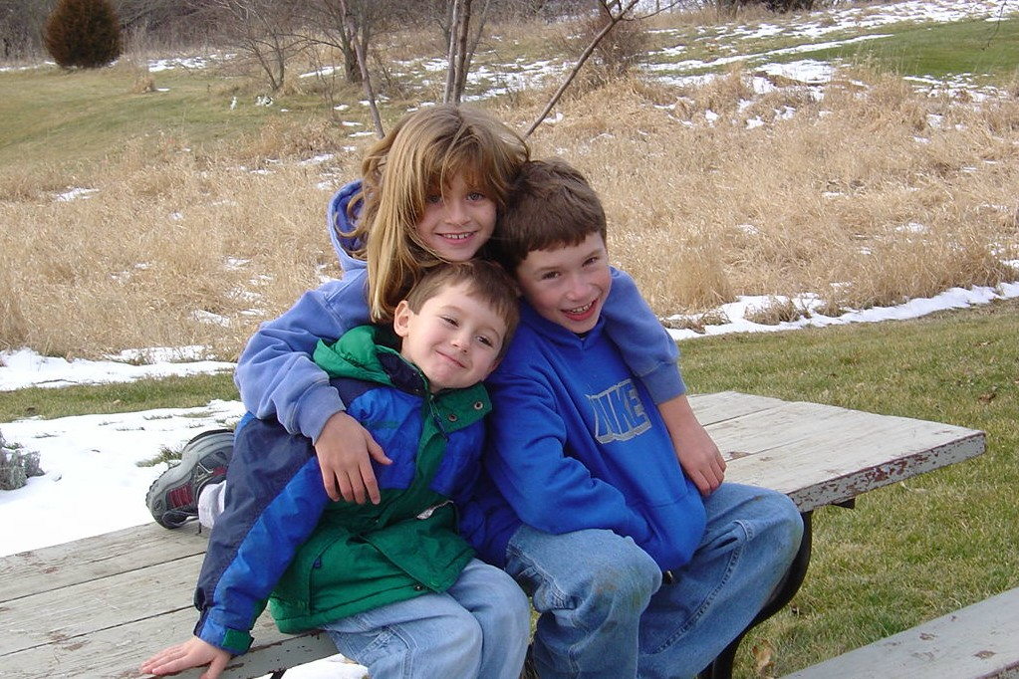

Wishing you all the best in 2004, from Rory, Erin, Malachy, Kathleen, and Greg!

