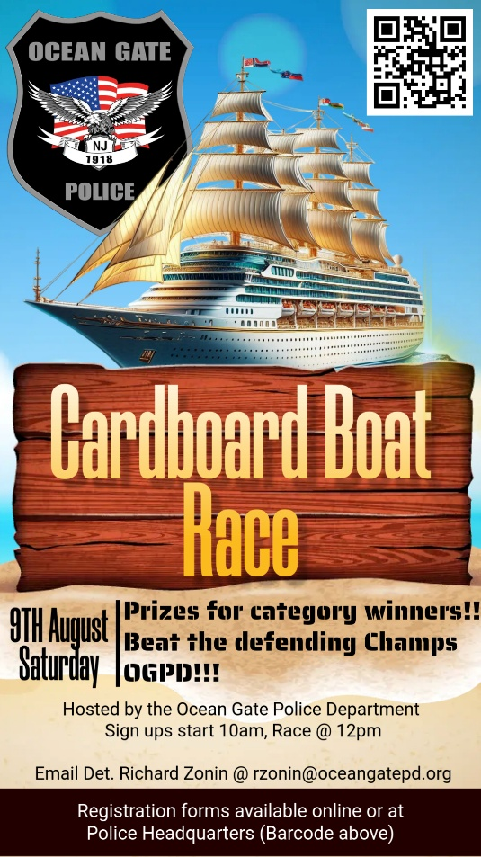

# PARTICIPATION RULES

1. During the competition, the crew must be **IN** the boat, not towing it, holding it between their legs, swimming, or allowing the life jacket to float the vessel.
2. NO pets can occupy a boat during competition.
3. Throwing water on another boat is a reason for disqualification unless said water comes from the incidental splash of a paddle or other propulsive device.
4. Contestants are expected to maintain the decorum and dignity expected of a yachtsman.
5. Sunken and discarded boats must be disposed of in the designated trash receptacle.

# RACE RULES

1. Each boat must have a designated captain. The captain must check in at the Registration Table area by noon on the day of the race.
2. To qualify for a trophy, the boat must correctly navigate the race course around the buoys. All crew members must be in the boat as it crosses the finish line.
3. All sailors MUST start the race in the boat. Only Elementary/middle school-age sailors can get a pushing off.
4. Any boat and/or crew not ready to race at the designated time will be disqualified.
5. Participants must retrieve their boats or boat remains from the water.

# SAFETY RULES

1. Boat occupants must wear appropriately sized, properly fastened, U.S. Coast

Guard-approved life jackets. **LIFE JACKETS MUST BE SUPPLIED BY AND WORN BY ALL PARTICIPANTS ON THE BOAT WHILE IN THE WATER.**

1. The passenger area of the boat must not be permanently enclosed above the shoulders of the occupants. Each occupant must be visible while the boat is in the water.
2. Boats must be free of sharp edges or anything that could pose a danger.
3. Consumption of alcoholic beverages or other substances that might impair a participant's judgment will not be permitted before or during the race. No alcohol is permitted on Ocean Gate Beach.
4. Children under eight will not be allowed to race.
5. All participants must be able to swim.

# CONSTRUCTION RULES

1. The **ENTIRE** boat must be built from cardboard and duct tape. Duct tape may be used to reinforce seams.
2. Corrugated Cardboard, Carpet Tubes, and Cardboard Blocks can be found at recycling centers, appliance stores, department stores, discount clubs, and electronics stores. Any thickness of corrugated cardboard is permitted.
3. Pre-treated cardboard, such as waxed cardboard, is allowed. No paint or varnish is allowed on the day of the event; all paint and varnished cardboard must be cured before boat launch. Paints and varnish are intended to be used as decorative elements only - not waterproofing.
4. Fastening material is to be duct tape only.
5. Hull wrapping in duct tape is allowed.
6. Decorations are allowed and encouraged, provided they are not used as structural or floatation elements.
7. Crew costumes are encouraged.
8. Design is left to the builder(s). Let your imagination take over.
9. Each boat must carry a closed-gallon plastic jug with a 10-foot rope attached to the jug and firmly secured to the vessel. Gallon jugs are to remain inside the boat while racing; they are not to be used as floatation for the vessel. This is for use in locating and retrieving any sunken remains.
10. The crew compartment CANNOT be enclosed to interfere with escape.
11. Any type of oar/paddles may be used.