Your story on paper:
Resumes, applications, and more
Virtual edition
Powered by Deloitte Academy



Workbook

Name: ___________________________ Date: __________
Deloitte Academy, a RightStep program
Presented by Deloitte Corporate Citizenship
Workbook activity #1: Do Now Activity
Deloitte Academy | “Your story on paper” workshop

INSTRUCTIONS
Below are three note spaces, each with a question to get you thinking about today’s topic. Write down your initial thoughts in the corresponding notes.
What is the job you’re aiming for: in 4 years, 4 months, OR 4 weeks from now? (pick one)
What skills are needed for that job?
What skills and experience do you have that make you a good fit for that job?

Workbook activity #2: What kind of “resume experience” do high school students have?
Deloitte Academy | “Your story on paper” workshop

INSTRUCTIONS
Brainstorm experiences that a high school student might have and write them in the appropriate column.
SCHOOL | OUTSIDE OF SCHOOL

Workbook activity #3: What kind of “skills” do high school students have?
Deloitte Academy | “Your story on paper” workshop

INSTRUCTIONS
Brainstorm and write down skills that a high school student might have.
SKILLS

Workbook activity #4: Putting the pieces together
Deloitte Academy | “Your Story on Paper” workshop

INSTRUCTIONS
Answer the questions on the screen in the boxes below.

CONTACT INFORMATION
PROFILE
EDUCATION

EXPERIENCE | EXPERIENCE
EXPERIENCE | EXPERIENCE
EXPERIENCE | EXPERIENCE
ACTIVITIES/SKILLS/INTERESTS | ACTIVITIES/SKILLS/INTERESTS
ACTIVITIES/SKILLS/INTERESTS | ACTIVITIES/SKILLS/INTERESTS
ACTIVITIES/SKILLS/INTERESTS | ACTIVITIES/SKILLS/INTERESTS

Tools, samples, and more
Deloitte Academy | “Your Story on Paper” workshop
ACTION VERBS

Aided
Advised
Budgeted
Checked
Coached
Composed
Constructed
Coordinated
Created
Demonstrated
Designed
Directed
Documented
Evaluated
Integrated
Interviewed
Influenced
Led
Maintained
Monitored
Organized
Performed
Planned
Prioritized
Provided
Recommend
Represented
Researched
Surveyed
Wrote

SUGGESTED RESUME CHECKLIST
FORMAT
- Length: One page
- Paper (if you are printing): Quality 8 ½ x 11 paper (white or ivory with black ink)
- Font: 10- to 12-point size font in Arial or Times New Roman
- Margins: Between 0.5”- 1.0”
- Categories:
  - Contact information
  - Profile
  - Education
  - Experience
  - Activities, skills & interests

CONTENT
- Your email address should be simple and professional (initials or name @reliable free email source)
- SPELL CHECK! GRAMMAR CHECK!
- Do not use abbreviations or acronyms
- If you’re aiming for a specific job, use key words from the job description or industry on your resume
- Use bullet points; do not write in full sentences
- Include specific numbers and details to demonstrate your impact
- For each “EXPERIENCE” item, aim for at least two bullet points to describe what you did and your results

TIPS
- Unless specifically requested, do not include your photo
- Review, Review, Review – Be sure to catch typos, inconsistent formatting, awkward word choice. Have at least three people review your resume (and be open to their feedback!)!

ANATOMY OF A RESUME
CONTACT INFORMATION
- Full name
- Address, phone number, e-mail
EXPERIENCE
  - Begin with most recent
  - Company names/locations
  - Positions held/dates of employment
  - Description of responsibilities and achievements – use numbers!
  - HINT: Use action verbs
PROFILE
- A brief summary of who you are and what you have to offer a future employer
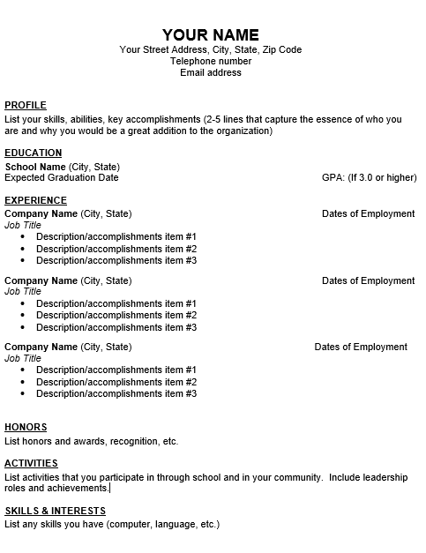
SAMPLE RESUME
ACTIVITIES/SKILLS/
INTERESTS
- Technical/computer knowledge
- Foreign languages
- Certifications and/or training
- Interests/activities (optional) – clubs and organizations, community service or other leadership
EXPERIENCE
- Begin with most recent
- Company names/locations
- Positions held/dates employed
- Description of responsibilities & achievements – use numbers!
- HINT: Use action verbs
EDUCATION
- Names of schools and locations
- Expected graduation date
- GPA
- Awards or honors
PROFILE
- A brief summary of who you are and what you have to offer a future employer

Stephanie Student
123 Broad Street, Philadelphia, PA 19103
(215) 555-5555 | Stephanie.student@email.com

PROFILE
Highly focused and responsible high school student guaranteed to contribute strongly within a customer service role requiring enthusiasm, charismatic communications skills, and an exemplary work ethic.
EDUCATION
Liberty Bell High School (Philadelphia, PA)
Expected Graduation Date: June 2021 GPA: 3.5
EXPERIENCE
Pizza Station (Philadelphia, PA) March 2019 to present
Hostess & Event Coordinator
- Greet guests and coordinate service at a neighborhood restaurant that serves 250 guests per day
- Assist the Catering Director to host 20 celebratory events in the restaurant’s private room per week
- Responsibilities include room set-up, menu planning, staff support, and on-site coordination
Habitat for Humanity (Camden, NJ) March 2018 to present
Volunteer
- Team with fellow youth group members to contribute to Habitat for Humanity projects. Work on construction teams to help build 20 new homes for low-income families per year
- Conceptualized and coordinated fundraising holiday shopping event that raised over $5,000
Grocery Town (Philadelphia, PA) May 2018 to April 2019
Cashier
- Process food purchases and payments for 100 customers per day at this high-volume supermarket
- Work with the latest payment technology that was recently introduced at the store

ACTIVITIES
Attended Deloitte Academy, a professional development workshop for high school students
Girls Inc. STEM Gems participant, 8th grade to present
Student Council representative
Captain, Dance team

SKILLS & INTERESTS
Fluent in Spanish
Experience with Microsoft Word and Excel

About Deloitte
Deloitte refers to one or more of Deloitte Touche Tohmatsu Limited, a UK private company limited by guarantee (“DTTL”), its network of member firms, and their related entities. DTTL and each of its member firms are legally separate and independent entities. DTTL (also referred to as “Deloitte Global”) does not provide services to clients. In the United States, Deloitte refers to one or more of the US member firms of DTTL, their related entities that operate using the “Deloitte” name in the United States and their respective affiliates. Certain services may not be available to attest clients under the rules and regulations of public accounting. Please see www.deloitte.com/about to learn more about our global network of member firms.

