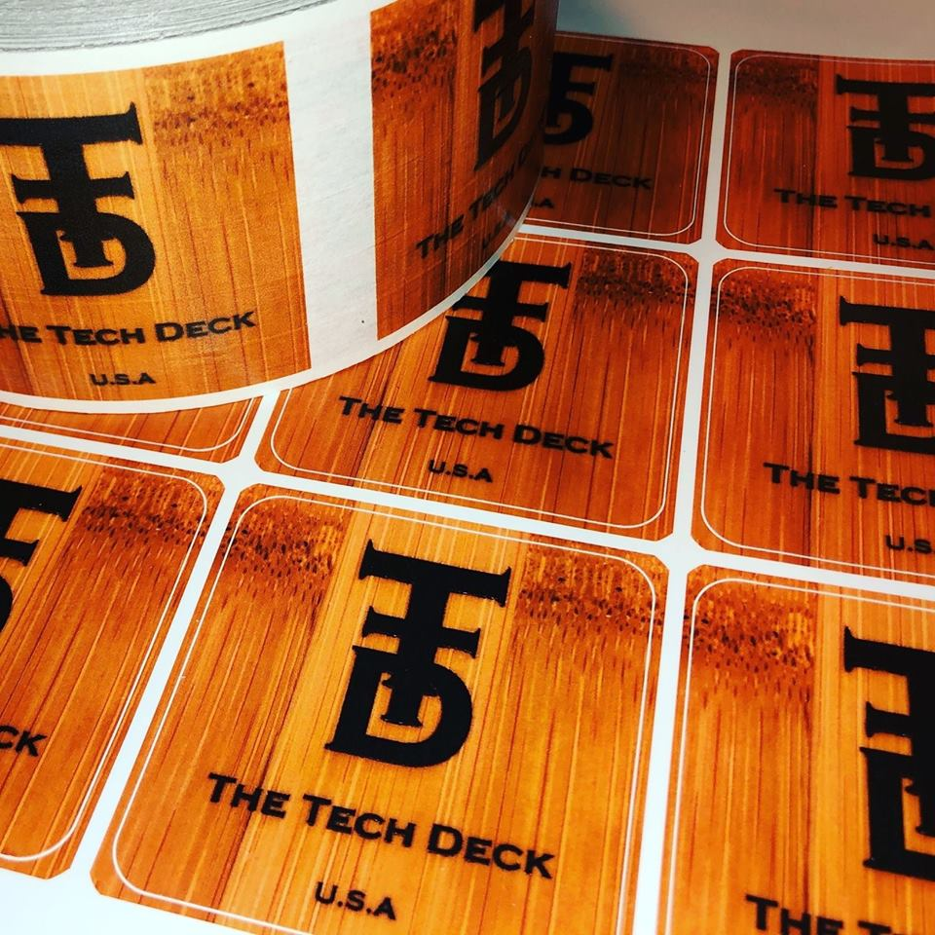

The Tech Deck
3D Print Form

Be sure to attach your file[s] that you want printed and this form to your email. Not all designs are printable due to size and complexity. Files submitted are subject to approval. Once your email is received and file[s] are approved, you will receive an invoice with the detailed cost of the print job.

Name:
Email:
Phone Number:

Material

PLA: Used for highly detailed prints, a bio-degradable plastic which is safe for the environment because it can be made from renewable resources.

Wood filament: A composite that combines PLA as a base filament with wood dust and other powdered wood derivatives that provides an incredibly smooth surface finish. As a result, parts printed with this material tend to be less abrasive than carbon fiber and metal filled filaments.

Elastic: Whether squeezed, bent, twisted, or crushed, elastic parts will immediately begin to take their original printed shape.

Nylon: Designers, engineers, and manufacturers work with nylon because of its strength, lightness, flexibility, and shatter-resistant quality. There are several different types of nylon blends to suit a wide variety of 3D printing needs. This gives designers the ability to choose the best filament for a particular print. We use a blend that focuses primarily on strength.

Carbon Fiber: Best in strength, durability, surface quality, precision, accuracy, and load and weight bearing needs.

Tell us what material you would like along with any other details (color, size, etc), we need to know prior to designing and printing.

____________________________________________________________________________________________________________________________________________________________________________________________________________________________________________________________________________________________________________________________________________________________________________________________________________________________________________________________________________________

*Manufactured in Minnesota, imperfections may occur.*

