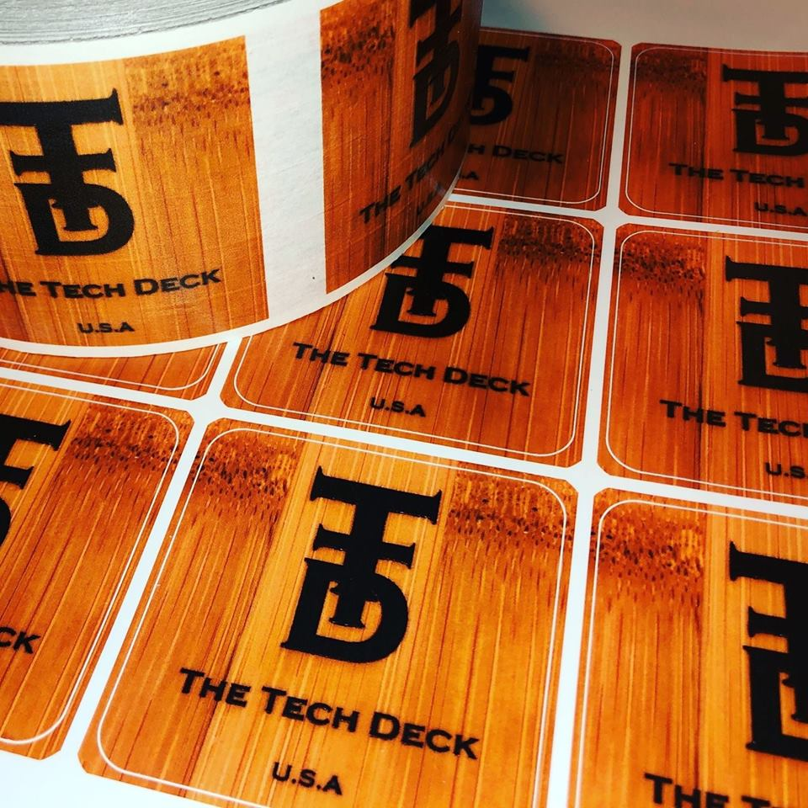

The Tech Deck

Decal Cutting Form

Be sure to attach your file[s] that you want cut and this form to your email. Not all designs are possible due to size and complexity. Files submitted are subject to approval. Once your email is received and file[s] are approved, you will receive an invoice with the detailed cost of the cutting job.

Name:

Email:

Phone Number:

Material

Carbon Fiber: Black, Gray, Blue, Red, White, Green

Metallic: Copper, Black, Purple, Red

Gloss: White, Black

Tell us what material you would like along with any other details (color, size, etc), we need to know prior to designing and printing.

____________________________________________________________________________________________________________________________________________________________________________________________________________________________________________________________________________________________________________________________________________________________________________________________________________________________________________________________________________________

*Manufactured in Minnesota, imperfections may occur.*