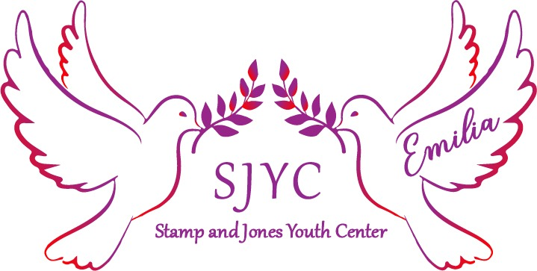
Volunteer & Internship Inquiry Form
Thank you for your interest in volunteering at the Stamp and Jones Youth Center (SJYC). We look forward to accomplishing the goals of the organization with you and would love for you to grow with us. There are numerous of ways someone can utilize their skills and contribute to making an impact in our community. Volunteers are important to SJYC and the lives of our youth. Please fill out this inquiry form to allow SJYC to learn more about you.
Stamp and Jones Youth Center requires all prospective volunteers to undergo a background check.

Name_________________________________________________________
Address_______________________________________________________
City_____________________ State ______________ Zip_______________

Any special talents or skills you have that you feel benefit the organization?
______________________________________________________________

Interest: Please tell us in which areas you are interested in volunteering.
_____ Administration
_____ Programs
____ Fundraising
_____ Events
_____ Mentor
_____ Tutoring
_____ Other __________________________________________________
Please indicate days available: Mon Tues Wed Thur Fri Sat

Times available: From__________________ To______________________

As a volunteer of our organization I agree by the policies and procedures. I understand that I will volunteering at own risk and the organization, its employees and affiliates, cannot assume any responsibilities for any liability for any accident, injury or health problems which may arise from any volunteer work I perform for the organization. I agree that all is work I do is on volunteer basis.

Print________________________________________________________

Signature____________________________________________________

Date________________________________________________________

Please provide us with an emergency contact.
____________________________________________________________

