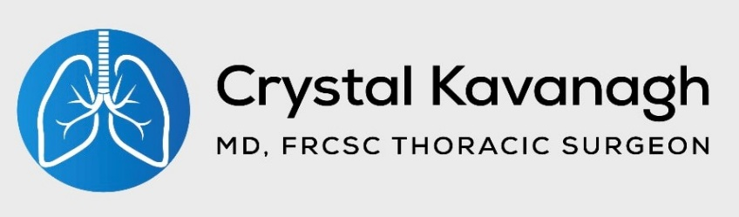
- 17730 Leslie St. Unit 116
Newmarket, ON L3Y 3E4
( (905) 967-9798
Fax (905) 967-9788
* office@dr-kavanagh.com

You will have some pain and discomfort as you heal. Take Tylenol and Celecoxib (if it was prescribed) as directed. You will be discharged with a limited amount of oral narcotic pills, these should be taken as a last resort to manage pain.

It is important to have regular bowel movements to reduce cramping and bloating after abdominal surgery. We will suggest an over-the-counter stool softener to take as needed. Remember that narcotic pain medications can cause constipation.

Pain ManagEment
  - Discharge Instructions and Guidance after Abdominal
You will have some pain and discomfort as you heal. Take Tylenol and Celcoxib (if it was prescribed) as directed. You will be discharged a with a limitied amount of oral narcotic pills, these should be taken as a last resort to manage pain.

Having regular bowel movements is important to minimize nausea and cramps. We will suggest an over the counter stool softener to take if you need it at home. Remember, narcotic pain medications can cause constipation.

Pain ManagEment
  - Surgery

Surgery: ___________________________________________________________________
Date: ______________________________________________________________________

[ ] Laparoscopic abdominal surgery: You will have 4-5 small cuts covered with little tapes called Steri-strips. Leave these on for 7-10 days, they will either fall off on their own or you can peel them off.
[ ] Open abdominal surgery: You will have one incision. Your large dressing will come off while you in the hospital, 2 days after surgery. Leave it uncovered.
[ ] Esophagectomy: You will have one incision on your abdomen and one on your right chest. Your large dressings will come off while you in the hospital, 2 days after surgery. Leave them uncovered. You will also have two small holes where your chest tubes were in place, these shouldn’t have any covering on them by the time you go home.
If you are going home with a feeding tube, Home and Community Care (HCCSS) nurses will assist with teaching you to care for it and changing the dressings.
Can I have a bath or shower?
If you go home without a feeding tube, you can shower as soon as your outer dressings are off. You can get in the shower with the Steri-strips in place, pat to dry. Please do not get into a bath, hot tub, lake or ocean for 4 weeks.
If you go home with a feeding tube in place, you will have to cover it to shower or do sponge baths until it is removed.
What Can I Eat?
Most patients after hernia, reflux or esophageal cancer surgery will go home on soft diet for four weeks. Our dietician will give you a list of foods you can eat to use a guide.
It is normal not to have a big appetite after abdominal surgery. It will come back over time.
What activities can I do?
You need a good balance of activity and movement with rest when you get home. Rest when you feel tired.
Take short walks and increase your pace and distance as you start to regain your energy. Walks and cardiovascular activity will help regulate your bowels and keep your lungs strong after surgery. Please keep using your incentive spirometer the way you were taught in the hospital.
Avoid lifting more than 10 lbs for four weeks. If you are involved in contact sports, please also avoid those for at least four weeks. You can resume sexual activity when you feel comformtable to do so.
You can start driving when you are no longer taking narcotic pain medications. Before you drive, make sure you can move your torso without feeling limited by pain or stiffness so you can make emergency maneuvers if needed.
What’s “normal”?
Feeling tired is normal. Rest when you need to.
Feeling soreness, numb or a “pins and needled” sensation in your incision is also normal. This will improve in the weeks to come.
It is normal to have some pain when you cough, sneeze, or take very deep breaths. Try using the splinting method by squeezing a pillow over your incision to minimize discomfort.
When should I be worried and visit the emergency department?
If you develop severe, sudden pain in your chest, abdomen, or legs.
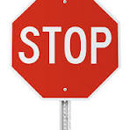
If you develop severe shortness of breath
If you can’t swallow, or experience forceful vomiting.
If you develop fever or chills
If your incisions become warm to the touch or red, this might be a sign of infection. Call us, visit your family doctor or a walk-in clinic to have your incisions looked at. You should be able to have this managed without going to the emergency department.
If you are in doubt, err on the site of being cautious. If you are ever unsure about something but it is not an emergency, call the office and we can help with questions.
We will call you within a few days of discharge to see how you are feeling and set your follow-up appointment.

