**What are the benefits of assuming the seller’s mortgage?**

In an assumption, a buyer arranges with the seller and the mortgage holder to take over responsibility

**A:**

for the mortgage debt.

Holders of conventional mortgages on a buyer’s assumption demand modification of the existing mortgage terms, including a change in the interest rate, monthly payments, repayment period and often the principal balance. These mortgages are considered “non-assumable mortgages.”

However, two types of mortgages are classified as “assumable” by a buyer on their existing terms:

* mortgages insured by the Federal Housing Administration (FHA); and
* mortgages guaranteed by the Department of Veterans Affairs (VA).

A seller may use the fact that their mortgage is assumable as an additional marketing tactic. In a time of increased interest rates, buyers are able to assume an FHA-insured or VA-guaranteed mortgage at a lower rate originated in more favorable times. Assumable mortgages also avoid incurring an appraisal fee and expensive loan origination fees demanded on new purchase-assist financing.

When the buyer assumes a mortgage, they must meet the mortgage holder’s requirements for a formal assumption of the mortgage. As a result, buyers need to qualify to formally assume a mortgage.

When the seller has a large equity in their property and the buyer needs to make up the difference between the balance of the mortgage and the purchase price to assume the mortgage, the seller may:

* require the buyer make a larger down payment; or
* carryback a second mortgage together with a smaller down payment.

When the buyer qualifies, the buyer formally assumes the mortgage by entering into a written assumption agreement with the lender. On conventional mortgage assumptions, the lender agreeing to an assumption also demands a loan modification to bring the interest rate and payments up to current market rates.

The assumption of a consumer mortgage constitutes a new mortgage origination — triggering new consumer mortgage disclosures by the lender — when:

* the mortgage is being assumed to finance the buyer’s purchase of their one-to-four unit principal residence;
* the lender agrees to accept the assuming buyer as the borrower; and
* the assumption agreement is in writing.



**Christy Dumlao Real Estate Broker**

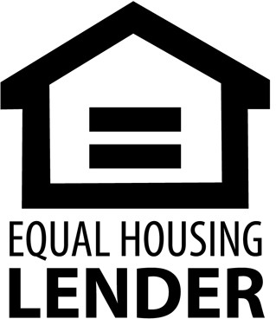DRE LIC# 01474985

925-395-0175

[christy@christyscarealty.com](mailto:christy@christyscarealty.com) christyscaliforniarealty.com