**What is a balloon**

**payment mortgage?**

Final/balloon payment mortgages contain due date provisions calling for final payment of the principal balance in a lump sum before the principal

**A:**

is fully amortized through periodic payments.

For homebuyer mortgages, a final/balloon payment mortgage has a scheduled final payment that is more than twice the amount of any of the six regularly scheduled payments immediately preceding the balloon payment date.

Final/balloon payments on consumer-purpose, homebuyer mortgages have become rare due to consumer mortgage legislation, known as Regulation Z (Reg Z). When your mortgage complies with Reg Z qualified mortgage (QM) standards, your mortgage needs to be fully amortized in substantially equal regular installments, a rule eliminating the inclusion of a final/balloon payment provision. Business- purpose mortgages often have a due date for a final/ balloon payment as they are not subject to federal consumer mortgage law.

When your consumer mortgage has a final/balloon payment, your lender needs to document their good

faith effort to determine your ability to actually repay the mortgage when it is due.

A consumer or business mortgage with a term exceeding one year which is secured by your primary residence and contains a final/balloon payment due date is required to include a 90/150-day due date notice provision.

The notice reminds you of the final/balloon payment and gives you an opportunity to modify, refinance or pay off the remaining principal balance before the final/balloon payment becomes due.

The notice needs to be delivered at least 90 days, but not more than 150 days, before the due date (hence the term 90/150).

When the notice is not timely delivered, the due date of the final/balloon payment is extended until 90 days after proper notice is delivered. No other terms of the note are affected. Thus, the accrual of interest and the schedule of periodic payments remain the same during the extended due date period.

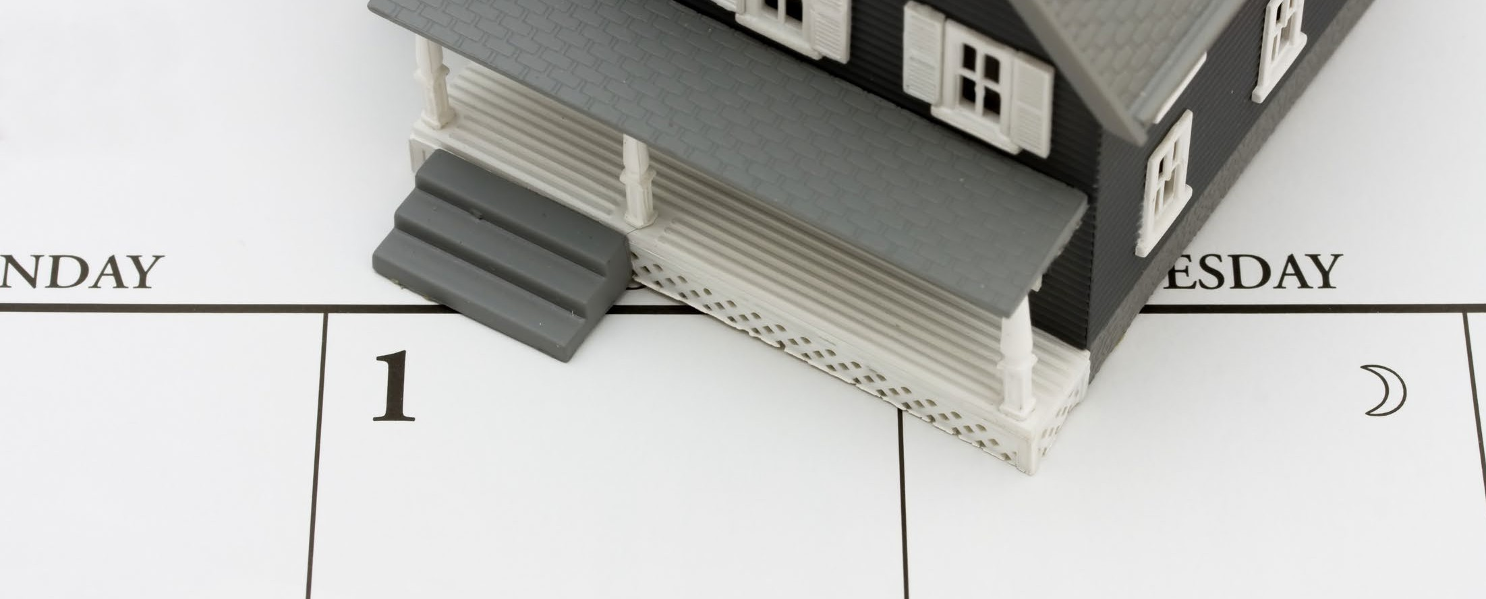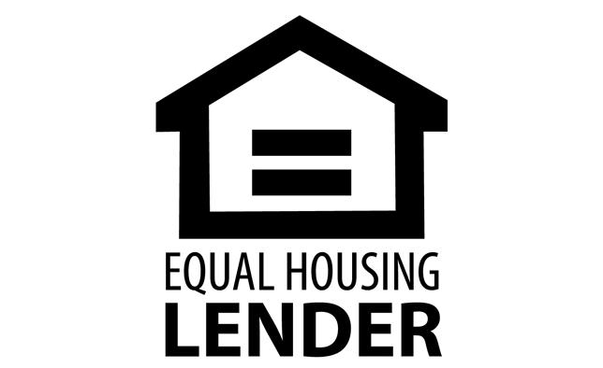

**Christy Dumlao Real Estate Broker**

DRE LIC# 01474985

925-395-0175

[christy@christyscarealty.com](mailto:christy@christyscarealty.com) christyscaliforniarealty.com