

**What will my homebuyer costs be and how much cash will I need?**

To determine how much cash-on-hand you will need to buy the home, a trip to a couple

**A:**

of mortgage lenders is necessary. Your visit with the lenders helps you determine:

* the maximum dollar amount of purchase-assist, fixed rate mortgage (FRM) funds you are pre- approved to borrow for the purchase of a property that qualifies as security for the mortgage; and
* the lender’s *loan estimate* of the dollar amount of all costs you will incur to obtain the maximum FRM you qualify to borrow.

The lender’s **Loan Estimate**, prepared on a uniform disclosure form for comparative shopping, includes your projected:

* monthly payments;
* taxes, insurance and assessments;
* closing costs; and
* total cash-on-hand needed to close.

**Christy Dumlao Real Estate Broker**

DRE LIC# 01474985

925-395-0175

[christy@christyscarealty.com](mailto:christy@christyscarealty.com) christyscaliforniarealty.com

During the conferences with lenders, your agent inquires about any restrictions the lender may place on their different mortgage commitments. For example, a loan-to-value ratio (LTV) may require a minimum down payment of up to 20% of the price paid for a property. Down payments smaller than 20% require mortgage insurance, which is an additional expense to the monthly payment.

Also, the lender may place limitations on the seller’s payment of your nonrecurring transactional and financing costs, such as permitting the seller to pay all, a limited portion or none of the costs of acquisition and funding.

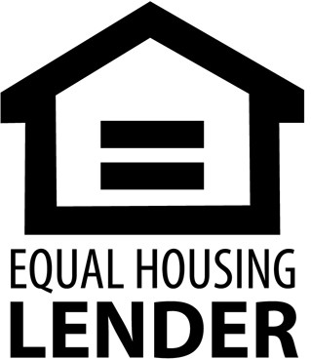With knowledge of any lender restrictions, your agent is able to structure purchase agreement offers to shift large amounts of transactional and financing charges to the seller. Thus, the charges may be paid by the seller out of funds the seller receives from you, not paid by you separately, which reduce the funds you have available to buy property. By shifting acquisition costs to the seller, you can acquire a more valuable property with more amenities or make a larger down payment and avoid the cost of mortgage insurance since you will have more funds available to buy a home.