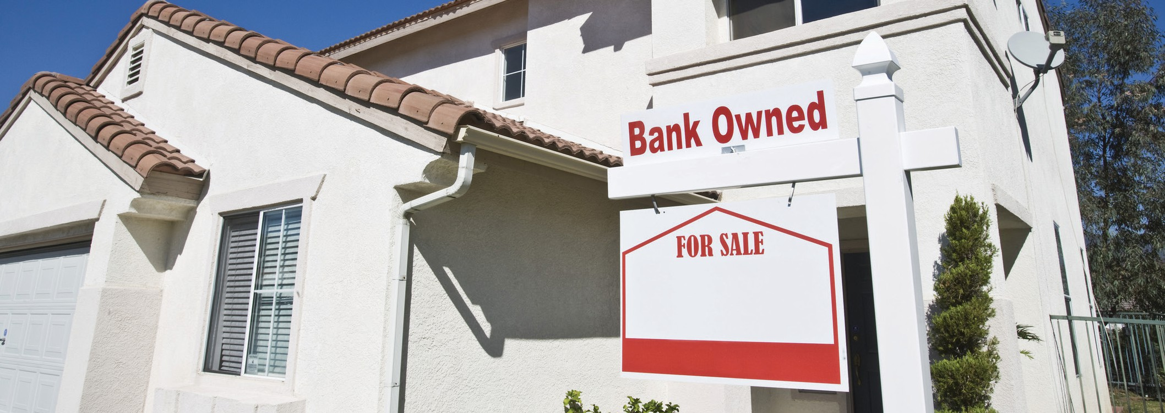

**What am I to expect**

**when buying a foreclosed,**

**lender-owned home?**

A home acquired by a lender through foreclosure is called real estate owned (REO) property.

**A:**

Three key differences exist between buying a home from an REO lender and buying one from a traditional seller:

1. REO properties typically have shortened due diligence and property investigation timeframes;
2. REO lenders on a resale are exempt from making property disclosures on the statutory disclosure form; and
3. REO properties are more likely to have undisclosed defects.

Since the purchase of an REO property is not a traditional sale, your negotiating power as a buyer is somewhat hampered by laws and the conduct of all participants. Lenders selling REO property deliberately rush you through the transaction by restricting the timeframes for your due diligence investigations into the conditions of the property. With shorter contingency periods, the risks of overlooking material defects and discovering problems after the transaction closes are greater.

The seller of an REO property is exempted from providing a buyer with a statutory Transfer Disclosure Statement

(TDS). However, no seller, including a lender selling an REO, is ever excused from disclosing known material facts. Importantly, the REO lender’s seller’s agent is not excused from performing their visual inspection and not exempt from reporting the adverse property conditions they observed or know about on the statutory TDS disclosure form.

Further, you need seek out others for additional information who may be familiar with the property or provide inspection services, such as neighbors, the foreclosed prior owner and home inspectors.

REO property may have several other issues not common to a traditional sale. When an owner of property is unable to make their mortgage payments, they likely were unable to properly maintain the home, or worse, commit intentional waste. Obtain a home inspection report (HIR) from a home inspector. After reviewing the findings on the HIR, consider hiring specialists to further evaluate any components of the improvements the HIR revealed to be of concern.

Further inspections of property components may be prudent, such as the roof, and any septic tank and pool equipment. Also, a termite inspection verifies the existence of any termite or fungal infestation on the property. With these inspections you avoid future discovery of undisclosed defects.

**Christy Dumlao Real Estate Broker**

DRE LIC# 01474985

925-395-0175

[christy@christyscarealty.com](mailto:christy@christyscarealty.com) christyscaliforniarealty.com