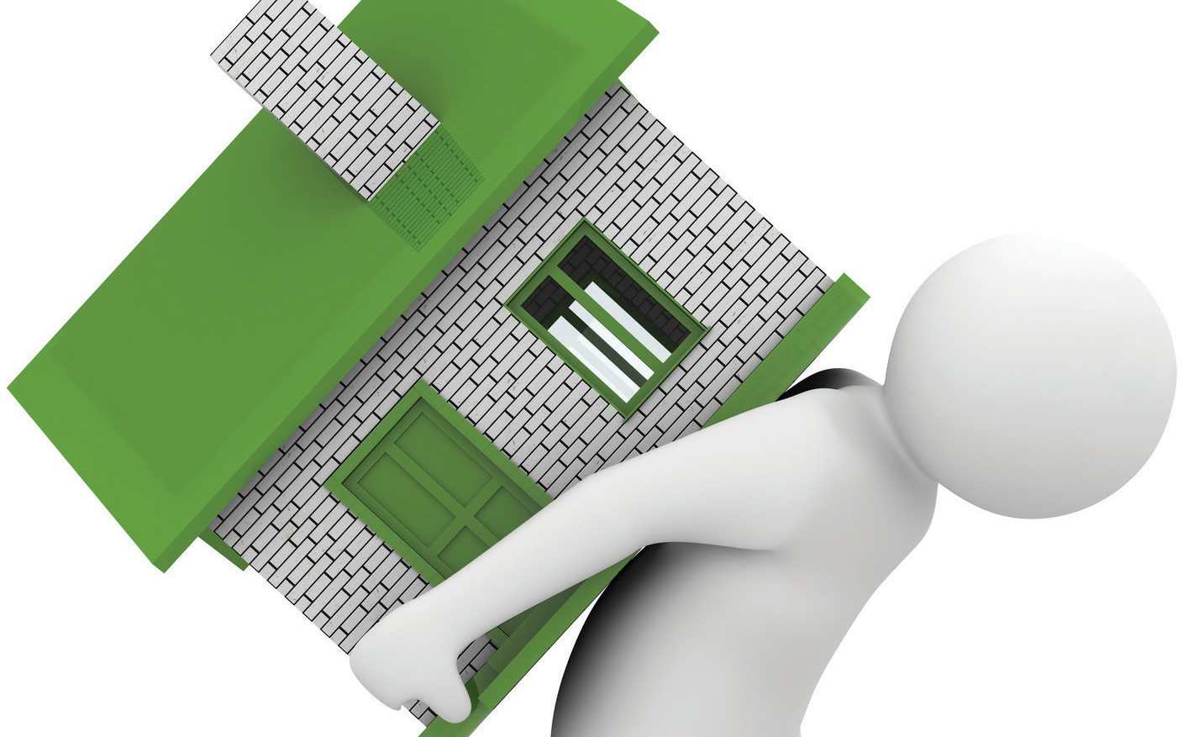

**What is a carryback sale?**

When a seller extends financing on the sale of their property for part of the sales price paid by the buyer,

**A:**

the transaction is called a **carryback sale**. The amount of the carryback debt the buyer owes the seller on closing is the portion of the price remaining after deducting:

* the down payment; and
* the amount of any existing or new mortgage used by the buyer to pay part of the price.

The carryback sale is also known as:

* seller financing
* an installment sale;
* a credit sale; or
* an owner-will-carry (OWC) sale.

**Benefits for sellers** entering a carryback sale include:

* not having to rely on lender financing, which requires appraisals and extensive paperwork to close the deal;
* greater marketability by appealing to a larger pool of buyers;
* usually a higher-than-market sales price; and
* the ability to defer taxes on taxable profit from the sale.

**Benefits for buyers** include:

* a down payment amount negotiated solely with the seller;
* competitive interest rates, as the buyer is realistically able to negotiate a below-market interest rate in exchange for the seller’s higher-than-market sales price;
* more flexible considerations for qualification and documentation than by mortgage lenders; and
* no origination costs or lender processing hassle.

However, the seller (former owner) takes on the risks of a mortgage lender when they extend carryback financing. If the buyer defaults on the seller-extended financing, the property is the seller’s sole source of recovery.

Also, the property’s value might decline or the buyer might commit waste in their treatment of the property. When a property’s value becomes less than the carryback debt, the carryback seller will experience a loss if they have to foreclose (except in the case of waste, which is recoverable from the buyer directly). Further, foreclosure and resale of the property have associated costs the seller needs to consider. Thus, the seller needs to screen the creditworthiness of the buyer to ensure the buyer has the ability to sustainably pay the carryback debt owed the seller.

**Christy Dumlao Real Estate Broker**