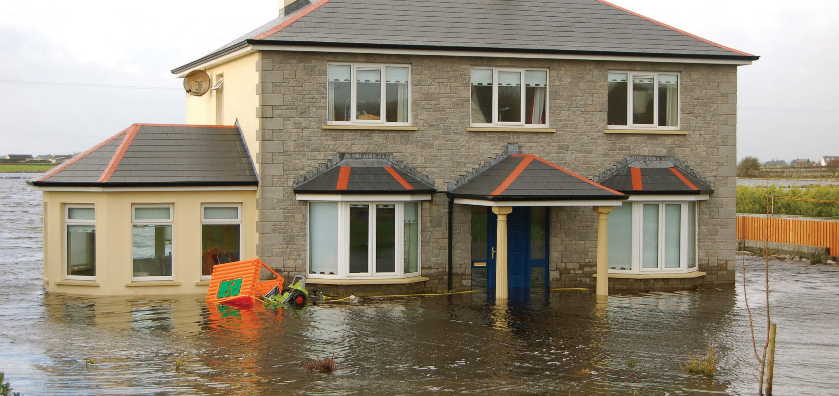

**How will I know if there are problems with the home I want to buy?**

The seller of a one-to-four unit residential property is mandated to complete and deliver to a prospective

**A:**

buyer a statutory form called a **Transfer Disclosure Statement (TDS)**, also called a Condition of Property Transfer Disclosure Statement. The TDS is to be handed to the buyer before the seller accepts a purchase agreement offer submitted by the buyer.

The seller is required to prepare it with honesty and in good faith. When preparing the TDS, the seller sets forth any property defects *known* or *suspected* to exist by the seller. To that end, the seller’s agent is to conduct a visual inspection of the property and note their further observations on the TDS before marketing the home for sale.

Prudent sellers and seller’s agents obtain and rely on the content of a **home inspection report (HIR)** to prepare their TDS for delivery to prospective buyers. The risk of later claims of non-disclosure is greatly reduced.

Any conditions known to the seller which might negatively affect the *value* and *desirability* of the property for a prospective buyer are to be disclosed, even though they may not be an item listed on the TDS. Disclosures to the buyer are not limited to property conditions preprinted on the form.

*Material defects* affect the price a reasonably prudent homebuyer may pay for the home, and are conditions which affect the property’s:

* market value;
* desirability as a dwelling;
* habitability from the elements; and
* safety from injury in its use as a dwelling.

Further, a **Natural Hazard Disclosure Statement (NHDS)** is also mandated to be delivered by the seller’s agent to potential buyers “as soon as practical” — which means before the seller signs a purchase agreement, according to the California Attorney General. If a hazard is known to any agent (as well as the seller) or shown by public records, it is to be disclosed to the prospective buyer before the seller enters into a purchase agreement on the property.

Locations where a property might be subject to natural hazards include:

* special flood hazard areas;
* potential flooding and inundation areas;
* very high fire hazard severity zones;
* wildland fire areas;
* earthquake fault zones; and
* seismic hazard zones

**Christy Dumlao Real Estate Broker**