

**What is a deed-in-lieu of foreclosure?**

Alternatives to foreclosure available to a homeowner in default on their mortgage

**A:**

include:

* forbearance;
* loan modification;
* **deed-in-lieu** of foreclosure;
* conventional sale; and
* short sale.

When a homeowner cannot avoid foreclosure by an arrangement with their lender for forbearance or loan modification, or simply a sale of the property, the homeowner may be able to arrange a **deed-in-lieu** of foreclosure acceptable to the lender.

The deed-in-lieu is usually a last resort arranged when:

* the mortgage balance encumbering the property is greater than the property’s value;
* the mortgage is a nonrecourse debt; and
* the owner fails to sell the property through a short sale.

A homeowner who signs and delivers a deed-in-lieu

acceptable to the lender essentially conveys their property to the lender in exchange for the cancellation of the debt.

Both the deed-in-lieu and a reconveyance of the trust deed are recorded, extinguishing the lender-borrower relationship between the lender and the homeowner.

A deficiency in the value of the mortgaged property to provide a full recovery of the mortgage debt most often provides the homeowner with **anti-deficiency** law protection, called a purchase-money mortgage or nonrecourse mortgage.

On a nonrecourse mortgage, the lender is not able to hold the original borrower personally liable for the deficient property value.

In contrast, a *recourse mortgage* does not provide anti- deficiency protection for the owner from a deficiency judgment. Further, when the mortgage is insured against default by the Federal Housing Administration (FHA) or the Department of Veterans Affairs (VA), the FHA or the VA have recourse to the homeowner under the default insurance for losses due to foreclosure, or in this case, a deed-in-lieu of foreclosure.

**Christy Dumlao Real Estate Broker**

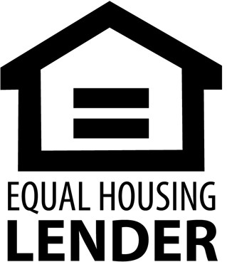DRE LIC# 01474985

925-395-0175

[christy@christyscarealty.com](mailto:christy@christyscarealty.com) christyscaliforniarealty.com