

**What is an FHA-insured mortgage?**

Homebuyers with little cash saved for a down payment can buy a home by qualifying for a purchase-assist mortgage insured by the Federal Housing Administration (FHA). An **FHA-insured mortgage** is characterized by a small down payment

**A:**

requirement and a high loan-to-value ratio (LTV).

To qualify for an FHA-insured mortgage, you need only a minimum credit score, meet debt-to-income (DTI) ratios for payments, have a down payment of at least 3.5% of the purchase price (5% on mortgages greater than $625,000) and occupy the property as your primary residence. The interest rate and costs on the mortgage are negotiated between you and the lender.

An upfront FHA mortgage insurance premium (MIP) of 1.75% of the mortgage amount is advanced by the lender and added to your mortgage balance.

The FHA does not lend you money directly. Rather, the FHA insures mortgages originated by lenders against default.

To meet DTI ratios for an FHA-insured mortgage:

* your total monthly payment to the lender may not exceed 31% of your gross income; and
* your total fixed payments on all debts may not exceed 43% of your gross income.

Your monthly mortgage payments include principal, accrued interest, property taxes, hazard insurance premiums and the MIP. In effect, MIP increases the annual cost of borrowing as it is an annual rate paid for the life of the mortgage. Together, the MIP and interest are the annual cost for borrowing FHA-insured funds.

Unlike conventional financing, California’s anti- deficiency laws do not apply to FHA-insured mortgages for lender claims on a buyer’s default and subsequent foreclosure. Thus, you are personally liable to the FHA for any loss the FHA suffers as a result of a foreclosure. However, the FHA rarely pursues deficiency judgements, though they have legal authority to do so.

**Christy Dumlao Real Estate Broker**

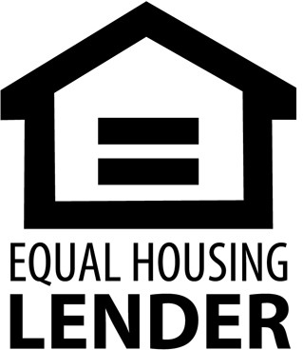DRE LIC# 01474985

925-395-0175

[christy@christyscarealty.com](mailto:christy@christyscarealty.com) christyscaliforniarealty.com