

**What happens during the foreclosure process?**

When you obtain a mortgage on your home, the power-of-sale provision in the trust deed authorizes

**A:**

the mortgage holder to foreclose on your home if you default on your mortgage payments and do not cure the default before the lender sells the property.

The foreclosure process has three stages:

1. a notice of default (NOD) is recorded and mailed to you within ten business days after it is recorded and to any holders of a recorded interest in your home within one month after it is recorded;
2. a notice of trustee’s sale (NOTS) is recorded, posted on the property and mailed to you no less than three months after the NOD is recorded; and
3. a trustee’s sale of the real estate by public auction occurs 20 days after the NOTS is recorded, followed by the execution of the trustee’s deed and distribution of sales proceeds.

Before the foreclosure process begins, the mortgage holder will contact you to:

* + assess your financial situation;
  + explore options to avoid foreclosure;
  + advise you of your right to an additional meeting within 14 days to discuss your financial options; and
  + provide you with the toll-free Department of Housing and Urban Development (HUD) phone number to find a HUD-certified housing counseling agency.

At least 30 days after this pre-foreclosure workout, the trustee — named in the mortgage or appointed by the mortgage holder at the time of foreclosure — will begin

foreclosure by recording the NOD.

The NOD sets forth your monetary default on the note or other obligation secured by the mortgage.

Once the NOD is recorded, the trustee needs to allow three months to pass before advertising and posting notice of the date of the trustee’s sale.

The trustee then posts a NOTS on your property and mails you a copy at least 20 days before the date of the sale.

However, after an NOD is recorded and prior to five business days before the trustee’s sale, you can terminate the foreclosure proceedings by paying:

* the delinquent amounts due on the mortgage as described in the NOD, plus foreclosure charges, called reinstatement; or
* the entire amount due on the mortgage, plus foreclosure charges, called redemption.

Thus, you will have approximately 105 days after the NOD is recorded to cure the default and reinstate the mortgage.

On reinstatement of the mortgage, the NOD is rescinded by the trustee and you can continue your ownership of the property as though the mortgage was never in default.

If you do not reinstate or redeem (full payoff) your mortgage, a trustee’s sale will be held in the county where your home is located via a public auction.

The trustee’s sale is final on the trustee’s acceptance of the last and highest bid.

Following the sale, the trustee has a duty to distribute any surplus funds back to you and the junior lienholders.

**Christy Dumlao Real Estate Broker**

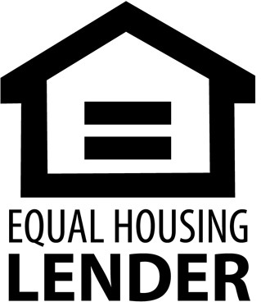DRE LIC# 01474985

925-395-0175

[christy@christyscarealty.com](mailto:christy@christyscarealty.com) christyscaliforniarealty.com