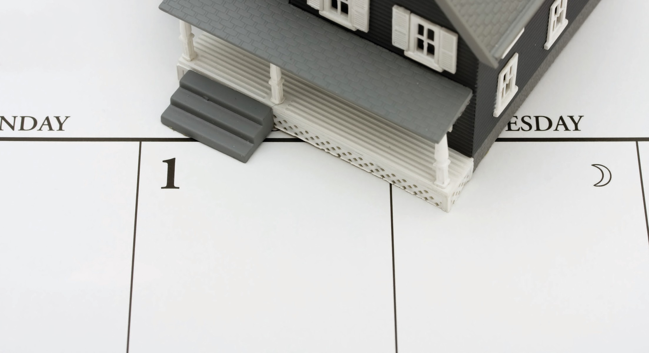

**What is a grace period?**

A **grace period** is the time period after a due date during which the agreed-to payment needs to be received by your lender to be timely paid. A payment received by the lender after the grace period expires is considered

**A:**

delinquent and triggers a late penalty.

The late payment provision contained in your mortgage calls for an additional charge if payment is not received by your lender when due or within the grace period.

The minimum grace period required before a mortgage on a one-to-four unit, owner-occupied residential property is delinquent is ten days after the due date, even if you agree to a shorter grace period with your lender or no agreed-to grace period is stated.

Simply mailing your payment within the grace period does not qualify the payment as timely paid. Your lender or the mortgage servicing agent needs to actually receive the payment no later than the last day of the grace period.

**Christy Dumlao Real Estate Broker**