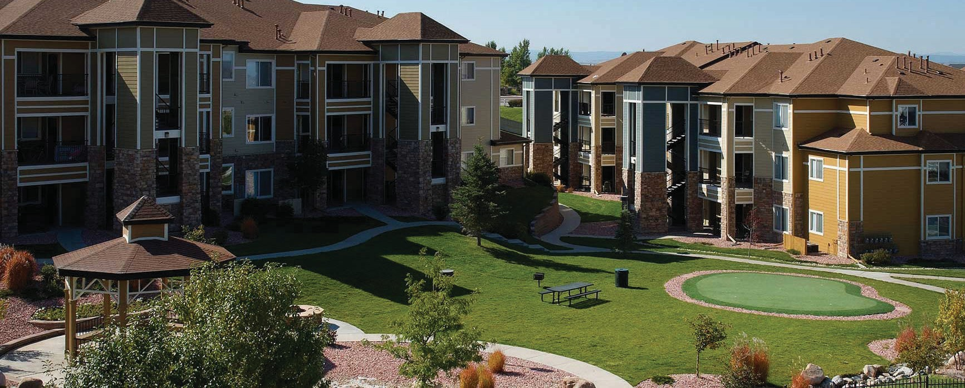

**What documents do I need to request from my HOA when selling my unit?**

At the listing stage, your agent on your behalf prepares a form requesting homeowners’ association (HOA) documents. It is sent to the HOA or management company to request their delivery of copies of the common interest development’s (CID’s) governing documents concerning the project’s **use**

**A:**

**restrictions** and **HOA finances**.

The HOA or management company will deliver the documents within 10 days of the request’s postmark or receipt of the hand-delivered request.

The HOA will charge a service fee to prepare and deliver the documents requested. This upfront fee is the same amount regardless of whether the documents are delivered by hand, by mail or electronically.

The HOA will also charge a transfer fee to change its internal records to reflect the new ownership of the unit. This fee is sometimes demanded to be paid up front with the HOA document request — before a buyer is even located.

Upon receiving the written request and appropriate fees, the HOA provides the governing documents you need concerning the project, which include:

* articles of incorporation;
* declaration of covenants, conditions & restrictions (CC&Rs);
* bylaws;
* rules and regulations;
* operating budget, assessment and reserve funding;
* financial records covering at least one previous year; and
* HOA meeting minutes from at least one previous year.

Your agent makes the HOA documents available to prospective buyers for their review as part of the marketing package for your property. To avoid buyer disputes or canellation, this information is handed to the buyer with disclosures, and before entering into a purchase agreement.

The buyer reviews the HOA documents along with other mandated property disclosures (such as the Transfer Disclosure Statement (TDS)) to determine the property’s value when preparing their offer to purchase.

**Christy Dumlao Real Estate Broker**

DRE LIC# 01474985

925-395-0175

[christy@christyscarealty.com](mailto:christy@christyscarealty.com) christyscaliforniarealty.com