**What are my tax deductions when I become a homeowner?**

When owning a home, your income tax reporting deductions arise out of three types of

**A:**

expenditures:

* the interest paid on your purchase-assist and equity mortgages;
* the premiums paid on mortgage insurance (MI) when your down payment is less than 20%; and
* the property taxes and bonded assessments you pay on the home.

Federal housing policy by design uses the tax code to encourage leveraged homeownership. The code permits a personal deduction for interest paid on mortgage debt incurred to acquire a home for your family use — called the mortgage interest deduction (MID). You are allowed to reduce your federal and state income taxes by use of the MID when you finance the purchase of a principal residence or vacation (second) home. You may deduct interest accrued and paid on:

* purchase or improvement mortgages up to

$1,000,000 principal; and

* home equity mortgages up to $100,000 principal.

Ownership of a personal residence and second home allows you to itemize accrued mortgage interest you

have paid and deduct the amounts from your adjusted gross income (AGI), with limitations on the very wealthy. The amount of tax reduction you experience is based on the amount of your AGI and tax bracket.

When financing the purchase of your principal residence, loan points (origination fees) and MI you or the seller pay to originate the mortgage are a type of interest payment you also itemize and deduct from your AGI. All other lender closing charges are non-recurring costs that are part of the cost of acquisition of your home and may not be written off as a deductible expense.

Property taxes you pay based on your home’s assessed value are also itemized and deducted from your AGI to further reduce your income taxes. Deductible property taxes are often prepaid at closing to reimburse the seller for the portion they paid that accrues after the date you acquire ownership. Any supplemental property taxes paid due to reassessment are also deductible.

Annually, you itemize and deduct each year’s property taxes paid on the home whether paid directly by you or indirectly through the lender under an impound account arrangement.

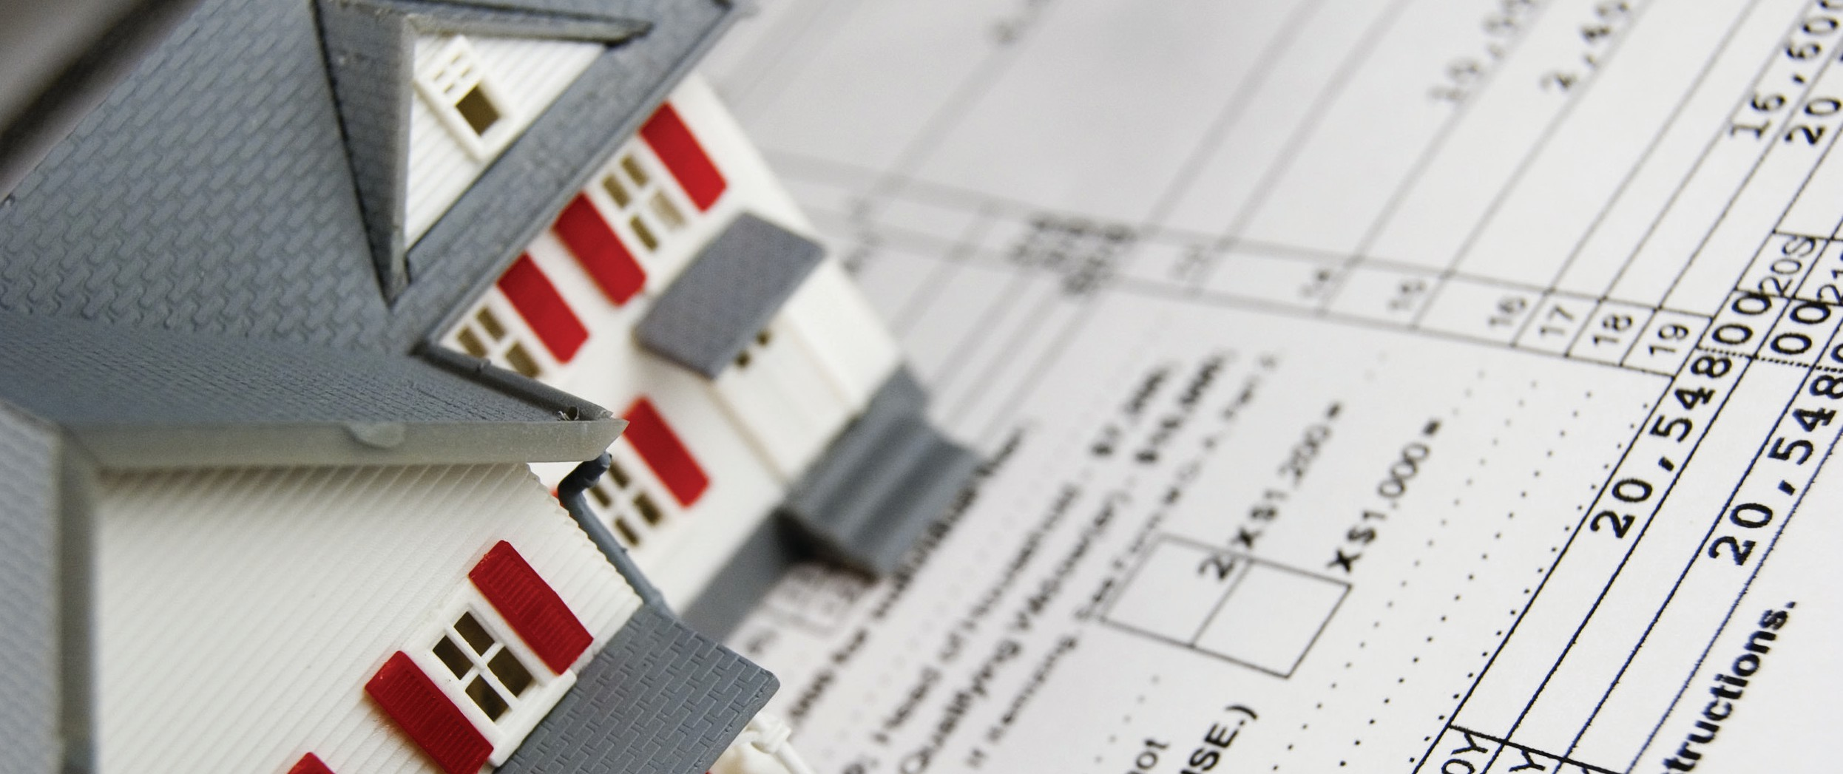

**Christy Dumlao Real Estate Broker**

DRE LIC# 01474985

925-395-0175

[christy@christyscarealty.com](mailto:christy@christyscarealty.com) christyscaliforniarealty.com