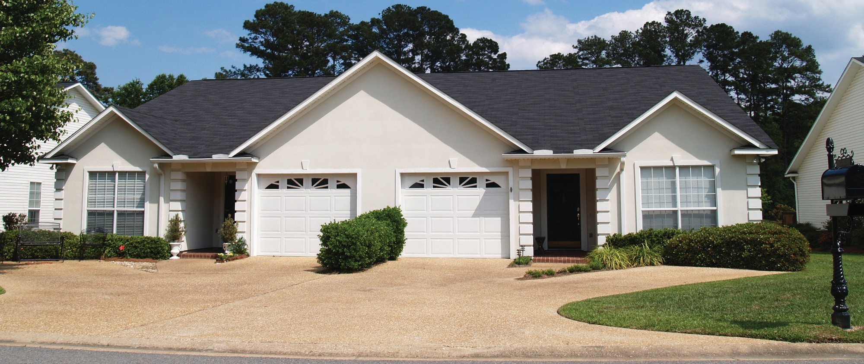

**What is an Income Property Brokerage (IPB) marketing package?**

The Income Property Brokerage (IPB) marketing package consists of forms and spreadsheets an owner’s agent completes in order to determine the amount of capital investment an income property has the ability to

**A:**

support.

The IPB package is comprised of several forms and is used for the prerequisite analysis of the property’s annual operations.

The IPB package is delivered to prospective buyers who show an interested in the property.

Preparing the IPB package begins with the agent’s cursory entry of numbers on the preliminary Work-Up Sheet Template. These preliminary numbers entered in the template automatically fill in corresponding fields in all the IPB forms.

A complete IPB marketing package presents all critical property disclosures, including:

* the physical attributes and condition of the property;
* the property’s location, zoning and uses permitted;
* the price and terms for acquiring the property;
* loan arrangements and transactional costs;
* the property’s operational and ownership effect on income taxes and after-tax cash flow; and
* the property’s current and, if feasible, anticipated operating figures.

The owner’s agent delivers a complete marketing package to all prospective buyers or their agents who express a further interest after receiving promotion information.

For buyers, data presented in an IPB package is used to set the capitalization rate (cap rate) they feel is justified based on the property fundamentals.

A buyer’s purchase of income property always relates to:

* net operating income (NOI);
* the cap rate;
* existing or new mortgage financing;
* cash-on-cash margin (spendable income cushion); and
* after-tax returns.

An instructive marketing package presents the property in a self-explanatory format which a potential buyer can quickly digest. A comprehensible package functions as a full up- front disclosure of a property’s operating and physical condition.

For buyers, the income and expense analysis section of an IPB marketing package is evidence of a property’s inherent value to support a flow of net income in the future.

**Christy Dumlao Real Estate Broker**

DRE LIC# 01474985

925-395-0175

[christy@christyscarealty.com](mailto:christy@christyscarealty.com) christyscaliforniarealty.com