

**What happens if my home listing expires?**

On your entering into an exclusive right-to-sell listing agreement with me, you have authorized my broker and me to **locate a buyer** and **negotiate a sale of your property.** We will be doing so on your behalf

**A:**

for the period of the listing. On locating a buyer during the listing period who acquires your property, you will owe a fee.

If the listing period expires before I have located a buyer who acquires your property, you are not obligated to pay me a fee. On expiration, you may **relist** the property for sale with me or another agent.

If you **withdraw** the property from the market or **terminate** my agency before the listing expires, you may owe a fee.

Further, the listing agreement calls for your payment of a fee when, within one year after the listing expires, a prospective buyer I worked with during the listing period contacts you and acquires your property.

Under this provision, you only owe a fee when:

* I provide **property information** to prospective buyers during the listing period;
* I notify you in writing, within 21 days after expiration of the listing, of the **identity of each prospective buyer** dealt with during the listing period; and
* a prospective buyer identified in the notice continues or resumes negotiations during the one-year period and acquires your property as a result*.*

**Christy Dumlao Real Estate Broker**

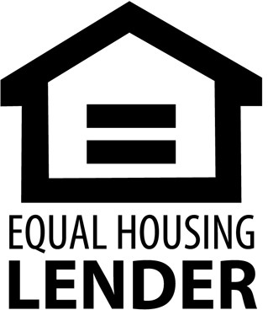DRE LIC# 01474985

925-395-0175

[christy@christyscarealty.com](mailto:christy@christyscarealty.com) christyscaliforniarealty.com