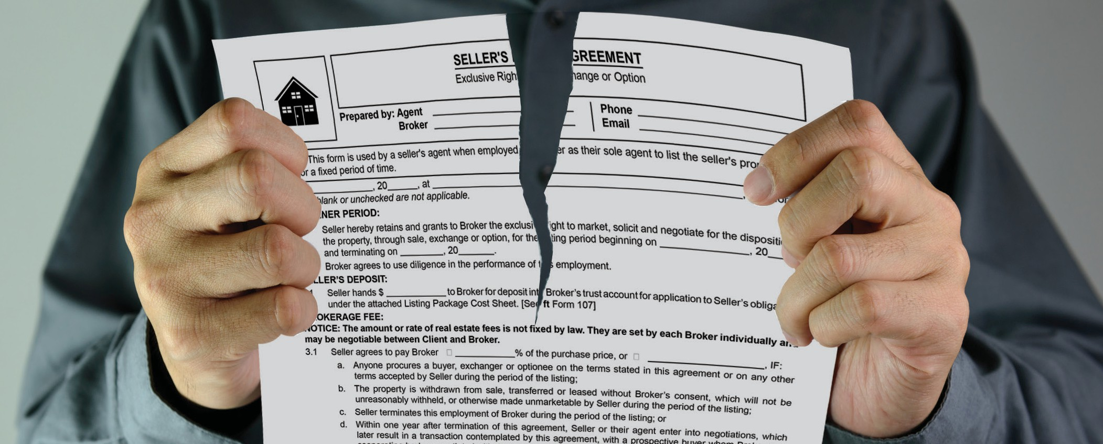

**What happens if I withdraw my listed property from sale?**

Occasionally, a situation arises which causes the owner of a property listed for sale to withdraw their property from the market. This owner has the option to voluntarily withdraw their listed

**A:**

property before it sells or the listing expires.

Reasons an owner may have for withdrawing a listed property from sale include:

* a change of job;
* a family crisis;
* the inability of the market to deliver the desired selling price; and
* other personal reasons.

An owner who withdraws their home from the market is *not breaching* the listing agreement. However, they do interfere with the broker’s expectations of locating a buyer and earning a fee.

Therefore, the owner needs the broker’s consent when withdrawing the property from sale. It not, withdrawal triggers the broker’s right to collect a full fee as agreed.

When the owner and the broker mutually agree to a

withdrawal of the property from the market, no fee is due the broker, unless:

* the owner and broker agree to the payment of a sum of money for the marketing effort undertaken and the opportunity the broker lost to earn a full fee by locating a buyer; or
* the property is sold within the listing or safety period — with or without the broker’s involvement

— in which case the full fee is due to the broker.

Conversely, the broker is entitled to a full listing fee when the owner’s conduct, *without* the broker’s consent, causes the listed property to be:

* withdrawn from the market;
* transferred to others;
* further leased; or
* otherwise made unmarketable.

Further, the full fee due the broker compensates them for the time, effort and money invested in the marketing of the property before the owner removed it from the market. Also important is the broker's lost opportunity to locate a buyer and earn a full fee under the listing.

**Christy Dumlao Real Estate Broker** DRE LIC# 01474985

925-395-0175

[christy@christyscarealty.com](mailto:christy@christyscarealty.com) christyscaliforniarealty.com