Most properties have three property lines setting the **common boundaries** with adjacent properties owned by others. A fourth property line usually sets the frontage on a public right of way, such

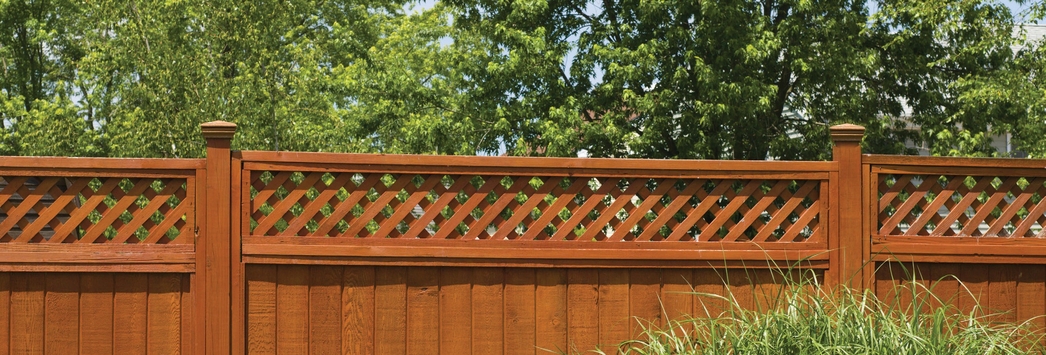

Who is responsible for maintenance of boundary fences and trees?

**A:**

as a street.

The location of the common property lines is typically represented by common boundary improvements such as shrubbery or trees. When setting up, maintaining or removing common boundary improvements, the adjacent property owners’ rights depend on the type of improvement.

Common boundary improvements, other than trees, located on a property line between adjacent properties are called **party walls**. Types of party walls include:

* boundary fences;
* driveways; and
* ditches.

Owners of adjoining properties are presumed to benefit equally from boundary fences. Under this legal presumption, all adjoining owners are *equally responsible* for constructing, maintaining and replacing boundary fences.

The responsibility for constructing, maintaining or

replacing boundary fences may be altered or removed only by:

* a written agreement between all affected owners; or
* an adjoining owner’s judicial petition to remove or alter their responsibility.

When trees mark a common boundary, each tree’s ownership is determined by the location of its trunk. Solely owned trees belong to the owner of the property on which the entire trunk is growing. Trees growing on government-owned parcels, such as a right of way for streets and sidewalks, belong to the local government, and thus the government is responsible for maintenance.

However, shrubbery or trees whose trunks stand partly on the land of two adjacent property owners belong to both adjacent owners. These trees are called **line trees** or **common boundary trees**.

Similar to maintaining a boundary fence, adjacent owners who own line trees are jointly responsible for maintaining the trees and, unless they agree to an alternate arrangement, share equal costs. To avoid disputes, adjacent property owners need to consider entering into an agreement detailing how they will handle the maintenance of boundary trees.

**Christy Dumlao Real Estate Broker**

DRE LIC# 01474985

925-395-0175

[christy@christyscarealty.com](mailto:christy@christyscarealty.com) christyscaliforniarealty.com