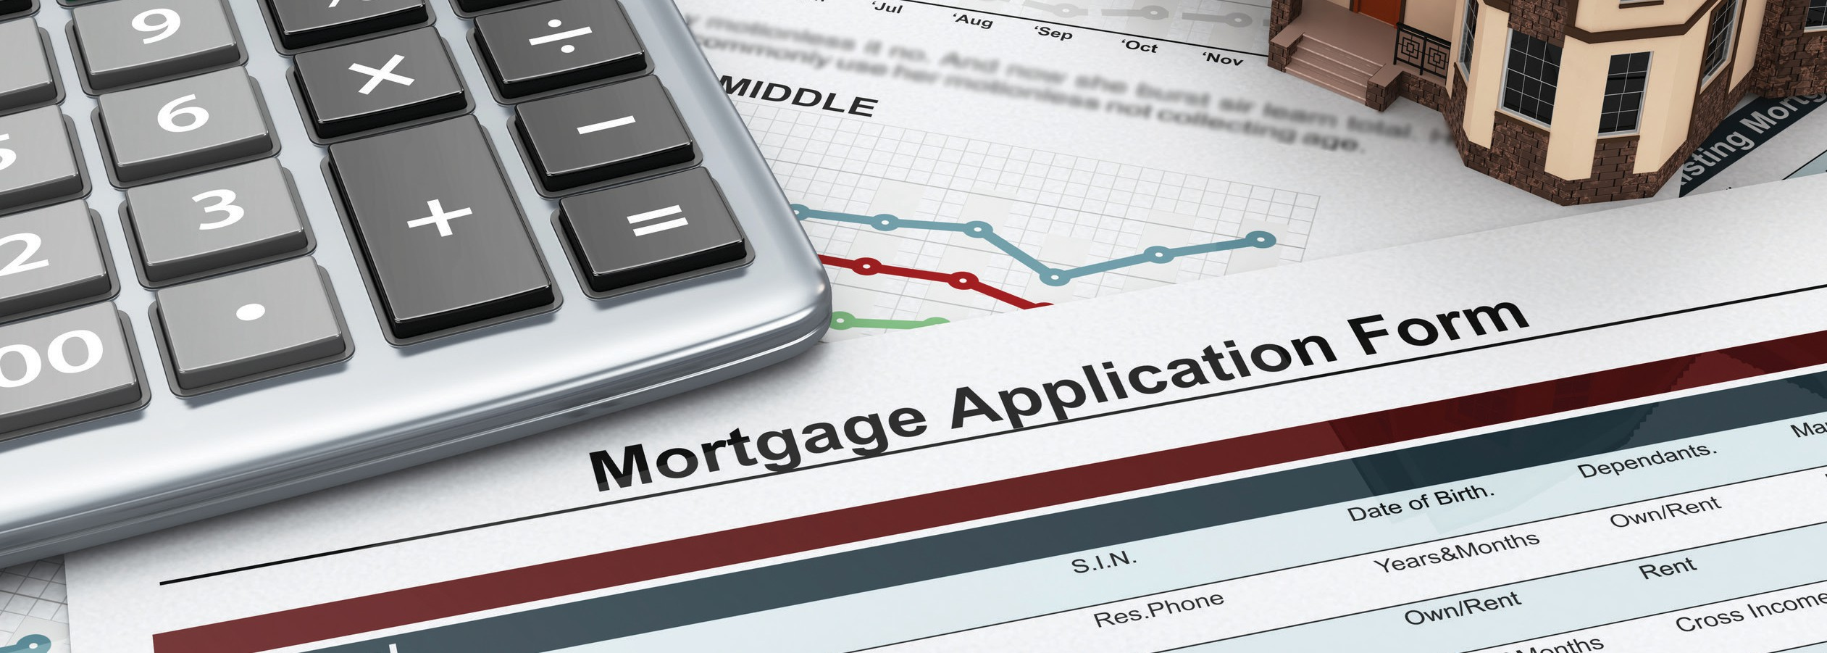

**I submitted a mortgage**

**application — what now?**

The **mortgage package** prepared and processed by your lender includes:

**A:**

* the Uniform Residential Loan Application;
* the property appraisal report;
* your credit report;
* the lender’s verifications of the information you provided on the mortgage application;
* the purchase agreement, escrow instructions and condition of property disclosure statement handed to you by the seller and their broker; and
* any other documentation needed to support your request, including operation balance sheets, tax returns, IRS Form 4506, title reports and bank statements.

Your agent uses a *mortgage tracking form* to set a schedule for when the mortgage processing activities are to occur. The form provides a clear picture of what events are to take place and when. Generally, your lender keeps your agent updated as events occur to keep the transaction on schedule

for closing.

Your lender may issue a **mortgage approval** conditioned on you or your agent providing more information or taking corrective actions. For example:

* the physical condition of the property may need correction;
* title may need to be cleared of defects;
* derogatory entries on your credit report may need to be eliminated; or
* your long- or short-term debt may need to be reduced.

Once conditions for funding are met and verified by your lender, the mortgage is considered approved. **Escrow** requests loan documents from your lender and prepares an estimated closing statement for the amount of closing funds you will need to deposit. When your lender funds the mortgage, escrow causes the grant deed and trust deed to be recorded, and the sales transaction is closed, transferring ownership to you.

**Christy Dumlao Real Estate Broker**

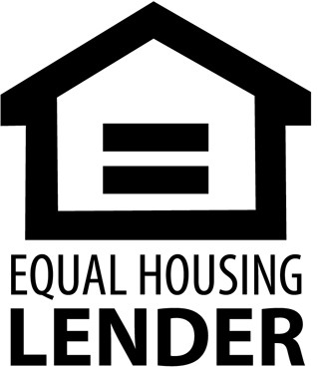DRE LIC# 01474985

925-395-0175

[christy@christyscarealty.com](mailto:christy@christyscarealty.com) christyscaliforniarealty.com