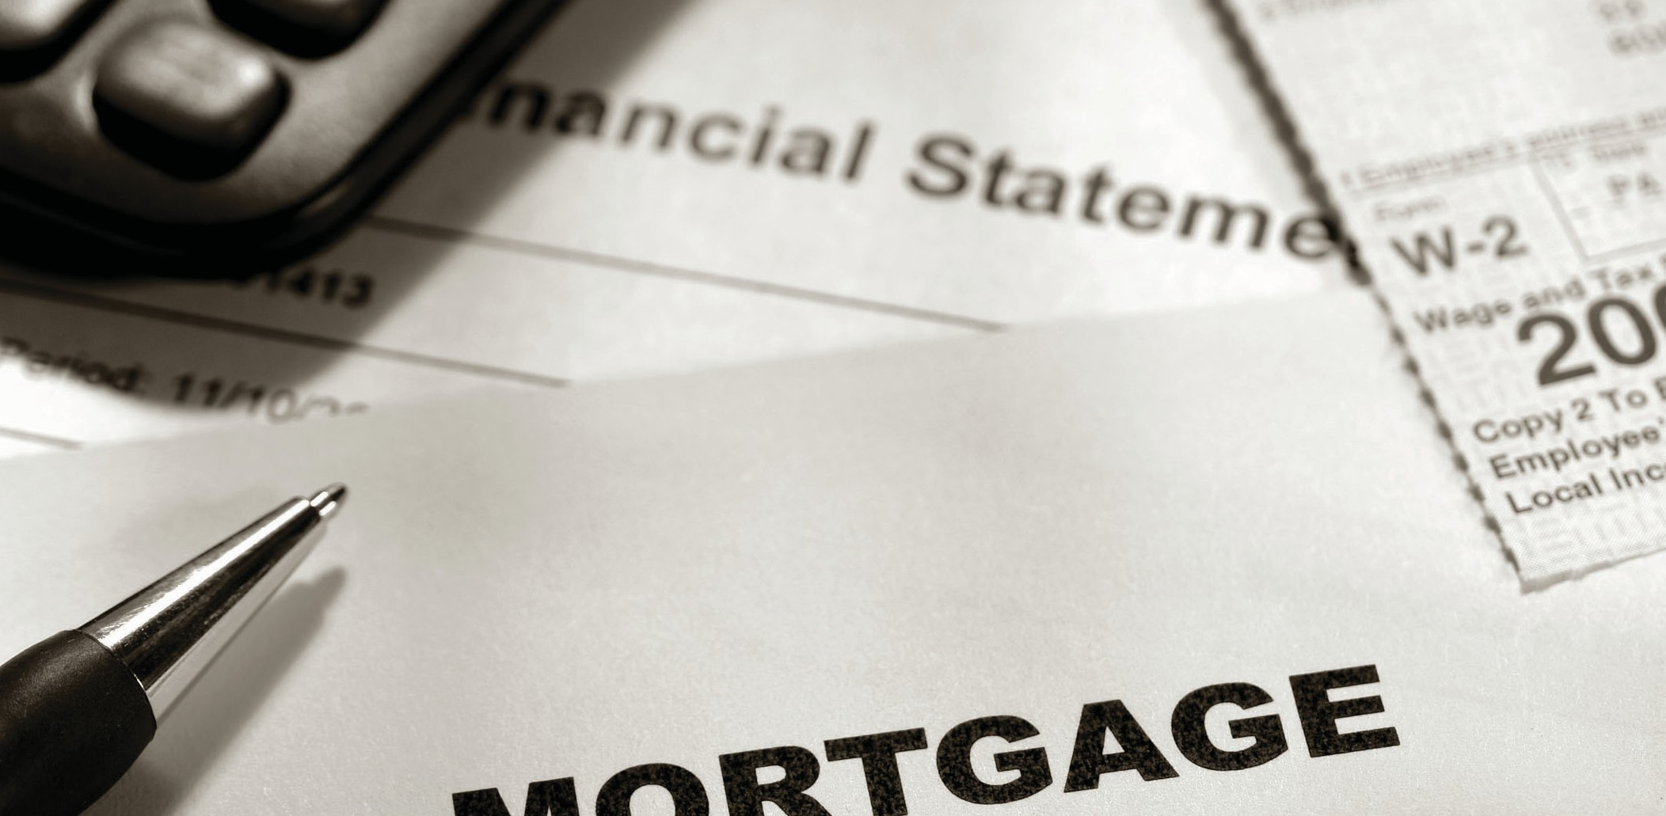

**What documentation do I need to qualify for a mortgage?**

Prior to making an offer to purchase a property listed for sale, your agent will

**A:**

assist you in submitting a Loan Application with multiple lenders.

As part of a loan application process, the lender requests documents they need to analyze your creditworthiness, including:

* W-2s or other tax documents, such as (Schedule C) for the self-employed;
* recent tax returns;
* recent bank statements; and
* recent paystubs to support your employment and income information.

After the seller accepts your offer, the mortgage lender or broker requests additional information from others to process your application, including:

* an appraisal report to establish the value of the property which will be security for the mortgage;
* verification of deposit;
* verification of income; and
* a credit report.

For your best interest, always submit applications to at least two lenders. Shopping for a mortgage allows you to compare the interest rate and lender fees each lender offers. This yields the lender with the best terms available in the market.

**Christy Dumlao Real Estate Broker**