**What is mortgage**

**insurance?**

**Private mortgage insurance (PMI)** is an insurance policy held by your lender which indemnifies them against losses on their investment in your mortgage when you default. PMI is not property insurance covering hazards to its

**A:**

improvements, a policy also required by the mortgage lender.

Typically, mortgages insured by PMI are covered for losses on amounts exceeding 67% of the property’s value at the time the mortgage is originated.

PMI is required as a condition for funding a mortgage when your down payment is less than 20% of the purchase price. Before your mortgage is funded, you will undergo an in-depth risk analysis based on the PMI insurer’s eligibility requirements.

The PMI investigation and documentation takes place after you submit a mortgage application. It is generally limited to verification of your representations on the application.

Your PMI premiums are typically paid through your monthly mortgage payments. However, some lenders and PMI insurers offer a lender-paid mortgage insurance (LPMI) program. When offered by the PMI insurer, your lender pays the mortgage insurance premium and passes the cost on to you as a higher interest rate on your mortgage. However, LPMI cannot be cancelled, while borrower-paid PMI may be cancelled or automatically terminated. LPMI only terminates upon a refinance or other total payoff of your mortgage.

Premium rates are set as a percentage of your mortgage balance and are calculated in the same manner as interest.

PMI coverage may be terminated when the equity in your property reaches 20% of its value at the time the mortgage was originated. Once the equity in your property reaches 22% of its value, PMI is automatically cancelled.

Federal Housing Administration (FHA)-insured mortgages are also available for homebuyers with little cash available for a down payment.

To qualify for an FHA-insured mortgage, you are required to make a minimum down payment of 3.5%.

When you obtain an FHA-insured mortgage, you pay a **mortgage insurance premium (MIP)** to the FHA. An upfront MIP is added to the principal amount financed in addition to the charge at the annual MIP rate, which is added to your monthly principal and interest payments, similar to PMI. However, the MIP remains in place, paid monthly for the life of the FHA- insured mortgage.

If you default on an FHA-insured mortgage, the FHA covers your lender against any loss on the balance of your mortgage.

However, you remain personally liable to the FHA for any loss the FHA suffers as a result of your default.



**Christy Dumlao Real Estate Broker**

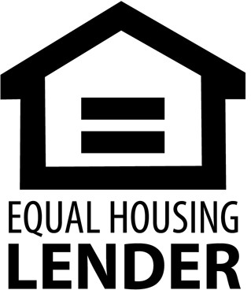DRE LIC# 01474985

925-395-0175

[christy@christyscarealty.com](mailto:christy@christyscarealty.com) christyscaliforniarealty.com