

**How do I negotiate a counteroffer?**

The preparation of a counteroffer allows you as the seller and your agent to take

**A:**

control of negotiations after a prospective buyer submits a purchase offer. Your agent, on receiving a prospective buyer’s offer, will review with you:

* the terms offered and contingency provisions

— conditions — which affect closing;

* the likely net sales proceeds the offer will generate; and
* their knowledge about the profit tax liability you will likely incur on the sale when the property is not your primary residence.

A counteroffer is made when the terms and conditions of the buyer’s offer are for any reason unacceptable without a change.

Your agent prepares your written counteroffer and reviews it with you before you sign it and your agent submits it to the buyer. Your signed counteroffer documents your intent to be bound by your offer to sell when the buyer accepts.

To counter a buyer’s unacceptable purchase offer, your agent may recommend that they:

* prepare your counteroffer on a new purchase agreement form;
* prepare your counteroffer on a counteroffer form;
* dictate escrow instructions based on terms and conditions orally negotiated with the buyer (or buyer’s agent);
* set up an auction environment by calling for the submission of all “best and final” offers in a multiple-offer situation; or
* orally advise the buyer’s agent about the changes they need to make before you will accept the buyer’s offer.

The buyer may agree to purchase your property on the terms stated in your counteroffer by merely signing the counteroffer and delivering it as accepted, or submit a counteroffer back to you for further negotiations.

**Christy Dumlao Real Estate Broker**

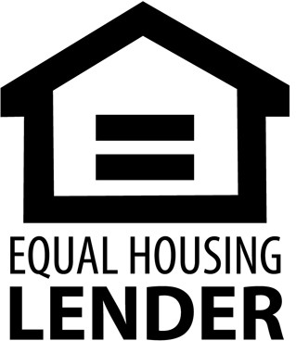DRE LIC# 01474985

925-395-0175

[christy@christyscarealty.com](mailto:christy@christyscarealty.com) christyscaliforniarealty.com