

**What to expect when making**

**an offer?**

During the initial stage of a real estate sales transaction, offers and counteroffers are prepared

**A:**

and submitted between buyers and sellers. When your offer is unacceptable to the seller they will likely make a written counteroffer to sell on different terms. If everyone is willing, a compromise in terms is reached, an acceptance occurs and a binding agreement is the result.

To be valid, your offer to buy needs to:

* show a serious intent to enter into an agreement;
* be definite and clear in detailing the essential elements of the purchase agreement and property identification; and
* be communicated to the person able to accept the offer.

On submission of your offer to the seller, it is either:

* accepted prior to its expiration; or
* rejected.

The seller’s acceptance of your offer forms a binding agreement. However, the agreement is typically not yet enforceable by actual performance — a closing — due to conditions stated in the agreement.

In contrast, a seller rejects your offer by:

* returning a signed, written rejection stating no counteroffer will be forthcoming;
* preparing and submitting a counteroffer, using either

a counteroffer form or a purchase agreement form stating different terms; or

* doing nothing, and letting your offer expire — no response.

Without first preparing and submitting a counteroffer, the seller may make an inquiry into your willingness to consider different terms. The inquiry for clarifications or changes is not a counteroffer or rejection of your written offer. Such an inquiry does not bar the seller from a later but timely acceptance to form a binding agreement.

However, when the seller attempts to accept your offer by first altering its terms in some way prior to signing the acceptance provision, the change in terms creates a counteroffer to perform on different terms. The written counter is a rejection which terminates your offer.

The seller’s agent has a duty owed to their seller to present every purchase offer they receive, regardless of the terms offered or the form used to present it. However, neither the seller nor their agent has any legal duty to respond to an offer. A failure to respond to an offer does not automatically mean your offer was not presented to the seller. Further, the offer need not be prepared on a form to be enforceable.

In fact, the back of a business card may be used to make an offer. However, provisions in boiler-plate purchase agreement forms state the essential terms and conditions of an offer needed to make it clear, complete and enforceable when accepted.

**Christy Dumlao Real Estate Broker**

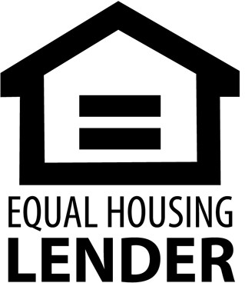DRE LIC# 01474985

925-395-0175

[christy@christyscarealty.com](mailto:christy@christyscarealty.com) christyscaliforniarealty.com