

**What is seller carryback financing and what are its benefits?**

Sellers looking for buyers during a tight mortgage market need to consider offering **carryback**

**A:**

**financing** to facilitate deals.

Carryback financing is also known as seller financing, an installment sale, land sales contract, a credit sale or an owner-will-carry sale.

In carryback financing sales, the seller receives a note and trust deed executed by the buyer and secured by the property sold to evidence the debt owed the seller as part of the purchase price.

The amount of the debt owed on the sale is the remainder of the price due to the seller after deducting:

* the down payment; and
* the amount of any existing or new mortgage obtained by the buyer.

On closing, the seller takes on the rights and obligations akin to a mortgage lender.

The buyer’s tangible benefits from seller financing arising out of purchase offer negotiations include:

* a moderate down payment;
* a competitive interest rate;
* less stringent terms for qualification and documentation than imposed by mortgage lenders; and
* no origination costs, extra title insurance premiums or lender processing hassles.

In contrast, mortgage lenders automatically require a minimum down payment of 20% if the buyer is to avoid private mortgage insurance (PMI) or an additional risk premium rate charged by the lender. Further, Federal Housing Administration (FHA)-insured mortgages include a mortgage insurance premium (MIP) regardless of the loan- to-value (LTV).

The amount of the down payment, interest rate and monthly payment is negotiable between the buyer and seller without the outside influences a mortgage lender automatically requires a buyer to agree to.

Taxwise, a seller may prefer to carry back a portion of the sales price, rather than cash out when taking a significant taxable profit on the disposition of an investment property.

The seller, with a reportable profit on a sale, is able to defer payment of a substantial portion of their profit taxes until the principal is received from the buyer. When the seller avoids the profit tax bite in the year of the sale, the seller earns interest on the portion of the principal in their carryback note that represents the tax deferred to future years when the principal is received.

When a seller does not carry back a note and cashes out, they will pay their profit taxes in the year of the sale, unless the profit is exempt or excluded from taxation, such as occurs with the principal residence profit exclusion or a

§1031 tax-exempt transaction.

**Christy Dumlao Real Estate Broker**

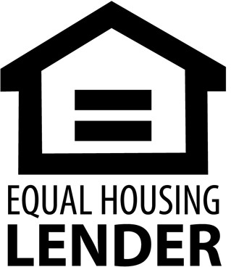DRE LIC# 01474985

925-395-0175

[christy@christyscarealty.com](mailto:christy@christyscarealty.com) christyscaliforniarealty.com