

**What are my selling costs going to be?**

To make an informed decision about the arrangements and conditions for selling your property, you need to know the costs you will incur on a sale. Selling costs consume some of the price you will receive and thus reduce the amount of net sales proceeds

**A:**

on closing.

Selling costs you will likely incur in the preparation and sale of your property include:

* *Home inspection report (HIR)*: The fee a home inspection company charges to conduct an inspection of the property and provide an HIR you use to properly prepare your transfer disclosure statement (TDS) your agent hands to prospective buyers.
* *Structural pest control report and clearance*: The fee a pest control operator charges to inspect and submit a report on their findings and the costs of repairs necessary to eliminate any infestation and repair any existing damage or condition allowing for infestation.
* *Compliance with local ordinances*: The costs associated with retrofitting, curative permits and any repairs necessary to meet local ordinance standards as a requisite to a change in ownership.
* *Natural Hazard Disclosure (NHD) report*: The fee charged by a third party for a review of the county records and the preparation and submission of an NHD report on the natural hazards affecting the property due to its location.
* *Smoke detector/water heater safety compliance*: The costs incurred to install smoke detectors and water heater bracing to comply with local ordinances.
* *Home warranty insurance*: The premium charged by a home warranty insurance company to issue a policy to the buyer.
* *Escrow fee*: The amount charged for escrow services to process the closing of the sale.
* *Recording fees/documentary transfer tax*: The combined recording fees and transfer taxes collected by the county recorder to convey title.
* *Title insurance premium*: The premium the title insurance company charges to issue a policy of title insurance on your conveyance of the property.
* *Reconveyance fees*: The reconveyance fees and recording fees charged when your mortgage is paid off to release the mortgage liens from the record title to the property sold.
* *Broker fees*: The fees earned by the transaction brokers and paid on the close of escrow for the sale of your property.

Your agent estimates the expenses you are likely to incur on a sale of your property by preparing a *seller’s net sales proceeds* sheet and reviewing it with you when listing your property for sale and reviewing the merits of each offer received to buy your property.

**Christy Dumlao Real Estate Broker**

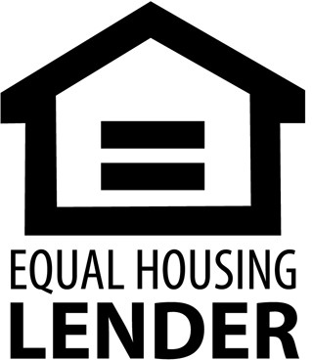DRE LIC# 01474985

925-395-0175

[christy@christyscarealty.com](mailto:christy@christyscarealty.com) christyscaliforniarealty.com