If you’re a California homeowner aged 55 or older, you have a once-in-a-lifetime right to

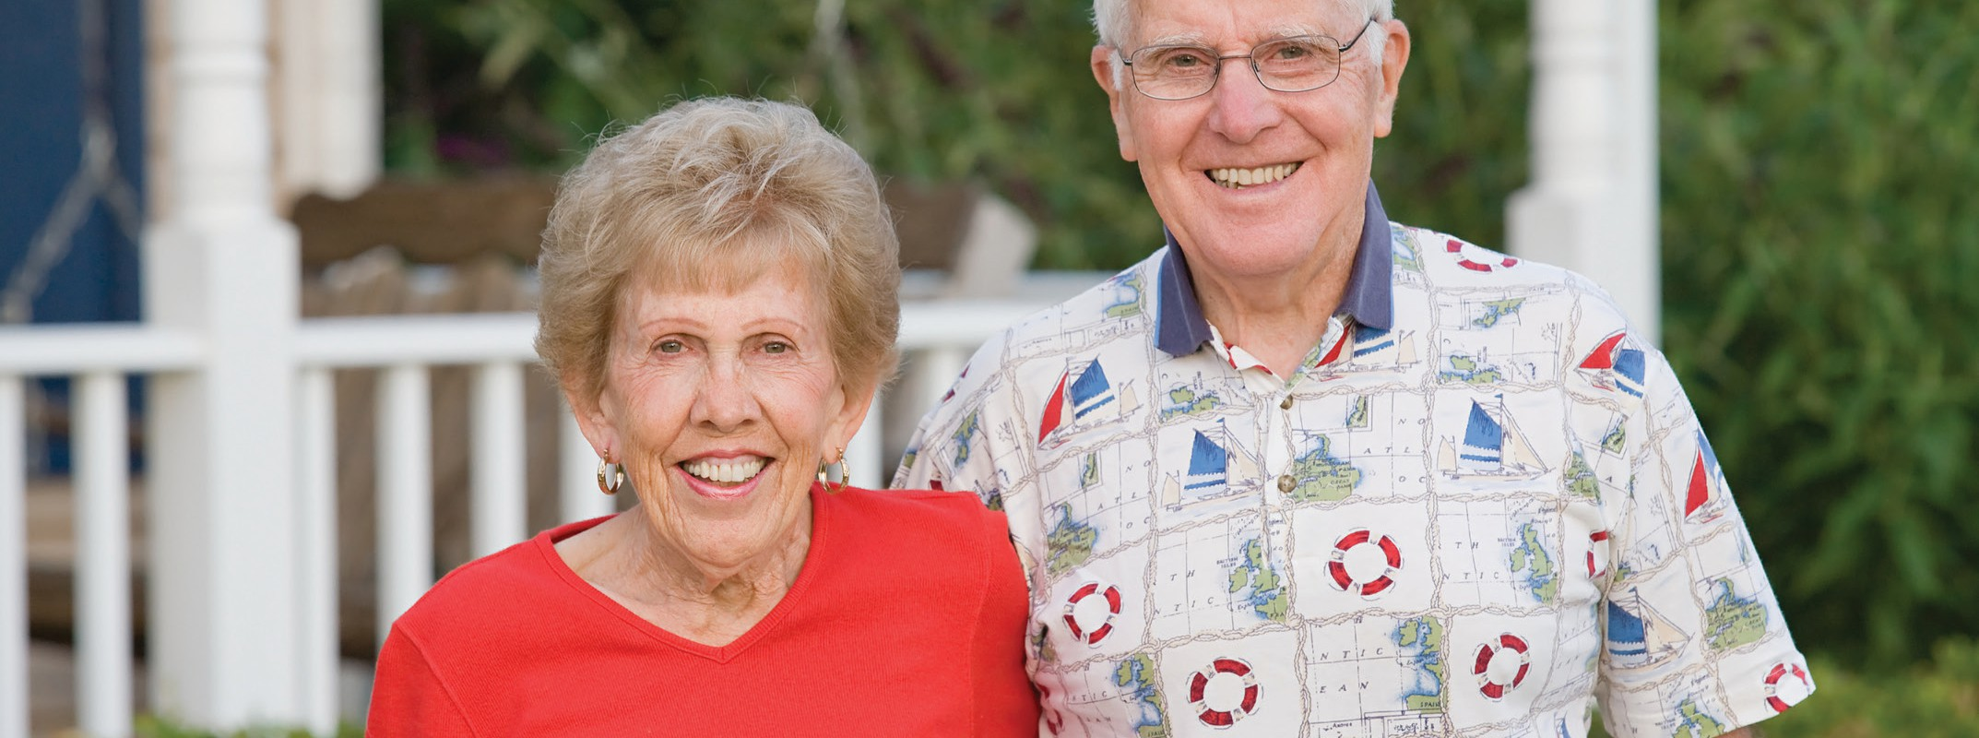

As a senior, can I carry forward my property’s current assessed value when I acquire a replacement home?

**A:**

sell your home and carry forward its current assessed value to a replacement residence of equal or lesser value.

To qualify to carry forward the current assessed value:

* you need to own and occupy the home sold as well as the replacement home;
* both homes must be eligible for the homeowner’s

$7,000 property tax exemption;

* you or your spouse must be at least 55 years old or severely and permanently disabled on the closing date of the sale of your old home;
* you need to purchase (or construct) a replacement home of equal or lesser value than the home you sold;
* the replacement residence must be located:
  + in the same county as the property sold; or
  + within another participating county; and
* the purchase (or construction) of the replacement home needs to close (or construction completed) within two years before or after closing the sale of your old home.

When your replacement home is not within the same county as the home you sold, the county of your replacement property needs to be a participating county which allows the carry-forward assessment from your prior county. Currently participating counties include Alameda, El Dorado, Los Angeles, Orange, Riverside, San Bernardino, San Diego, San Mateo, Santa Clara, Tuolumne and Ventura counties (subject to change).

Only one carry-forward assessment exemption is allowed per married couple. For example, if a married couple takes a carry-forward assessment exemption, and one spouse later dies, the surviving spouse may not take a carry-forward assessment exemption even if they later remarry.

When you and a co-owner both reside in the home and are not married, you both individually qualify for the carry-forward assessment. However, on the sale, only one of you may use the exemption. Thus, the co-owner who does not apply for the exemption is precluded from any future use of the assessment carry-forward tax relief.

The only exception is when you become severely and permanently disabled after receiving the carry- forward tax relief due to your age. In this case, you may use the exemption a second time under a separate claim due to the disability.

**Christy Dumlao Real Estate Broker**