A **special assessment** lien is placed on real estate to repay bonds that financed the construction of public improvements benefitting property within an improvement district. These public improvements include sewers, streets,

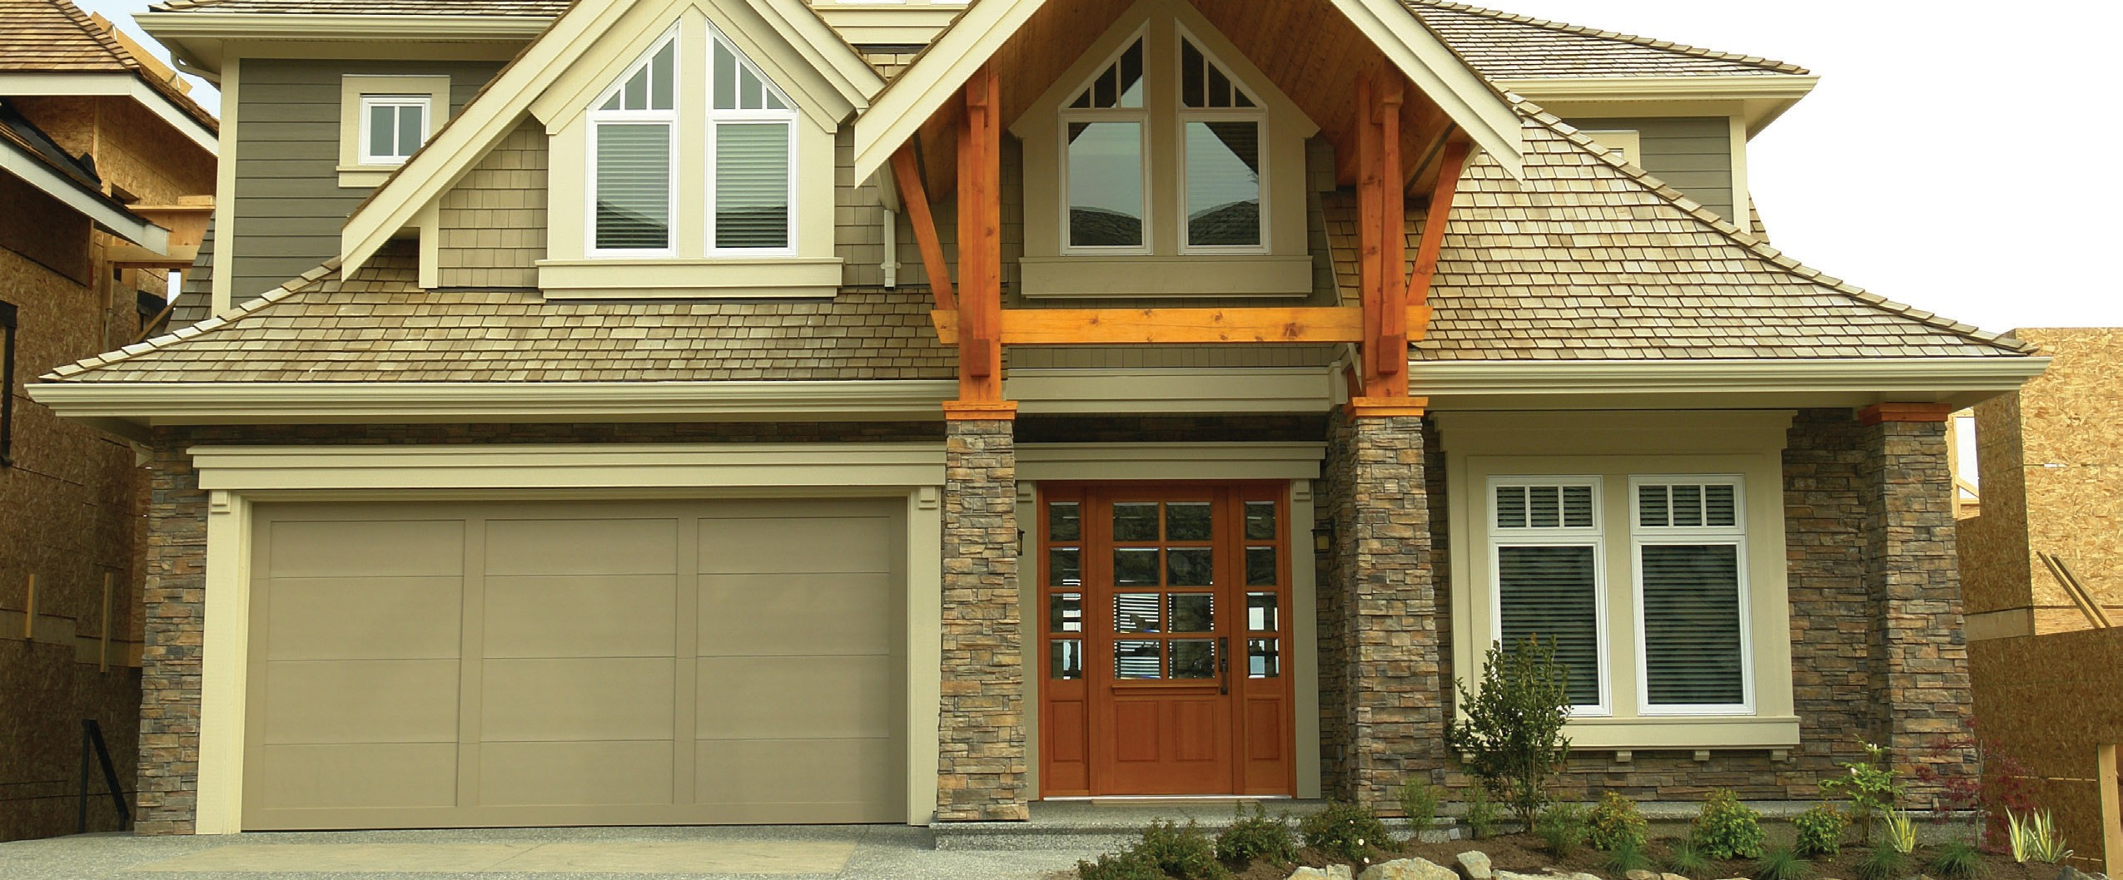

What are special assessments and Mello-Roos bond payments?

**A:**

sidewalks and streetlights.

The special assessment charge shows up on the annual tax bill and is collected at the time for payment of the **property taxes**. This coupling of unrelated taxes and assessment charges is a constant source of confusion.

A special assessment lien is based on the proportional benefit each property in the district receives from the improvements. Thus, the amount of the special assessment payment is not uniform for each property owner. In contrast, a property tax is determined annually based on the property’s value.

Since special assessments are unrelated to the assessed value of a property (or to property taxes), they have nothing to do with the county assessor, whose job it is to “reassess” the value

of property on a change of ownership for the purpose of the county tax collector imposing and collecting property taxes.

Unlike a property’s assessed value, a buyer of a property subject to a special assessment lien for bonded indebtedness may assumed the principal debt and payments on the assessment, but cannot assume the seller’s assessed value for the property, the property assessment being reset at the price the buyer paid.

One type of special assessment is a Mello-Roos lien which shows up on your tax bill as **Community Facilities District** charges. Mello-Roos payments are used to pay off bonds issued to finance public facilities and services like schools, parks and libraries.

This type of special assessment lien is often found in large, new subdivisions, and the principal debt is typically amortized over 20-25 years. The financing funds the subdivider’s construction of required improvements located on publically dedicated parts of the subdivision.

**Christy Dumlao Real Estate Broker**

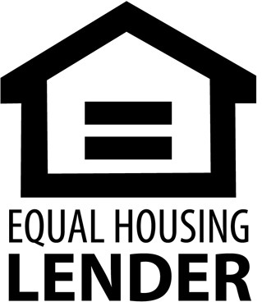DRE LIC# 01474985

925-395-0175

[christy@christyscarealty.com](mailto:christy@christyscarealty.com) christyscaliforniarealty.com