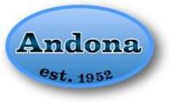

P.O. Box 256
Andover, MA 01810

March 2022

Dear Community Member:

Thank you for your interest in being a community partner.

Andona is a registered nonprofit organization run by women volunteers that has been raising money to fund youth programs in Andover, MA for 70 years! As with all Andona fundraisers, money raised from this drive will go toward the continued support of Andover youth, schools and programs that provide athletic, educational, cultural, and health/welfare opportunities for Andover’s youth. Any donation amount is appreciated and goes directly back into the Andover community via Andona’s fund request process, summer campership program for children of families in need, and annual scholarship program. Last year, with the help of our members, local residents, and small businesses, we were able to give back $26,975!!!

As part of our fundraising drive, we are offering you an opportunity to sponsor Andona’s ClownTown on Friday, May 20, 2022 and Saturday, May 21, 2021 (very heavy rain date May 22, 2022). Please visit our website at www.Andona.org for a list of businesses that sponsored ClownTown 2021.

*We will be organizing a scavenger hunt for children involving all of the ClownTown booths to ensure plenty of foot traffic to all of our generous sponsors! We really couldn’t do this without you!*

Andona’s ClownTown Sponsorship Levels:

Ring Master: For a $5,000 donation Andona is offering advertising space on the beautiful park Gazebo which serves as our DJ booth and is located in the center of ClownTown. This area is visible to all who attend the carnival. There is ample room for signage, balloons, and you may have staff circulate around the Gazebo area to hand out flyers and business cards etc. In addition to items noted for booth sponsorship, you will also have your logo on all publicity materials that Andona uses to promote ClownTown. We’ll feature you on our website and on social media as our one Ring Master for ClownTown 2022 and as our former Ring Master for our next ClownTown up until the event. Andona will also provide 15 lawn signages with your logo around the grounds a sponsor for the event. There will be only one Ring Master Sponsor.

Grand Stand Sponsor: For a $3,000 donation you may sponsor the main walkway into ClownTown which can serve as advertising space for your business. Multiple signage and balloons along the walkway are examples of what can be placed in these areas. Andona will also provide 10 lawn signages with your logo as a sponsor for the event. In addition to items noted for booth sponsorship, you will also have your logo on all publicity materials that Andona uses to promote ClownTown, and your business promoted on social media as a Grand Stand Sponsor.

Big Top Sponsor: For a $1,500 donation you may sponsor our Games Area which can serve as advertising space for your business. Signage and balloons are examples of what can be placed in these areas. Andona will also provide 5 lawn signages for with your logo around the grounds as a sponsor for the event. In addition to items noted for booth sponsorship, you will also have your business promoted on social media as a Big Top Sponsor.

Booth Sponsor: For a $500 donation you may sponsor an Andona booth with signage to advertise your business. This booth is offered only for Saturday from 10-4. Andona will provide a table, tent and two chairs in a central location for you to pass information out to our attendees, plus have your business name featured as a sponsor by our DJ on Friday and Saturday. Your business will also be featured as a sponsor on our coloring page which goes out to local school children approximately one week prior to ClownTown. We will be limiting the number of Booth Sponsors on the field. Availability will be on a first come, first served basis.

Sponsor a ride: For a $500 donation Andona offers an opportunity for those who do not wish to staff a booth. This option provides companies a sign designated to a particular ride to feature your business. Andona will provide the banner for display.

ClownTown is Andona’s biggest fundraiser of the year and is one of Andover’s best attended annual events, often drawing thousands of local residents. In order to be eligible for ClownTown sponsorship (Booth, Big Top, or Ring Master), payments must be received by Friday, April 29, 2022.

Donations in any amount are also welcome and appreciated. Please complete and return the enclosed “Cash Donation Response Form” along with your payment made payable to “The Andona Society”, P.O. Box 256, Andover, MA, 01810. Your sponsorship of Andona may qualify as a tax-deductible donation. Andona is a registered 501c(3) nonprofit and our Tax ID number is 04-619-2700.

If you have any questions about making a donation or ClownTown sponsorship, please feel free to contact us at waysandmeans@andona.org.

Thank you for your consideration.

Christine Orlandella, Fundraising Chair

Donation Response Form

Contact Name: _________________________
Phone Number: ________________________
Email: ________________________________

□ I have enclosed a check for $______________ made payable to “The Andona Society.”
□ I have paid $______________ through PayPal on www.Andona.org
Company Name and website to appear on the “Donor Support” page as:
_______________________________________________________________________________
________________________________________________________________________________
(Please email a high-quality resolution logo by Friday, April 29, 2022)

____ I am interested in being a RING MASTER SPONSOR - $5,000*

____ I am interested in being a GRAND STAND SPONSOR - $3,000*

____ I am interested in being a BIG TOP SPONSOR - $1,500*

____ I am interested in being a BOOTH SPONSOR - $500*

____ I am interested in being a RIDE SPONSOR - $500*

____ I would like to make a donation to Andona in the amount of __________.

*Upon receipt of your payment and this response form, we will contact you to confirm receipt and go over details. Please note that all payments must be received by Friday, April 29th to be eligible for ClownTown sponsorships.
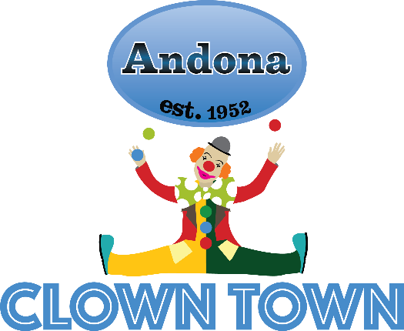

If you’d like to be contacted first for next year’s event, please check below.
____ Please contact first for ClownTown 2023

