**SATURDAY OCTOBER 25th, 2025 6:30PM**

**PARADE ROUTE THROUGH NEW BO DISTRICT!**

PARADE ENTRY FORM MUST BE RECEIVED AND PAID FOR BY **MONDAY, OCTOBER 13TH, 2025 BY 12:00 NOON**. PLEASE SEND SUBMISSIONS TO [pdurin@terry-durin.com](mailto:pdurin@terry-durin.com) or [dklosterman@terry-durin.com](mailto:dklosterman@terry-durin.com)

**Rules and Guidelines for Parade Participants**

**CASH PRIZE IN 3 CATAGORIES**

-MOST SCARY FLOAT -MOST CREATIVE FLOAT -MOST CREATIVE WALKING UNIT

* All entries are subject to approval by TD Halloween representative
* The theme is CREEP SHOW CARNIVAL!
* **ALL VEHICLES MUST BE DECORATED AND ENCOURAGE LIGHTS!**
* All entries must provide their own identification, signs, etc.
* TD Halloween Organization will issue a parade number in the staging area to be adequately identified by the judges and spectators.
* By submitting this Entry Form, you agree to release the TD Halloween Organization and our sponsors from liability for any injuries or damage that may occur (a) to any participant in your entry; and, (b) as a result of actions by any participant or component or portion of your entry.
* All participants must obey Parade Marshals at all times
* **Candy may be passed out to spectators on roadsides, hand-to-hand ONLY. For safety reasons, throwing candy or other objects into the crowd is NOT PERMITTED.**
* No littering or discarding of decorations or other materials on public streets or private property, including dumpsters.
* The TD Halloween organization has been granted a permit allowing live animal entries in the parade. No special requirements are in place, however, should air temperatures be extreme at parade time, we may be required to remove certain animals from parade participation. Please be certain all animals are current on their vaccinations and are wearing appropriate tags if applicable; and provide ample fresh water for your animal(s). Also, please be prepared to immediately collect from the parade route any feces generated by your animal(s).
* Any violation of parade rules will result in immediate removal from the parade and any future participation.

**All parade entries will be judged, and awards will be handed out at 8:15 at the New Bo City market stage**

* Most Scary with lights
* Best Animal Entry
* Most Creative
* Kids Choice Award
* Best Float
* Best Walking Entry
* Most Enormous Float

**Staging of Entries: 4:30PM – 6:00PM**

**Parade 6:30PM – 8:00PM**

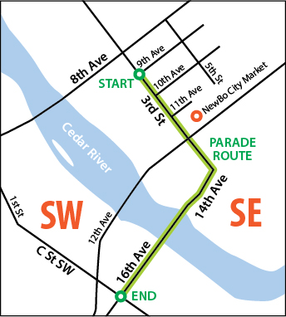

Contact Information:

Organization/Business Name

____________________________________________________________________________________

Contact Person

____________________________________________________________________________________

Phone

____________________________________________________________________________________

Email

____________________________________________________________________________________

Street Address

____________________________________________________________________________________

City/State/Zip

____________________________________________________________________________________

Entry Information:

NOTE: All entries are limited to 2 motorized vehicles or 1 motorized vehicle and trailer. For extra vehicles you will need to sign up for additional entries.

**Unit Type**

Select all that apply

_____ **Float**

Dimensions (in feet)

_____ **Walking Unit**

Number of People

_____ **Decorated Vehicle**

Number of Vehicles

**_____ Footprint of Entry**

How many feet your entry will occupy

**Unit Will Include:**

Select all that apply

_____ **Music Playing (Please Describe)**

_____ **Animals (Type, How Many)**

_____ **Other (Please Describe)**

**Entry Type:**

_____ Military, Veterans or Public Safety Groups - $0.00

_____ Non-profit Organization - $35.00

_____ Commercial, Business or Non-Public Safety Government Organizations - $60.00

_____ Political Campaign - $100.00

**Describe your parade entry:**

This is what the judges will read that day! (max 500 characters)

____________________________________________________________________________________________________________________________________________________________________________________________________________________________________________________________________________________________________________________________________________________________________________________________________________________________________

________________________________________________________________________________________________________________________________________________________________________________________________________________________________________________________________________________________________________________________________________________

____________________________________________________________________________________

**PROCEEDS FROM THE PARADE WILL BE DONATED TO GREEN SQUARE MEALS AND MISSION OF HOPE.**