**NORTHERN CALIFORNIA CAMELLIA SOCIETY**

**PETAL PUSHERS NEWSLETTER**

**February 2024**

Inspirational Thought: *“The best and most beautiful things in the world cannot be seen or even touched – they must be felt with the heart.”*— Helen Keller

**CALENDAR FOR YEAR 2023-24**

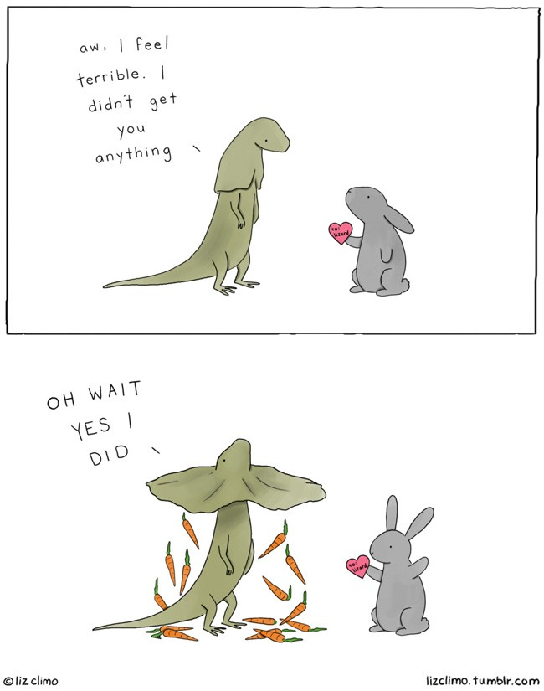

October 1, 2023 2PM

November 5-NCCS Meeting 2PM

December 2 Holiday Luncheon

January 7-NCCS Meeting 2PM

February 4- NCCS Meeting 2PM

February 17 – Judges Symposium/ Mini Show

February 24 - Peninsula Show

March 2 - Sacramento Show

March 3 - NCCS Meeting 2PM

March 9/10 - Nor Cal Show

March 16 - Modesto Show

March 23 – Justin’s Mini Show

April 7 - NCCS Meeting 2PM

May 5 - DeVino’s 2PM

July 6– Christmas in July

**NCCS AND ACS DUES FOR 2024**

NCCS + ACS - $10 + $30 = $40 1 Year

NCCS + ACS - $20 + $58 = $78 2 Years

NCCS + ACS - $30 + $80 = $110 3 Years

NCCS ONLY - $10

**Send to NCCS**

**c/o Jay Humiston**

**754 Palm Ave**

**Martinez, CA 94553**

**MEETING FOR THIS MONTH:**

This month Justin will give a tutorial on how to be a clerk for the shows and what to expect when helping.

**WHAT TO DO THIS MONTH:**

Let’s get ready to rumble….Our season is here!! Good luck to all participants!

**MEETING MINUTES FROM JANUARY 2024:**

1. A huge thank you to Irene Bergamini for the amazing presentation from her trip to Mongolia.
2. Still need trophy donations for our show. Melissa and Joellen have offered to shop for your trophy donation if you would like to donate money. We have already received several donations, but we still need more.
3. We made $25 dollars on the raffle. Our winners for this month were Fred and Nancy. They each took a plant home.

**JUDGES SYMPOSIUM:**

DON’T FORGET - We are hosting the 2024 Judges Symposium Saturday, February 17th for those interested in becoming a judge along with our annual kick-off mini show. Even if you are not eligible to become a judge, join us and find out what judging flowers is all about.

**FUN FACT:**

Did you know the sun makes a sound but we cannot hear it? In the form of pressure waves, the sun definitely makes a sound. The wavelength of the pressure waves from the Sun is measured in hundreds of miles, however, meaning they are far beyond the range of human hearing.

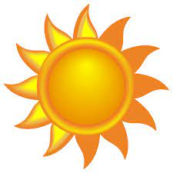

**SHARING PHOTOS AND NEWS:**

Want to share news or photos with the camellia society?

Feel free to send us a picture or share news with us and we will put it in the newsletter. You’re your information or photo to Joellen Bergamini at [peanut_71@yahoo.com](mailto:peanut_71@yahoo.com).

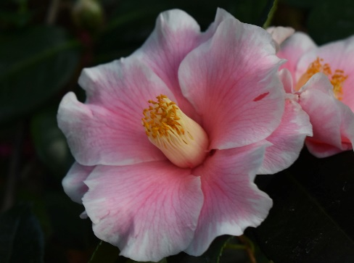 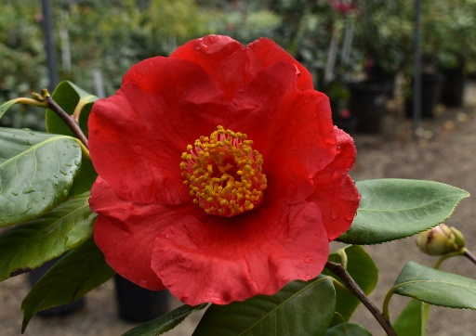 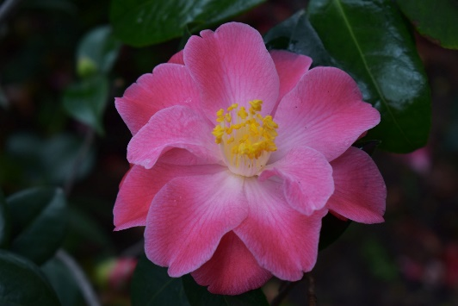

Happy Harlequin Red Crystal Island Sunset

***These photos are from the So-Cal Camellia Facebook page*****

**RECIPES FOR THE MONTH:**

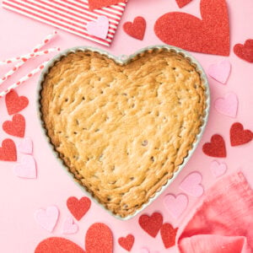

**Chocolate Chip Cookie Cake**

**Ingredients**

* 1/2 cup unsalted butter, softened
* 1/2 cup packed brown sugar
* 1/4 cup granulated sugar
* 1 large eggs, whisked
* 2 teaspoons vanilla extract
* 1 cup all-purpose flour
* 1/2 teaspoon baking soda
* 1/4 teaspoon kosher salt
* 1 cup semi-sweet chocolate chips

**Instructions**

* Preheat oven to 375 F.
* Cream the butter and sugar in a standing mixer (or in a bowl using a hand mixer) for 4-5 minutes until light and fluffy.
* Add the egg and vanilla extract and mix for 1 minute.
* Combine the flour, baking soda and salt in a bowl and slowly incorporate into the butter and egg mixture.
* Mix until combined then pour in the chocolate chips and stir.
* Press the dough into a greased heat shaped pie pan.
* Bake for 20 minutes, or until golden brown.

**CHECK OUT THESE WEBSITES:**

[www.nucciosnurseries.com](http://www.nucciosnurseries.com)

[www.americancamellias.org](http://www.americancamellias.org/)

[www.ruthbancroftgarden.org](http://www.ruthbancroftgarden.org)

OUR WEBSITE: [www.northerncaliforniacamelliasociety.com](http://www.northerncaliforniacamelliasociety.com/)

Don’t forget to check out our website and encourage the curious to do the same.

2024 Nomenclature Book is Available

You can Purchase the hard copy or the digital with photos at Amazon by clicking on one of the links below:

[2024 SCCS Camellia Nomenclature](https://www.amazon.com/dp/B0CGXFVF35/ref=sr_1_1?crid=3GOTZ30FFHF5D&keywords=2024+Camellia+Nomenclature&qid=1693428021&sprefix=2024+camellia+nomenclature%2Caps%2C112&sr=8-1)

[2024 SCCS E-Nomenclature](https://www.amazon.com/2024-Camellia-Nomenclature-Picture-Gallery-ebook/dp/B0CGVW61CX/ref=sr_1_2?crid=3GOTZ30FFHF5D&keywords=2024+Camellia+Nomenclature&qid=1693428118&sprefix=2024+camellia+nomenclature%2Caps%2C112&sr=8-2)

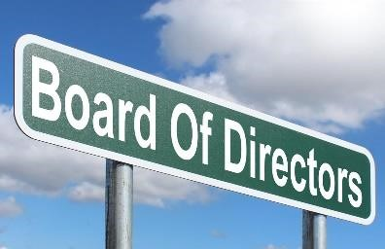 

**Your Board of Directors:**

President: Justin Bergamini

Vice President: Beverly Heathorn

Secretary: Joellen Bergamini

Treasurer: Jay Humiston

**The Board:** Mary Bergamini, Nancy Samelson, Don Lesmeister, Joan Lesmeister, Julie Vierra, Barbara Gilmartin and Sarah Lytle