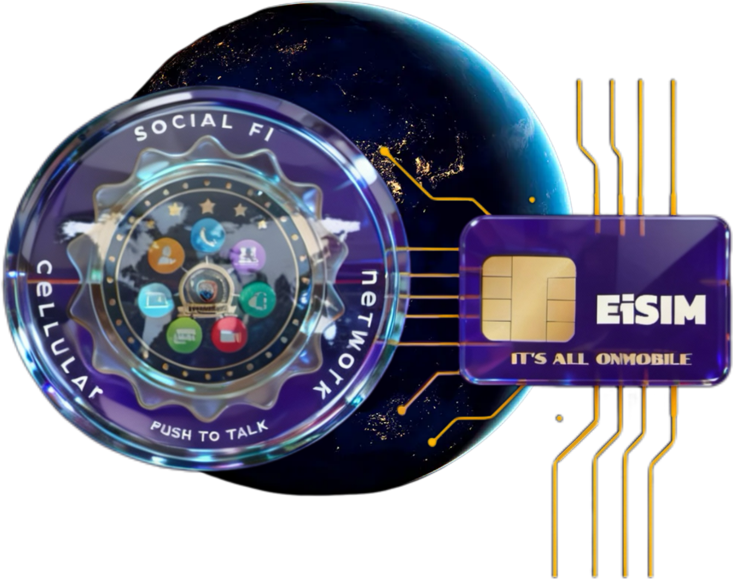
This website uses cookies to ensure you have the best experience possible. Privacy Policy
Got it!
EiSIMN By: SOCIAL FI CELLULAR NETWORK , AI SERVICES NETWORK
Privacy Policy
Effective Date: May 1, 2025
This Privacy Policy replaces all previous versions.

This Privacy Policy (“Policy”) explains how Internet EiSIMN By: SOCIAL FI CELLULAR NETWORK (referred to as “EiSIMN By: SOCIAL FI CELLULAR NETWORK ,” “we,” “us,” or “our”) collects, uses, discloses, retains, and protects certain information (including personal information) from Users of our Service (referred to as “you,” “your”).

This Policy is an integral part of our Terms of Service and applies to your access and use of the EiSIMN By: SOCIAL FI CELLULAR NETWORK .NET site and any content, software, products, services, or functionality offered on or through the site or by us, including EiSIMN By: SOCIAL FI CELLULAR NETWORK products, websites, and services listed at https://EiSIMN By: SOCIAL FI CELLULAR NETWORK .net (collectively, the “Services” or “Site”).

YOUR USE OF THE SITE AND SERVICES IS CONDITIONED ON YOUR ACCEPTANCE OF THIS POLICY. By creating an account, using the Services, or continuing after updates to this Policy, you agree to its terms. If you do not agree, please do not access or use our Services.

We may update this Policy periodically without prior notice. Significant changes may be communicated as outlined in our Terms of Service. Updates become effective upon posting on our site. Continued use indicates your acceptance of the changes. Please review this Policy regularly.

Scope of Policy

In this Policy, a “User” may be a Customer, Host, or Participant. A “Customer” is typically an entity or organization subscribing to our Service. A “Host” is an individual authorized by the Customer to host meetings and use Services. A “Participant” is someone who accesses or uses Services other than as a Host. Participants are bound by this Policy but do not have Customer or Host privileges. Hosts may also participate as Participants in some contexts. A “person” can be an individual or any legal entity. You confirm you have the authority to agree to this Policy on behalf of yourself or your entity.

This Policy outlines the types of information we collect from or about you when you visit the Site and use our Services, and our practices for handling that information.

This Policy covers information collected:

- On this Site
- Through your use of our Services, including content you or other Users share (“Content”)
- Via email, text, and electronic communications with this Site
- Through mobile and desktop apps downloaded from this Site
- When interacting with our advertising and applications on third-party sites that link to this Policy

This Policy does not apply to information collected offline or via other websites operated by EiSIMN By: SOCIAL FI CELLULAR NETWORK or third parties, nor to third parties’ content or applications accessible from this Site.

We do not control Users or third parties who access the Services. Customers and Hosts operate independently when managing their accounts and content.

If you access our Services through a Customer’s account, that Customer controls the data processing and is the data controller. Please review their privacy policies for details.

Information We Collect

We collect various types of information about Users, including:

- Personal information such as name, address, email, phone number, or other identifiers
- Non-identifying information about you
- Details about your internet connection, device, and usage

We collect this information:

- Directly from you
- Automatically as you navigate our Site (including IP addresses, cookies, web beacons, and tracking technologies)
- From third parties with whom we have business relationships

Examples of information collected include:

- Connections and groups within our Services
- Metadata about Content you create
- Information you provide via forms, registrations, contests, or support inquiries
- Correspondence records
- Survey responses
- Transaction details
- Search queries

Automatic data collection technologies gather data such as:

- Site visits, usage, traffic and location data
- Computer and internet connection information like IP address, browser type, and OS

This data helps us improve our Services by analyzing audience size, personalizing your experience, speeding searches, and recognizing returning users.

Technologies include:

- Cookies: small files stored on your device; disabling cookies may limit Site functionality.
- Flash Cookies: stored objects for preferences and navigation data.
- Web Beacons: tiny files tracking page visits and email opens.

Special Note Regarding Content

You may share Content, including personal information, with other Users through the Services. Content includes messages, posts, audio/video, files, chat logs, transcripts, and uploads.

Content is owned by the Customer granting access and is used solely to provide the Services. We do not monitor, sell, or use your Content beyond service provision.

You disclose Content at your own risk. While privacy settings exist, we cannot guarantee unauthorized access by other Users.

Third-Party Use of Cookies and Tracking Technologies

Third parties such as advertisers and content providers may use cookies and tracking technologies on our Site to collect information about your online activities to provide targeted advertising. We do not control these third parties’ practices. For questions about such content, contact the responsible provider directly.

Use By Children

EiSIMN By: SOCIAL FI CELLULAR NETWORK does not knowingly allow customers under 18 to create accounts. Minors under 18 may use Services only when invited by a Customer or Host 18 or older, who is responsible for obtaining required consents.

If we discover personal information from a child under 13 without consent, we will delete it. Please contact us if you believe we have such information:

EiSIMN By: SOCIAL FI CELLULAR NETWORK , AI SERVICES NETWORK
INFO@EiSIMN By: SOCIAL FI CELLULAR NETWORK .NET
Attn: JOHN ARCENEAUX
Phone: 1-337-366-2240

How We Use Your Information

We use your information to:

- Fulfill service requests
- Maintain and improve Services
- Respond to inquiries and provide support
- Communicate account and policy updates
- Inform you of features and promotions
- Detect and prevent fraud or violations
- Customize your experience
- Enable interactive features
- For purposes disclosed at collection or with your consent

You may opt out of promotional communications by emailing info@eisim.net By: SOCIAL FI CELLULAR NETWORK .com.

We may use collected data to display targeted advertisements but do not share personal information with advertisers without consent.

Disclosure of Your Information

We may share aggregated or non-identifying data freely.

We do not sell or rent your personal information to unaffiliated third parties.

We may disclose personal information:

- To Customers, Hosts, subsidiaries, affiliates, contractors, or service providers bound to confidentiality
- To successors in business transactions
- To third parties for marketing if you have not opted out
- To comply with legal requirements
- To protect rights, property, or safety
- To enforce agreements

Data Security and Retention

We implement physical, electronic, and administrative safeguards including encryption and limited access to protect your information. However, no system is completely secure.

You are responsible for keeping your passwords confidential and cautious sharing personal information.

We retain information as long as necessary to provide Services, fulfill legal obligations, prevent fraud, and enforce agreements. Retention periods vary by data type.

Choices About Your Information

You can manage cookie preferences via your browser settings.

To opt out of sharing information for third-party advertising or promotional offers, adjust your account settings or email INFO@EiSIMN By: SOCIAL FI CELLULAR NETWORK .NET.

Some functional protocols require disclosure of certain information, such as IP addresses and valid contact details, which cannot be opted out of.

Accessing and Correcting Your Information

Customers can update their information through their account profile. Other Users should contact their Customer’s administrator.

Your Content may remain accessible in cached or archived pages or by other Users.

Your California Privacy Rights

If you reside in California, you may have additional rights under California law. For details, see our CCPA privacy notice.

Users Outside the United States

If located outside the U.S., your jurisdiction may provide additional privacy protections. Please refer to your Customer’s policies or for EU residents, see our GDPR document.

Changes to This Privacy Policy

We will post updates on this page. The effective date is noted at the top. Please review regularly.

Contact Us

For questions about privacy or security, contact us at INFO@EiSIMN By: SOCIAL FI CELLULAR NETWORK .NET

