***A Restorassage Workshop***

***Me, Myself and my Chakras***

***September 19th from 7-9PM at the Hopewell Train Station***

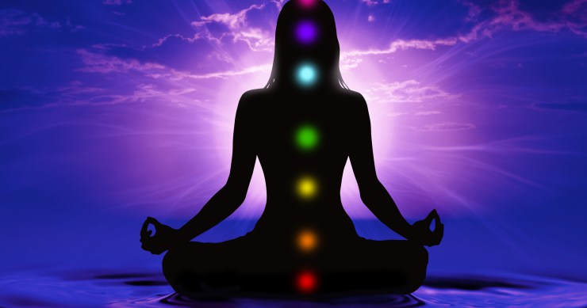

Please join Nancy for this special chakra restorassage workshop. Your chakras organize your prana which is your life force. Let’s connect a little deeper this fall with our energy body and the seven centers of consciousness called chakras to discover and better understand the essence that makes us unique, mysterious, dynamic and complex.

While resting in relaxing comfortable poses, students will receive gentle hands on massage and stretches to encourage the release of tension and to promote deep relaxation. By blending Shiatsu stretches, which offer meridian stimulation, gentle massage techniques and yoga you will feel the full effects of total body integration. I hope to leave you in a Zen-like state by bringing your mind, body and spirit into balance and harmony.

**This 2- hour workshop is limited to 8 students for a fee of $80. Please bring your yoga mat, a thick blanket and a pillow. Early bird register for $80 or pay $90 after September 10th.**

***Please register by September 10th, 2019.***

**Name:____________________________________ Phone:_________________________________**

**Email:____________________________________ Amount paid: __________________________**

Make Checks payable to: **One Spirit Yoga or Nancy McCormack**

Mail to: **9 First Street, Hopewell, NJ 08525**

***A PayPal invoice can be sent by email by request.***