2019 PLVD PLAYGROUND SAFETY AUDIT
2019-01: Playground Surfacing Material: PRIORITY
Reference: ASTM F-1487 Standard 13.2.1; 2223-10
CPSC Handbook - Section 2.4 Table 2
The Playground area and structures does not have approved surface material. The use of sand or pea gravel is not recommended due to its limited head impact attenuation and compaction properties. ADA compliant surface materials such as engineered wood fiber and shredded rubber are highly recommended. **In addition, sand and grass has infiltrated the play areas, resulting in little to no head impact attenuation protections. Surface material deficiencies must be promptly addressed**2019-02: Entrapment hazards: PRIORITY-Remove Equipment

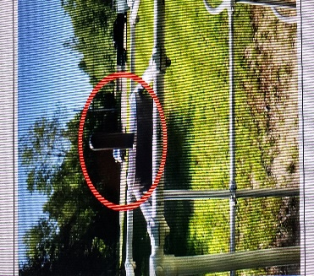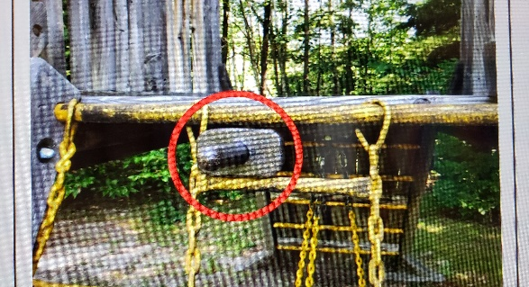
Reference: ASTM Standard 3.1.13
CPSC Handbook – Section 3.3.1
Note: Head Entrapment hazards have resulted in fatalities. As illustrated by the highlighted area in the picture, a child’s torso (probe in circle) may fit through the opening but the head (larger probe in circle) would not pass through creating an entrapment hazard.
2019-03: Entanglement hazard: PRIORITY-Remove Equipment

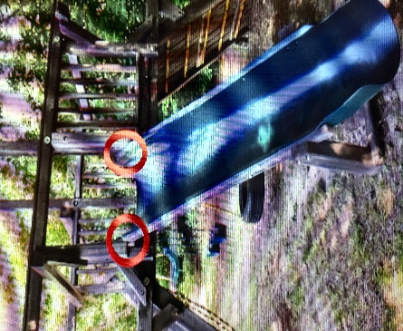
Reference: ASTM Standard 3.1.12
CPSC Handbook – Section 3.2/3.2.1
Note: Entanglement hazards can be potentially fatal. As illustrated by the highlighted areas in the picture.
2019-04: Multi Axis Swing: PRIORITY-Remove Equipment
Multi-axis swing should not be mounted on composite structures. Element should have a dedicated swing bay.

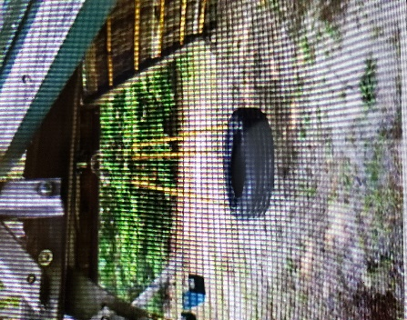

Reference: ASTM F-1487 Standard 8.6.1.2 – 8.6.5.2
CPSC Handbook - Section 5.3.8.4 – 5.3.8.4.1
.2019-05: To–Fro Swings: PRIORITY-Remove from Current Location

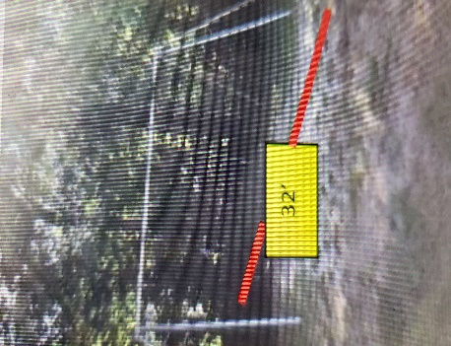

Reference: ASTM F-1487 Standard 9.4.1.1
CPSC Handbook - Section 5.3.8.3.3
The use zone is twice the distance of the swing chain from the pivot point to the surface material. In this case, the use zone must extend sixteen (16’) in front of the swings and the same for the rear. The use zone must include the protective surface material as described in 2019-01.
2019-06: Enclosed Buckets: PRIORITY-Remove Bucket
Toddler buckets and / or special needs swings should not be mixed with other types of swings.

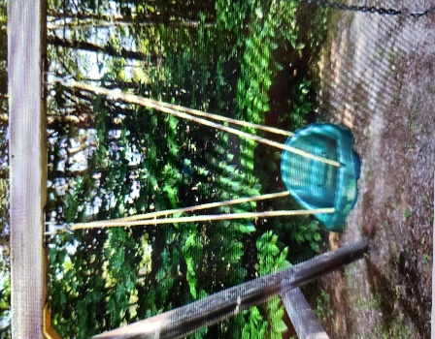

Reference: ASTM F-1487 Standard 9.4.1.
CPSC Handbook – Section 5.3.8.1
Swings should not be mounted to composite structures. Use zone must be a minimum of 2X the length of the pivot point to the seat
2019-07: Ship Structure: Fall Protections - PRIORITY-Remove

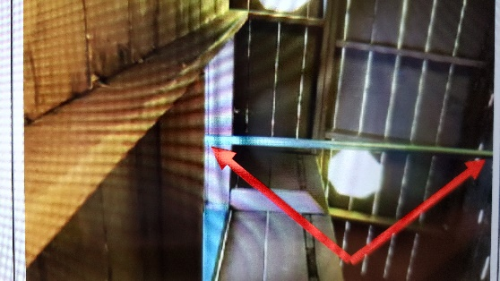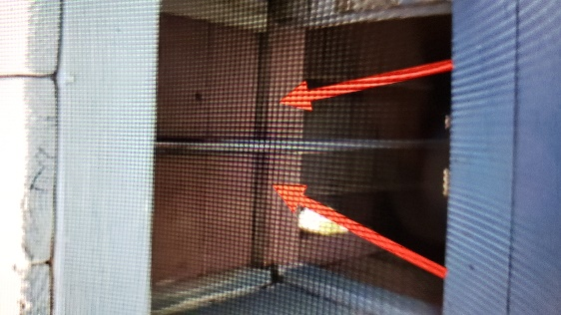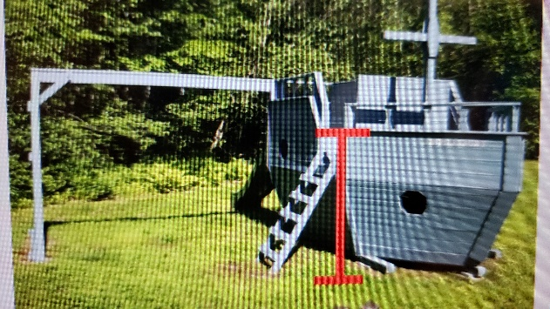

Reference: ASTM F-1487 Standard 7.5.5.2 / 7.5.6.3
CPSC Handbook-Section 5.1.3
Due to the fall height of the structure, there must be a guardrail 38” in height. Even though this structure has functionality, due to the height there are many hazards identified including the lack of approved surface material. The sliding pole contained within the mid-ship section does not have the proper clearances and a fall from the top could result in serious injuries.
2019-08: Merry-Go-Round: Clearances-PRIORITY-Remove

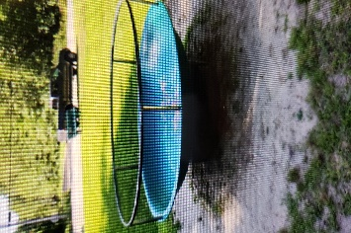

Reference: ASTM F-1487 Standard 9.1.1 / 9.2.1
CPSC Handbook – Sections 5.3.4
Metal surfaces for playground structures is not recommended due to the overheating potential.
2019-09: Maintenance of Components: Mod. Hazard-Remove

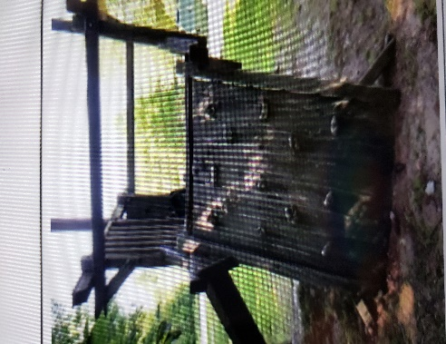
Reference: ASTM F-1487 Standard -Section 12 & 13
CPSC Handbook – Section 4.1
Degradation of Structural Members is evident on some key components. Cracked and splintered members can injure users.
2019-10: General Maintenance Hazards – Labelling & Signage:

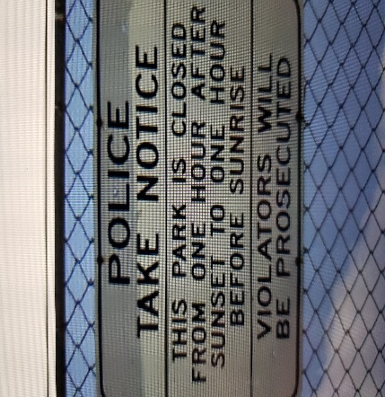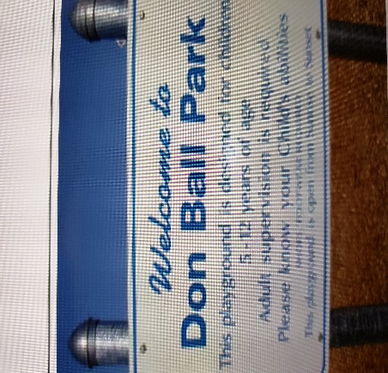

Moderate Hazard - Best Practice
Reference: ASTM F-1487 Standard 14
CPSC Handbook - Section 2.2.3; 2.2.6; 2.2.7
The playground “User Age Group (s)” should be clearly defined and park rules should be posted. In addition, a reference to “Parental / Guardian / Adult Supervision Required”, is a best proactive for preventing playground related injuries. Signage should be on Park Gates /Fencing and age appropriate labels should be affixed to playground structures.
General Risk Management Concerns
2019-11: Structural Hazards: BB Backboards: Significant Hazard
The wooden backboard structures are showing excessive wear and could fail without warning. The structures are substantial in weight and could cause significant injury to a user. It should be noted that only one backboard remains intact. The other post is void of any other structures. The support posts are littered with nails / staples and other fasteners which could cause injury as well. Recommend replacement of the support posts and backboards with commercial components designed and engineered for outdoor basketball courts.
2019-12: Structural Hazards: Significant Hazard
There is a section of fencing located at the west end of the playground that has been removed. This condition now allows children to (if unsupervised), wander to the water’s edge, and become hidden by vegetation and lack of available site lines. Replace fence section to maintain playground security.

