FULL LENGTH PAPER TEMPLATE

TITLE: BOLD, UPPER CASE, TIMES NEW ROMAN, 14 PT CENTERED

First Author^{1*}, Second Author¹, Third Author², Fourth Author^{3*}

¹Department of Mechanical Engineering, Manipal University Jaipur, India-303007
²Department of Mechanical Engineering, Manipal University Jaipur, India-303007
³Department of Mechanical Engineering, Manipal University Jaipur, India-303007

Abstract

This guide has been prepared for authors of papers to be presented at the International Conference on Sustainable Energy and Thermal Systems (SEATS 2026), September 10-11, 2026. Authors are requested to follow these guidelines to achieve uniformity in the presentation of the proceedings. The main format of the paper is as follows: Text: Times New Roman (or equivalent), 11 pt type size, left and right justified. Headings: Times New Roman, all caps, 12 pt. type size, centered. Page size A4 (210 × 297 mm); 20 mm borders all round; paper title starts at 40 mm from top of page except the first page. The manuscript is transferred to PDF file and is sent to the Online Submission Portal in the prescribed format. The abstract summarizes key findings in the paper and should be a paragraph of not more than 250 words. It should give an account of the most relevant contributions of the paper. It is also important to indicate briefly the goal, the methods, the results, and conclusions. Avoid abbreviations, equations, and references.

KEY WORDS: Times New Roman, 10pt, Convection, Computational methods, Heat exchanger, Cooling turbine blade, Film cooling, High temperature (Minimum three and maximum five Keywords)

1. INTRODUCTION (Details for Submitting Paper)

The paper must be formatted using the respective templates, the Word template are provided on the conference website. Papers not conforming to the correct format will not be considered. If modifications to your paper are NOT required from the reviewers, it will be published as received. There will be no opportunity to alter it.

It will be assumed that the corresponding author will represent the paper. All presenting authors must register for the Conference before the due date to ensure that their paper is included in the Conference Program.

2. LENGTH AND LAYOUT

Papers submitted using A4 size (210 × 297 mm) pages should be no more than 10 pages (including tables, figures and references. Very short papers and very long papers are discouraged. Papers may include colour figures. Each file size should not exceed 10 Mb after transforming to a PDF file.

The layout of the paper should follow the style of this document, starting with a title, name(s) of author(s) and affiliation(s). Put a blank line between paragraphs.

Title: The title should appear 40 mm below the top edge of the page. It should be brief, clear and descriptive. Use Times New Roman 14 pt. all bold capital letters (except if formulae or symbols appear in the title), centered on the width of the typing area. Authors’ names should be in lower-case letters in bold and the affiliations should be in no bold.

ABSTRACT: A brief abstract (100 - 250 words) should appear beneath the affiliation of the author(s). It should give an account of the most relevant contributions of the paper. It is also important to indicate briefly the goal, the methods, the results, and conclusions. Avoid abbreviations, diagrams, and references. It must be complete and understandable without reference to the text. Leave a blank line between the Author’s affiliation and the Abstract. Leave a blank line between the abstract and keywords.
KEYWORDS: Keywords can be selected to describe the feature of the paper. Leave two blank lines between keywords and the first major heading.

Header and footnotes: The header of the first page and footnote after second page include Paper number. The footnote of the first page contains E-mail address of the corresponding author.

3. HEADINGS AND EQUATIONS

If your paper is divided into sections and subsections, please use the format adopted here, in which first-level headings are in 12 pt bold capitals, centered on the line. Put two blank lines before the heading and a blank line after the heading.

3.1 Second-Level Headings: Second level headings should be in 12 pt bold lower case (initial capital), left aligned.

Third-level headings. Third-level headings should be placed at the beginning of a paragraph.

All equations should be numbered as shown below.

$\frac{∂(u_{i})}{∂x_{i}}=0$ (1)
$ρ\left(u_{j}\frac{∂(u_{i})}{∂x_{j}}\right)=-\frac{∂p}{∂x_{i}}+\frac{∂}{∂x_{j}}\left((μ+μ_{t})\frac{∂u_{i}}{∂x_{j}}\right)±ρ_{i}g_{i}$ (2)
$u_{j}\frac{∂T}{∂x_{j}}=(α+α_{t})\frac{∂}{∂x_{j}}\left(\frac{∂T}{∂x_{j}}\right)$ (3)

4. FIGURES AND TABLES

4.1 Figures Care should be taken to ensure that figures are contained within the typing area. All original drawings should be prepared.

Figures should be numbered consecutively, e.g., Fig. 1 with a single letter space between the word “Fig.” and the Arabic numeral. Place figures centered on the width of the text page and either at the top or bottom of the page as close as possible to their first mentioned in the text. Type the word “Fig.” and its number followed by two-letter space. Then type the legend single spaced, with an initial capital for the first word and for proper nouns only.

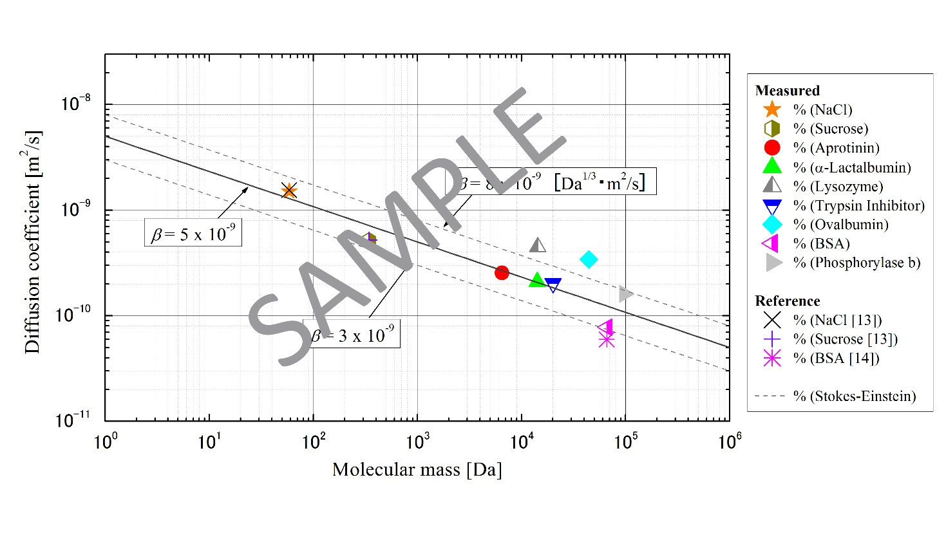
Fig. 1 One-line figure captions are centered under the figure. Add 1 line space above the figure caption.

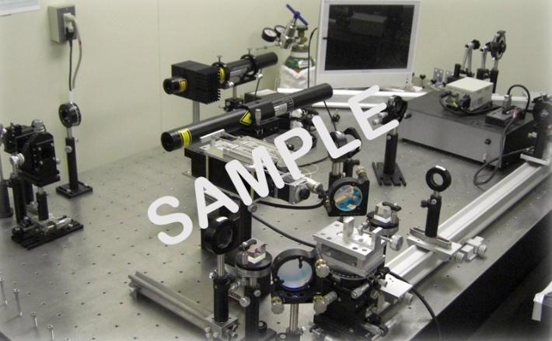

Fig. 2 Two or more lines are flushed left under the figure. Add 1 line space above the figure caption.

4.2 Tables When tables are mentioned in the text, they should be referred to as Table 1, Table 5, i.e., with a single letter space between the word “Table” and the Arabic numeral.

Tables are in Times New Roman, 11 pt. size. The table caption goes above the table, with 1 line space above and below the caption.

Table 3 Table captions go above the table, captions that are 2 or more lines are flushed left, 1 line space above and below the caption.
Case | Diameter, (mm) | (Hz) | We | St
1 | 0.5 | 731 | 117 | 0.15
2 | 0.5 | 1799 | 620 | 0.16
3 | 1.3 | 198 | 124 | 0.17

5. CONCLUSIONS

Briefly mention the major conclusions of the present work in a paragraph.

ACKNOWLEDGMENT

Acknowledgement should be placed immediately following CONCLUSIONS, if necessary.

NOMENCLATURE

A short nomenclature defining unusual or non-standard symbols should be placed immediately above the REFERENCES. SI Units must be used.

Be dimensionless variable ( - )
Ĉ second variable (s²)
Q_{A} third variable (kJ)
w_{x} fourth variable (m²/s)
ϕ(Ω) function
ζ dimensionless variable ( - )
Ω fifth variable ( s⁻¹ )

REFERENCES

Reference List at the end of the article should be numbered consecutively in the order they are mentioned, using Arabic numerals in square brackets [4] and formatted according to the following samples. References should be in Times New Roman, 9 pt type size, both side justified copy.

[1] Guo, Z.Y., Zhu, H.Y., Liang, X.G., “Entransy - A physical quantity describing heat transfer ability,” Int. J. Heat Mass Transf., 50(13-14), pp. 2545-2556, (2007). Journal Paper
[2] Nield, D.A. and Bejan, A., Convection in Porous Media, New York: Springer-Verlag, pp. 125–176, (2005). Book
[3] Buyevich, A. and Alexandrov, D.V., Heat Transfer in Dispersions, Connecticut: Begell House, Available at http://www.edata-center.com/ebooks/b7f98f1e271b3e77a.html/ EBooks [accessed May 5, 2005] (2005). E-Books
[4] Yang, W. and Kim J.H. Eds., Rotating Machinery, New York: Begell House, (1992). Edited Book
[5] Nishikawa, K. and Ito, T., “Augmentation of Nucleate Boiling Heat Transfer by Prepared Surfaces,” In T. Mizushina and W.J. Yang, Eds., Heat Transfer in Energy Problems, Washington, D.C.: Hemisphere Publishing, pp. 111–1182, (1982). Book Chapters
[6] Ma, T.M., “Effects of Geometrical Shapes of Reentrant Grooves on Boiling Heat Transfer from Porous Surfaces,” Heat Transfer 1986, Proc. of 8th Int. Heat Trans. Conf., vol. 4, pp. 2013–2018, (1987). Conference Proceedings
[7] Richmond, J., Steady State Thermal Conductivity, Ph.D. Thesis, University of Connecticut, (2004). Dissertation
[8] Author, A.A. and Author, B.B. Title of article. In Title of book or larger document (chapter or section number). Retrieved month day, year, from http://www.someaddress.com/full/url/, (Date of publication). Chapter or Section of a Web document
[9] Author, A.A., & Author, B.B., “Title of article,” Title of Journal, volume number. Retrieved month day, year, from http://www.someaddress.com/full/url/, (Date of publication). Online Scholarly Journal Article

