ABSTRACT TITLE
First Author¹, Second Author² and Third Author^{1*}

¹Department of Mechanical Engineering, Manipal University Jaipur, India-303007
²Department of Mechanical Engineering, Manipal University Jaipur, India-303007
*Corresponding Author Email: abc@jaipur.manipal.edu

ABSTRACT
This is a template for the abstract, which is the only file required for the submission of the paper to be presented in the conference and published Conference Proceedings. The accepted abstract will be asked to submit full length manuscript which will be published in the conference proceedings. The selected full-length papers after the presentation will be published as per the regulations of the Journal. For abstract submission, please follow the guidelines below:
- The abstract should be submitted in this template and should not exceed more than one page.
- Without a figure, the word limit is a minimum of 300 words and a maximum of 500 words.
- With a figure, the word limit is a minimum of 150 words and a maximum of 300 words.
- Each abstract will be reviewed, and authors will be requested to submit the full-length manuscript in the prescribed template to the conference portal after incorporating the suggestions/comments.
Key Words: Heat Transfer, Finite Elements, Natural Convection. (Minimum three and maximum five Keywords)
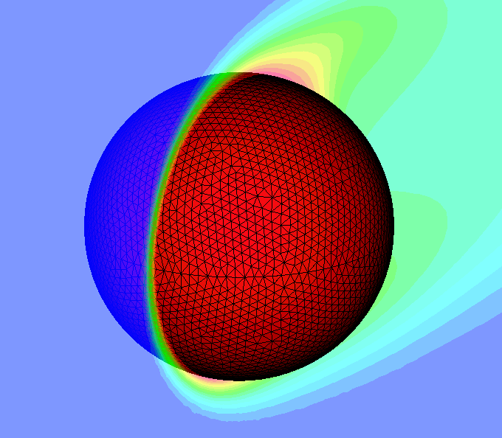

Figure 1: Result of the present work (Optional)

