What to do PRIOR to teaching student

All Instructors:
- Make sure you have enough eCards to issue to students.
- Make sure you have enough eBooks or real books to provide to students – if teaching a live class.
- Make sure you have enough online codes to provide to students – if they are seeing you for a skill session.
- Make sure you have let us know about your class/skill session. DO this at least 24 hours prior to meeting students.
- Make sure you have all the paperwork you need.
After you have told us about your event, we will schedule it into your HOVN account.
- Log in to HOVN.app and make sure you pick Instructor – upper left corner
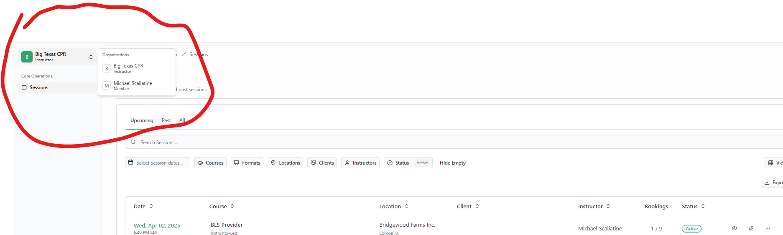

- Find the session you are looking for, click on the green date of your session.
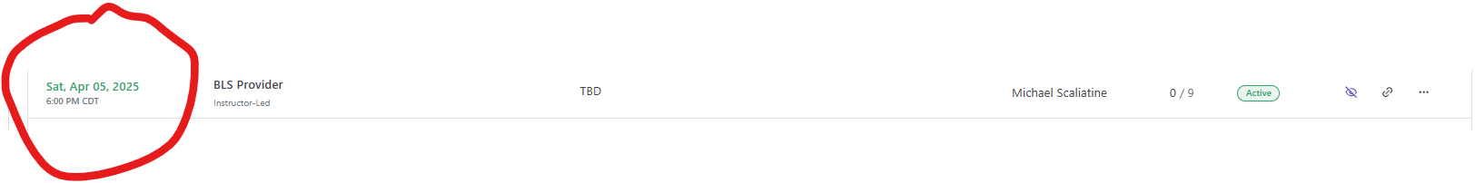
- Click the share button if you want to provide a sign-in link for your students.

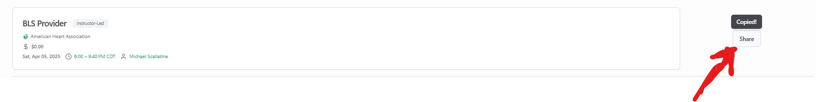
- Or click on the Bookings button if you want to add student information. Enter the student information and press the confirm button. 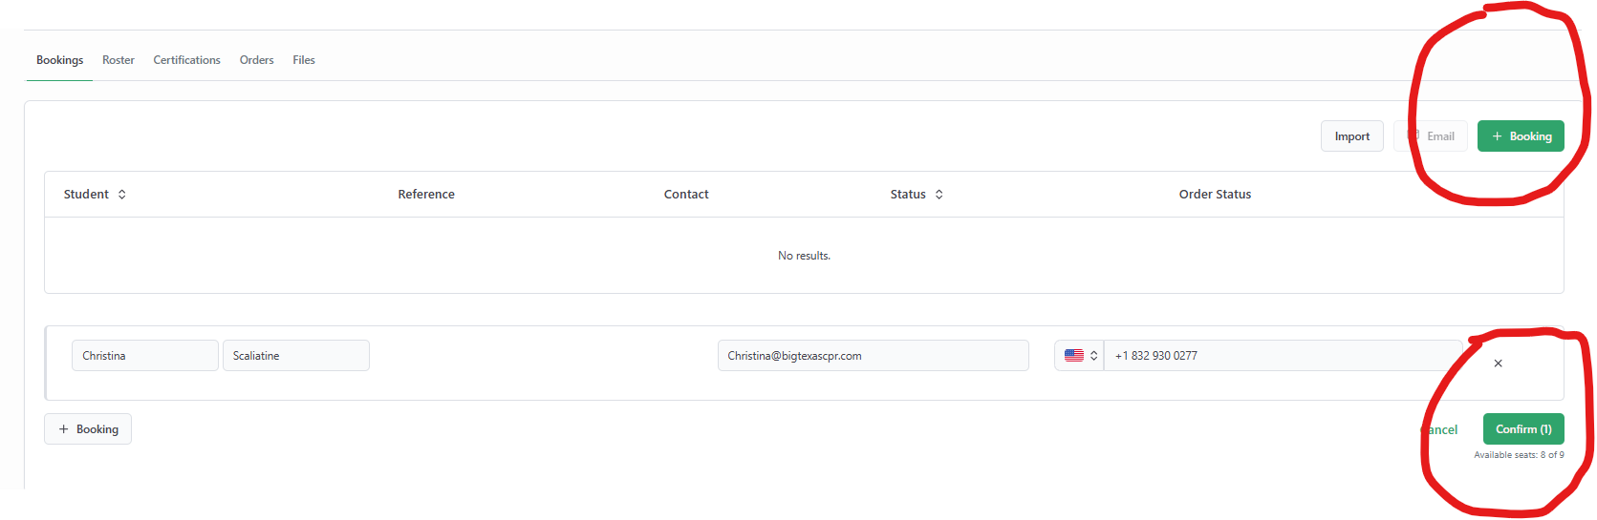
- That’s it… Check the documents folder (Current Instructor page at BigTexasCPR.com) for what to do AFTER teaching students.
Instructors can NOT adjust times, dates, locations – Contact us if things change. If a student decides to change dates or cancel, please contact us to let us know.
Every student has their own access and profile to HOVN.app.. They just need to sign in with their email. This also means that instructors can NOT change student data.
Students might sign into their own accounts to change their information.

