New Patient Intake Form
Date: ________________________ Name: _______________________________________________ [ ] Male [ ] Female

Street Address: __________________________ City, State, and Zip: __________________________________________

Home Phone: ___________________________ Emergency Contact & Phone: Number: ____________________________

Work Phone: ___________________________ Email: ______________________________________________

Birth-date: _________________________ Age: ____________ Height: _____________ Weight: __________________

Marital Status: ______________________ Occupation: ___________________________ Referred by________________

Have you had acupuncture before? [ ] Yes [ ] No Chinese Herbal Medicine? [ ] Yes [ ] No
Are you under the care of a physician now? [ ] Yes [ ] No

If yes, what for? _________________________________________________________________________________________
Who is your physician? ____________________________________ Physician/s Phone: _____________________________
Other concurrent therapies: _______________________________________________________________________________

Reason for visit today? ____________________________________________________________________________________

How long have you had this condition? __________________________________ Is it getting worse? [ ] Yes [ ] No
Does it bother your: [ ] Sleep [ ] Work [ ] Other: ____________________________________________________

What seemed to be the initial cause? ___________________________ What seems to make it better? _______________
What seems to make it worse? ________________________________ Is there any litigation pending? ______________
Family Medical History
[ ] Allergies [ ] Alcoholism [ ] Heart Disease [ ] Seizures [ ] Asthma [ ] Diabetes [ ] High Blood Pressure
[ ] Stroke _________________________________________ [ ] Arteriosclerosis [ ] Cancer [ ] Other _________________________________________________________________________________________________
Your Past Medical History
(Check any of the following conditions you currently have, or have had in the past.)
[ ] AIDS / HIV [ ] Chicken Pox [ ] Herpes [ ] Polio [ ] Tuberculosis
[ ] Alcoholism [ ] Diabetes [ ] High Blood Pressure [ ] Rheumatic Fever [ ] Typhoid Fever
[ ] Allergies [ ] Emphysema [ ] Measles [ ] Scarlet Fever [ ] Ulcers
[ ] Appendicitis [ ] Multiple Sclerosis [ ] Epilepsy [ ] Seizures [ ] Venereal Disease
[ ] Arteriosclerosis [ ] Goiter [ ] Mumps [ ] Stroke [ ] Whopping Cough
[ ] Asthma [ ] Gout [ ] Pacemaker [ ] Surgeries (list) [ ] Other: (specify)
[ ] Birth Trauma (yours) [ ] Heart Disease [ ] Pleurisy [ ] Thyroid Disorders _______________
[ ] Cancer [ ] Hepatitis [ ] Pneumonia [ ] Major Trauma __________________ _________________________________________________________________________________________________________
Your Daily Nutritional Intake
Appetite : [ ] Coffee [ ] Artificial Sweetener [ ] Salty Foods [ ] Thirst for Water (# glasses per day) [ ] Low [ ] High [ ] Soft Drinks [ ] Sugar ___________________________
Average Daily Menu
Morning Snack Noon Snack Evening Snack
___________________ ____________ ________________ ___________ _________________ ____________
___________________ ____________ ________________ ___________ _________________ ____________

Pharmaceuticals Taken in Last 3 Months
________________________ _______________________ ________________________ _______________________
________________________ _______________________ ________________________ _______________________

General Symptoms
[ ] Bleed or Bruise easily [ ] Heavy Appetite [ ] Poor Appetite
[ ] Bodily Heaviness [ ] Heavy Sleep [ ] Poor Circulation
[ ] Chills [ ] Insomnia / Disturbed Sleep [ ] Recent Weight Loss / Gain
[ ] Cold hands or Feet [ ] Lack of Strength [ ] Shortness of Breath
[ ] Dream-disturbed sleep [ ] Muscle cramps [ ] Strongly like cold drinks
[ ] Fatigue [ ] Night Sweats [ ] Strongly like hot drinks
[ ] Fever [ ] Peculiar taste _________________ [ ] Vertigo / Dizziness
(describe)
Head. Eyes, Nose, Throat
[ ] Blurred Vision [ ] Excessive saliva [ ] Headaches [ ] Recurrent sore throat [ ] Teeth problems
[ ] Cataracts [ ] Eye pain [ ] Itchy eyes [ ] Red eyes [ ] TMJ
[ ] Concussion [ ] Eye strain [ ] Lumps in throat [ ] Ringing ears [ ] Other head or neck
[ ] Dry mouth [ ] Facial pain [ ] Migraines [ ] Sinus problems problems:
[ ] Earaches [ ] Glasses [ ] Night blindness [ ] Sores on lip or ___________________
[ ] Enlarged thyroid [ ] Glaucoma [ ] Nose bleeds [ ] Spots in eyes ___________________
[ ] Grinding teeth [ ] Poor hearing [ ] Swollen glands [ ] Poor vision ___________________
[ ] Excessive phlegm [ ] Gum problems
Color of phlegm _________
Respiratory
[ ] Asthma/ Wheezing [ ] Color of phlegm________ [ ] Pneumonia Other respiratory Problems: [ ]
[ ] Cough [ ] Coughing blood [ ] Shortness of breath ____________________________
[ ] Wet [ ] Dry [ ] Difficulty breathing [ ] Tight chest ____________________________
[ ] Thick [ ] Thin when lying down [ ] Difficult inhalation? Exhalation?
Cardiovascular
[ ] Blood clots [ ] Fainting [ ] Low blood pressure [ ] Tachycardia
[ ] Chest pain [ ] High blood pressure [ ] Heart Palpitations
[ ] Difficulty Breathing [ ] Irregular heartbeat [ ] Phlebitis
Gastrointestinal
[ ] Acid regurgitation [ ] Bloody stools [ ] Hemorrhoid [ ] Burning anus Bowel movements:
[ ] Anal fissures [ ] Nausea [ ] Vomiting [ ] Constipation Frequency_____________________ [ ] Nausea [ ] Vomiting [ ] Bad breath [ ] Rectal pain Color ________________________ [ ] Black stools [ ] Diarrhea [ ] Itchy anus [ ] Mucous in stools Texture / Form_________________
[ ] Bloating [ ] Gas [ ] Laxative use Odor_________________________ [ ] Hiccough [ ] Intestinal pain or cramping [ ] Other
Musculoskeletal
[ ] Joint pain [ ] Low back pain [ ] Rib pain
[ ] Limited range of motion [ ] Muscle pain [ ] Upper back pain
[ ] Limited use [ ] Neck / shoulder pain Other ____________________________

Skin and Hair
[ ] Acne [ ] Eczema [ ] Hives [ ] Rashes
[ ] Change in hair / skin texture [ ] Fungal infections [ ] Itching [ ] Ulcerations
[ ] Dandruff [ ] Hair loss [ ] Psoriasis [ ] Other
Neuropsychological
[ ] Abuse survivor [ ] Depression [ ] Numbness (where?)__________________________ [ ] Tics
[ ] Anxiety [ ] Easily stressed [ ] Poor memory [ ] Other _________________________
[ ] Considered suicide [ ] Irritability [ ] Seizures [ ] Seeing a therapist?
Genitourinary
[ ] Bedwetting [ ] Impotence [ ] Nocturnal emissions [ ] Urgent urination
[ ] Blood in urine [ ] Incomplete urination [ ] Pain on urination [ ] Venereal disease
[ ] Decreased libido [ ] Premature ejaculation [ ] Wake to urinate
[ ] Frequent urination [ ] Unable to hold urine [ ] Kidney stones
Gynecology
Age menses began______ #Live births_______ Age at menopause_______ Date last period began_______ [ ] Painful periods Length of cycle_______ # Pregnancies______ Breast lumps______ Date of last PAP______ [ ] PMS [ ] Clots______
Duration of flow________ #Premature births__ [ ] Irregular periods [ ] Vaginal discharge [ ] Vaginal odor or sores
Other

OKLAHOMA HEALING ARTS INSTITUTE
3516 N.W. 50th, Okc, OK 73112 Phone 405-662-2650 PATIENT EVALUATION / TREATMENT – PROGRESS – NOTES / DOCUMENTATION
Patient Name: ___________________________________________ Date: ____/____/________ Last First
Date of Birth: ____/_____/____ Home Phone: _______________ Work Phone: ______________
Please indicate precisely the area of your symptoms using “XXX” on the figures below
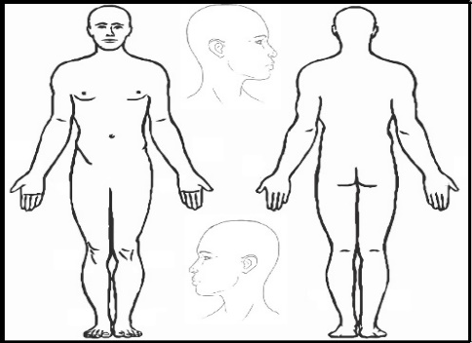
Significant Medical History Current Medications Email Address: ________________ ___ __& Supplements

I consent to treatment by Scott Rigsbee and other Practitioners at Oklahoma Healing Arts Institute. I understand that they are not medical doctors, but practitioners of natural healing arts and they do not diagnose disease but work to correct Imbalances in the body.

______________________
Patient Signature

Date____/____/_________

Name your condition in the space below: Please circle current pain level:
(Main problem today) Better Worse
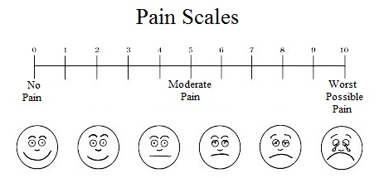
________________________

________________________

________________________

________________________

_____________________________

_____________________________

Areas of Therapy Practitioners Notes
Needle
Count
Needle Count -Total
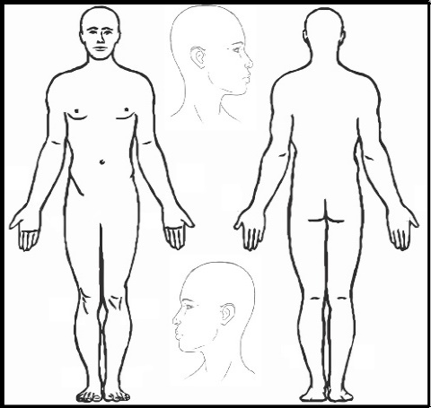

Signature____________________ Date_________

Acupuncture Affiliates Oklahoma Healing Arts Institute 3516 N.W. 50th Street, Okc, OK 73112 Phone (405) 779-5605 okhealingarts@gmail.com
Per Session | Modalities | Office Visit | Fee
1 | Acupuncture
1 |  | New Patient-Initial Session | 75
1 |  | Patient-Complex | 75
1 |  | Patient-Moderate | 50
1 |  | New Patient-Brief | 35
1 |  | Established Patient-Complex | 55
1 |  | Established Patient-Moderate | 50
1 |  | Cupping | 25
1 |  | Instructor / Intern. TX | 50
 | Chinese Medicine
1 |  | Chinese Internal Medicine
1 |  | Western Herbal Medicine
Herbal Medicine/
Supplementation
1 |  | Consult-Brief | 25
1 |  | Consult-Moderate | 35
1 |  | Consult-Complex | 45
 | Bodywork
1 |  | Tui Na (Chinese Bodywork) | 75
1 |  | Massage-Integrative | 120 (2 hour)
1 |  | Massage-Lymphatic/Regional | 120 First 50 there after
 |  | Shiatsu (Japanese Bodywork) | 85
1 |  | Aroma Wrap | 65
1 |  | Massage-Myofascial-Trigger Point | 65
1 |  | Massage-Medical | 85
1 |  | Massage-Chinese Stone Therapy | 60
1 |  | Foot Reflexology | 50
 |  | Chair Massage | $1.00 per min
 | Nutritional Counseling
1 |  | Complex | 150
1 |  | Moderate | 95
1 |  | Brief | 55
 | Integrative Nutrition Health Coach | 1 Session | 75
 | Empowerment Guru | 1 Session | 50
1 | Ionic Foot Bath (Detox) | Per Session | 15
1 | Zyto Scan | Per Session | 20
Our Financial Policies:  We accept: Cash, Check and Credit Cards A charge $35 will be required for all Insufficient Check or Credit Card Payments  We do not submit Insurance Claims. You are responsible for payment at time of service.  You are responsible to deal with your Insurance Company for reimbursement. We will provide a receipt at time of service, KEEP THIS RECIEPT FOR YOUR RECORDS. ADDITIONAL COPIES are $10 for the first, PAYABLE in advance. You’re Insurance Company reserves the right to deny payment for your care.  **Rx Dispensary: Effective February 1, 2016) Call at least 72 hours in advance: (405-662-2650) a and leave your order on voicemail with: (1) Date & Time of call; (2) Name & Phone number;  (3) Rx (If RX is to be mailed. Giver your current shipping address with Zip Code; (3)Rx Name,  (4)(Credit Card Number with your House Number or  PO Box Number & Zip Code (No Delivery to PO Box) ** Allow 3 days to 2 weeks for delivery. 72 hours office minimum.  Shipments are packaged and mailed on Tuesday only. RECOMMENDATION: Do not deplete your supply. An order may require 1-2 weeks to reach you.  THANK YOU! |  |  | Service Fee__________  Fee Total ___________  Product(s)___________  Tax___________  Grand Total _________  Payment____________  CA____CK____CC___  CK #  ____________

PATIENT SIGNATURE____________________________ Date____/____/______ PRACTITIONER_________________________________

