Golden retriever and JackRussell puppy check list….almost all of this can be purchased at www.vsgoldenfood.com

- *1 bag of 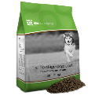all life stages or bag of large breed puppy food. (a 40lb bag lasts an adult golden 2 month, you can also mix 50/50 with one of these wildology, Holistic select, TLC, victor/.
- Nuvet Plus you can call 800-474-7044 and mention order code: 55847 or go to www.nuvet.com/55847 Your puppy will already be started on this as well.
- Some training treats or I like to use just the dry kibble, this helps with keeping them from getting over weight.
- Pet insurance. Specially if your puppy is needing a long travel. Trupanion has a 30days free no card or anything needed. I will give you an activation # BR1VS1421 (remember this cannot be activated tell 24 hours before baby leaves. Or no later than 24 hours after you take your furbaby home) you can call or go online to activate your free 30days. I recommend doing this the day before your puppy leaves my place. Or call Aug. 13th is the earliest day you can call them. Also AKC offers a free 30 pet insurance. Once you register your puppy than just activate the pet ins. I can help you register your pup for you (all just need an extra 35.00 for reg. and 17 to register the microchip).
- *A crate large breed, wire crate is best as you can make smaller and slowly in large as your puppy grows.
- *Dog bed
- *Food water bowls (try to stay away from plastic, can cause canine acne).
- *Collar and leash -collar size 10”-15”
- *A cleaning product that is pet friendly. Bio deodorizer exp.. Spray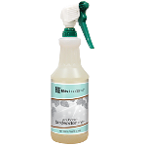or Floor Wash Concentrate 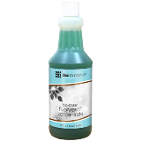or Oban (found with other house hold cleaning products) Vinegar is another good chemical free cleaner.
- Make sure you have spoken to some veterinarians and have one you are comfortable with lined up. Pup will need 2nd set of vaccinations in 3-4 week from there 8 week mark day
- Shampoo I use life’s abundance shampoo. Or amazon an oatmeal shampoo make sure it is not a cheap shampoo and watch there ears and eyes.
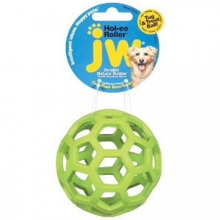
- Toys they love toys that squeak and crackle, a ball, fetch toys. 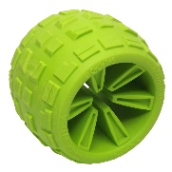 these are a few toys they like.
- Chews knuckle bones, bully sticks, cow hoofs, Smart bones, dream bones ( need to be given sparingly). Kong toys are also great. Etta says (the hardy chews) Etta have become my favorite lately.
- Baxter and Bella pet training. Code: VSGOLDENS will get you 25% off the life time membership. They have trainers you can work with live!

Flea & Tick prevention:
We highly suggest adding organic apple cider vinegar with mother to your pups water, just a splash in the bowl does the trick, or a tsp in a bowl is fine as well (depending on how large of a bowl). Just enough to change the color of the water slightly. IF your pup will not drink his/her water after it is added then try adding to food instead. Plenty of water is VERY important, especially during this hot weather; we need our pups to drink a lot of water! Organic ACV has worked wonders keeping fleas off our dogs but also with a combination of also taking their NuVet vitamin everyday.
also advise using dog SAFE essential oils for a homemade flea & tick collar (this also helps keep mosquitos away which helps as a natural heartworm preventative) or a spray bottle of apple cider vinegar mixed with essential oils that you can spray on them every couple days.. You can find which ones are safe by clicking this link: https://www.essentialoilhaven.com/best-essential-oil-brands/ HOWEVER, I do not recommend using essential oils till they are at LEAST 12 weeks of age. Essential oils good for repelling mosquitos, fleas and ticks that are dog safe are as follows: Citronella, cedarwood, rosemary, peppermint, lemongrass, lemon, orange, rose geranium, and lavender. I find they work best when combined, and mixed with apple cider vinegar.
they typically use a 4oz-8oz amber glass spray bottles. add 10 drops each of about 5 different essential oils in them that prevent against mosquitos. would fill at least half the container with organic apple cider vinegar and then remainder with water, and a carrier oil like coconut oil. We typically add 10-20 drops of neem oil as well. Modify as necessary.
Brewers Yeast: Another amazing addition to add to their food is BREWERS YEAST, this is also used in many products to keep fleas away. And can also be made into a spray: Simply put a teaspoon of powdered brewer's yeast into their food. You can also dissolve 1/4 cup brewer's yeast into 1 quart of water. Place in spray bottle and spray pet, combing into fur as you do.
It will take at least four weeks of oral doses of brewer's yeast for the brewer's yeast to effectively drive away fleas, so you should begin supplementing your pet's diet with brewer's yeast in early spring if you hope to prevent a flea infestation. Brewers yeast van be used as a probiotic and digestive aid. 2 tsp. for medium-sized dogs and up to a tablespoon for large dogs

These are all recommendations from Talk with Bostick- How to raise your dog Naturally!

