Rail Life Designs

**Geometry Car Instruction Manual**

**General Usage**

This car is designed to detect defects in rail primarily side to side on an X axis. The car does measure the Y axis front to back tilt at roughly 1% grade increments. The sensitivity of the X axis can be adjusted to your needs. (The recommendation is 5-6 but may vary per car and per your needs. The car is meant to be pushed or pulled by hand or by locomotive at a slow walking pace. You can experiment with the pace for the best results. Electric locomotive would be preferable because the vibration of a gas engine can interfere with readings.

The manual level is to help you set an initial level point. The unit must be Zeroed/Leveled prior to each use. This is due to the car not knowing what you consider level. Once you press Zero, you tell the car the track it is sitting on is level, and all measurements will be taken from that value.

If you notice the X or Y value going up or down when the car is not moving, give the Gyroscope a few seconds to stabiles and press the Zero button. You may have to press it a couple times when first powering on to allow the gyro to stabilize. PRESS FOR ABOUT 1 SECOND.

If you notice your values don’t seem to be right, you need to zero. You will need to adjust the sensitivity for your own preferences. Usually, 5-7 works well. When changing the sensitivity, you will need to zero.

The manual level on the car is there to help you determine the level point for zeroing. You can also use this to calibrate the sensitivity of the Gyro. You may notice that the Gyro LED’s respond much faster and more reactive than the manual level. This is because the gyroscope is much more sensitive than the manual level.

NOTE!

This car is NOT designed to be part of a consist. It’s designed to give it the ability to pivot in the center but not designed to be pulled on in a train. As well the sensitive electronics are not designed to be pulled around on a regular basis.

**Geometry Box**

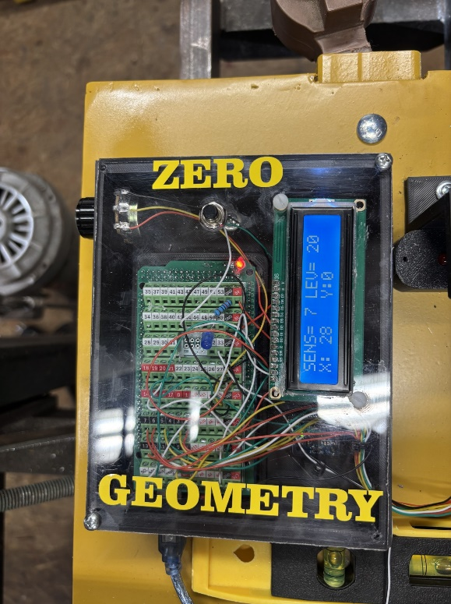

Read out screen

Zero Button

Sensitivity Knob

**Zero button** sets the value to what YOU say is level. This has to be done at each power up or when readings seem off. Must also be done when you change the sensitivity.

**Sensitivity Knob** changes the number of units you want the LED’s to respond to. If you are zeroed at a value of 20, your sensitivity is set to 5, that means the LED will change to the next LED when that X reading shanged to 25>30>35>ECT and 15>10>5 ECT.

5 is usually a good nuber to start with for sensitivity. YOU MUST REZERO when changing the sensitivity.

**Screen on Gyroscope box**

When powering on the Unit. The Gyro in the Geometry Box will calibrate. It will indicate “Calibrating, Please Wait” This will take roughly 5 seconds. Once this is complete you can press the Zero button

3rd screen Calibrated not zeroed

2nd screen Gyro calibrating

4th screen Calibrated and zeroed

1st screen when starting

The screen below shows the sensitivity set to 6, Your Zeroed level is 25 (This is the value recorded when you press the zero button, and your X and Y value currently read from the Gyro.

*Sensitivity knob DOES NOT CHANGE the Y value sensitivity. This is a fixed value.*

With the sensitivity set to 6 and your zero value at 6, every time X changes a value of 6 then the next LED will light up until you get to RED. When the RED LED lights up, either X or Y the system records the Latitude and Longitude value to the SD Card in the GPS Box. And time the RED LED lights up, the BLUE LED in the Gyro box will light up to let you know it is recording an event.

**GPS BOX**

Mapping Mode

Defect Mode

SP Card slot

GPS Unit

**SD Card** is used to record the Latitude and Longitude values for mapping

**MM/DM** switch changes the units oporation. In DEFECT MODE the system uses the Gyro values and only writes *LAT/LONG* values about every 1 second when there is a defect indicated by the RED LED ON THE LED BAR. *MM* records a *LAT/LONG* value ever 1 second no matter what the Gyro box is doing. This allows you to create a GPS map of your track.

**RED LED** lights up when *LAT/Long* vales are being written to the *SD card* for *Mapping Mode*

**BLUE LED** lights up when *LAT/Long* vales are being written to the *SD card* for *Defect Mode*

**GPS Car Screens**

Memory/SD card has initialized successfully

Memory/SD card is initializing

GPS Unit Starting

**NOTE:**

If the SD Card fails to initialize, make sure SD is seated, you may have to take the card out and delete all data on the card then restart.

**NOTE:**

It can take up to 2 minutes for the GPS to track LAT/LONG. The screen will be blank until it tracks LAT/LONG

GPS Unit has tracked satellites and is now recording LAT/LONG

**Power**

The system is designed to use a Dewalt 20 volt battery. (BATTERY NOT INCLUDED) The system DOES NOT monitor battery power so please make sure your battery is charged prior to use.

Battery socket and fuse block (3-5) amp

Power switch

20 Volt Dewalt Battery

**Memory Card and GPS Data**

Location of SD Card on GPS Unit

System records GSP Data to SD card in GPS Box

Once LAT/LONG data is written to the SD card, the system will create a file called GPS.txt on the card. For each new mapping session, you will need to remove the file from the SD card.

Note:

It is OK to delete the file from the SD card. When the GPS box initializes, it will create a new file.

**Working with the GPS file**

Remove the SD card from the GPS Box and insert it into your computer, open the file in notepad and ensure there are NO blank lines. You can also remove duplicate lines if you would like.

This is how the GPS.txt file should look.

Remove the spaces if there and save file. There should usually NOT BE SPACES.

**Google Earth PRO**

Download and install Google Earth Pro. This program is Free from Google. *MAKE SURE YOU USE PRO VERSION.*

**Loading and mapping**

1. Open Google Earth Pro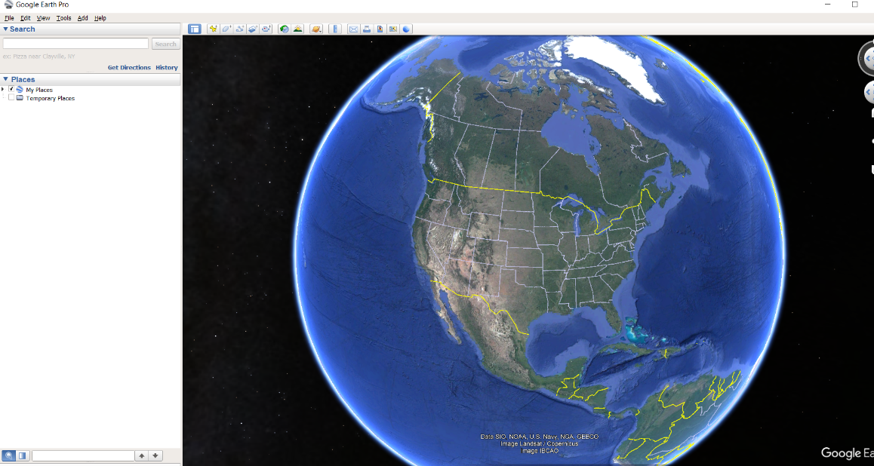
2. Click File, and Import, Browse to the location of your GPS.txt file.A screenshot of a computer

   Description automatically generated
3. Once you have opened the file ensure Field type is Delimited, Delimited box should have Comma selected and you will see the LAT/LONG data at the bottom. Click NextA screenshot of a computer

   Description automatically generated
4. Change the Longitude box to the second set of values so the top box shows LAT and the bottom box shows LONG value. Click NextA screenshot of a computer

   Description automatically generated
5. Do not change any values on this screen. Click Finish

1. You can apply a style sheet if you want but select NO if you are not familiar with that feature. A screenshot of a computer

   Description automatically generated
2. Click on the check boxes and it will apply your points to the map. You can then zoom in and see your map. You can then save and manipulate this data in Google Earth as you wish. A screenshot of a computer

   Description automatically generated

**Note:**

Google Earth is a product of the Google Corporation and Rail Life Designs do not support this product. If you have problems with Google Earth. Please contact Google.

**Troubleshooting**

*No power*

* Make sure Dewalt battery is charged and fully seated in battery slot.
* Make sure USB connections to boxes and voltage adapter are seated well
* Make sure fuse is not blown (3-5) recommended.

GPS Box

*SD Card fails to initialize*

* Make sure card is installed and seated in GPS Box secure
* Erase all data from the SD card and reinsert it into GPS Box.

*GPS Unit screen blank*

* Give the GPS up to 3 minutes to track satellites and display LAT/LONG Data
* Make sure you are not indoors or there is not too much cover for GPS to track

*Geometry box shows no value in the LEV box.*

* Press the Zero button