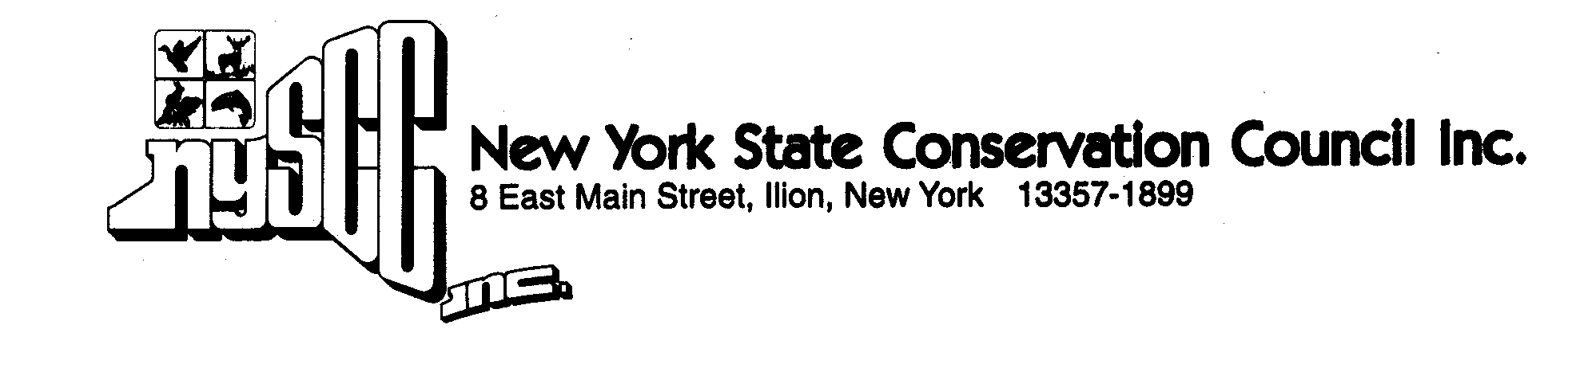
MEMORANDUM IN OPPOSITION

Bill # A 10011 Mayer Same as S 7874 Kaminsky

Title: Limits educational institution’s ability to authorize the possession of a
weapon on school grounds to certain officers or agents of a law
enforcement agency.

This legislation would mandate that no educational institution issue written authorization to possess a firearm, rifle or shotgun to any person who is not primarily employed as a school resource officer, law enforcement officer, or security guard.

Justification:
The stated purpose of this bill is to prevent educational institutions from authorizing the possession of firearms by any staff member or other person who is not employed as a security officer for the purpose of providing security. The issue of arming educators for security purposes is outside of the purview of the Council and we take no position on it.

The proposal would, however, override the authority of the institution to permit the possession of firearms in or upon the buildings or grounds of the institution for educational or recreational purposes. This we do oppose.

Among the activities that would be prohibited:
Educational use for historical purposes or technical education
Competitive and recreational shooting programs
Hunter safety training classes
Inclusion in museum collections
Veteran’s color guards and salutes

This legislation is unnecessary. Under existing statutes, the administration of each institution has the authority to control the possession and use of firearms on its grounds and there is no evidence that this authority is not adequate for maintaining staff and student safety nor is there any evidence of abuse that would warrant new legislation.

Contact:
A. Charles Parker, President
NYS Conservation Council, Inc.
Phone: 315/963-8413
Email: nyscc@nyscc.com

