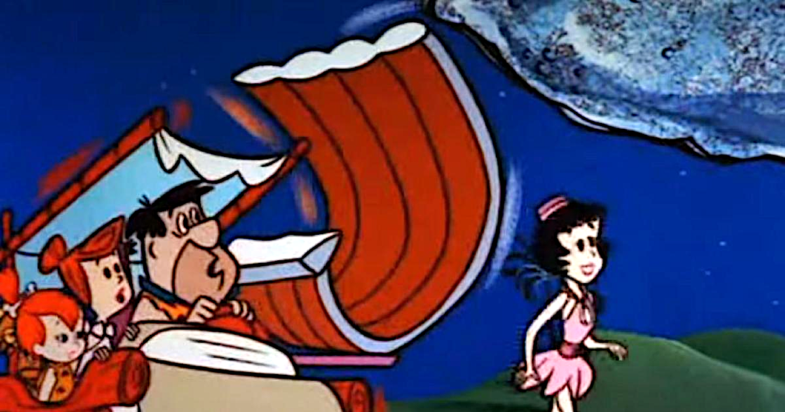

**MENU POUR ENFANT/ CHILDREN’S MENU**

Pogo et frites/

Pogo and Fries

Croquettes de Poulet et frites/

Chicken fingers and fries

Hamburger et frites/

Hamburger and fries

Fromage grillé et frites/

Grilled cheese and fries

Portion enfant de côtes levees et frites/

Children’s portion of ribs and fries

$6.99