Bienvenue Au
Welcome To

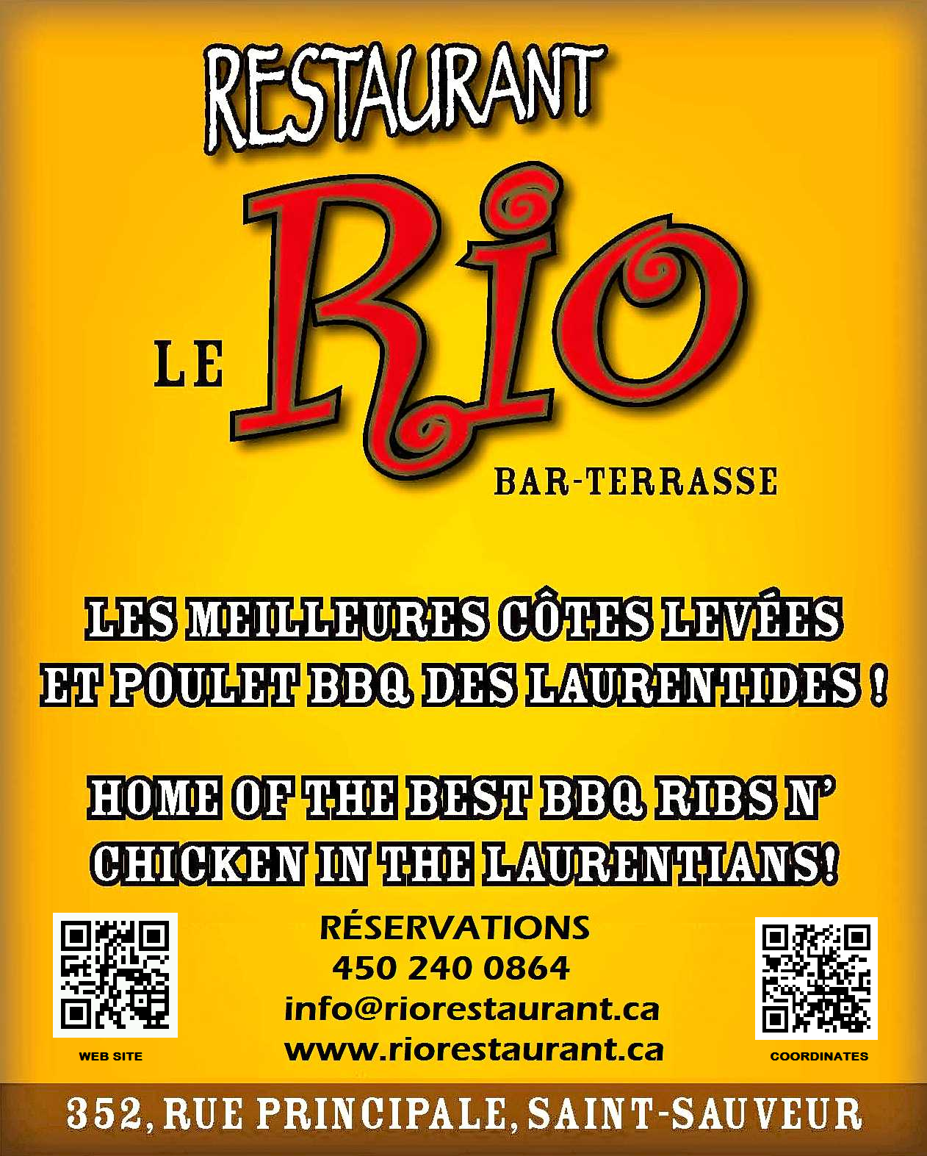

MENU

``BON APPETIT``

ENTRÉES | APPETIZERS
Soupe du jour (Maison)  $3.95 | Soup of the day (Home Made)  $3.95
Cocktail de Crevettes  $9.95 | Shrimp Cocktail  $9.95
Ailes de poulet Santa Fé  Ailes de poulet style “Sud-ouest” servies avec  vinaigrette ranch maison et crudités  $12.50 | Santa Fé Chicken Wings  Southwest chicken wings served with special sauce,  homemade ranch dressing with fresh vegetables  $12.50
Filets de poulet  Filets de poulet “Sud-ouest” servis avec vinaigrette  ranch maison et crudités  $9.95 | Chicken Tenders  “South-West Tenders” recipe served with  homemade ranch dressing and fresh vegetables  $9.95
Champignons Croustillants  Champignons panés et frits.  Servis avec vinaigrette ranch maison  $8.50  Champignons à l’ail gratiné  Champignons sautés au beurre a l`ail gratiné  avec un mélange de fromages Tex-Mex  $9.95 | Mushroom Crunchers  Button Mushrooms breaded and deep fried  Served with homemade ranch dressing  $8.50  Mushrooms à l’ail gratiné  Mushrooms sautéed in garlic butter and covered  with Tex-Mex cheese  $9.95
Pelures de pommes de terre  Pelures de pommes de terre frites recouvertes de fromage  cheddar, crème sûre et de bacon fumé à saveur d’hickory  $7.95 | Potato Skins  Deep-fried potato skins smothered with  cheddar cheese, sour cream and hickory smoked bacon  $7.95
Escargots à l’ail gratiné  Escargots sautés au beurre a l`ail gratiné  avec un mélange de fromages Tex-Mex  $10.95 | Escargots à l’ail gratiné  Escargots sautéed in garlic butter and covered  with Tex-Mex cheese  $10.95
Calmars  Style “Sud-ouest” légèrement panés dans la  farine assaisonnée  $11.95 | Calamari  Style “Southwest” Lightly fried in our  special seasoned batter  $11.95
Méli-mélo  Ailes de poulet Santa Fé, champignons croustillants,  pelures de pommes de terre et calmars servis  avec trempettes maison et crudités  $17.95  Bruschetta  Une “Tradition Italienne ”  Tomates et herbes fraîches, fromage,  vinaigre balsamique, et oignon  $12.95  Nachos  Nachos, accompagnés avec salsa, jalopeno, olive noire,  crème sûre, tomate, et notre fromage spécial  Gros $15.95 Petit $12.95 | The Sampler  Santa Fé Chicken Wings, Mushroom Crunchers,  Potato skins and Calamari served  with our homemade sauce and fresh veggies  $17.95  Bruschetta  An “ Italian tradition”  Chopped tomatoes with fresh herbs, cheese, and  Balsamic vinegar, with chopped onion.  $12.95  Nachos  Nachos, Accompanied with Salsa, Jalopeno, black olives,  Sour Cream, Tomatoes, and our Special Cheese  Large $15.95 Small $12.95
SALADES | SALADS
Toutes les salades sont servies avec notre vinaigrette maison  Salade Maison  $5.95 | All our salads are served with our house dressing  House Salad  $5.95
Salade César  Petite - $10.95  Grande - $12.95  Avec poulet - $16.95 | Caesar Salad  Small - $10.95  Large - $12.95  With chicken - $16.95
Salade Californienne  Poitrine de poulet grillée, amandes caramélisées et  mandarines  $16.95 | California Salad  Grilled Chicken breast, accompanied with caramelized  almonds & mandarins  $16.95
Salade de poulet grillé style “Sud-ouest”  Délicieuse poitrine de poulet grillée et désossée servie  avec notre salade maison  $16.95 | South-West Grilled Chicken Salad  Our delicious grilled boneless chicken breast  served on our refreshing house salad  $16.95
DE LA MER  Filet de Saumon  (Cajun Crème ou Citron)  Saumon grillé sur un lit de riz ou frites  et salade  $29.95 | FROM THE SEA  Filet of Salmon  (Cajun Cream or Lemon)  Grilled Salmon served on a bed of rice or French Fries  and salad  $29.95
Filet de Doré au Beurre a L`échalote  Filet de Doré au beurre à l`échalote servi  avec riz et salade  $27.95 | Filet of Walleye with Shallot butter  Filet of Walleye with our special homemade shallot butter  served with rice and salad  $27.95
Fish’n Chips  Poisson frit style “English pub” servi avec frites maison,  sauce tartare et salade de chou  $17.95 | Fish’n Chips  Homemade English pub style.  Served with homemade fries, tartar sauce and coleslaw  $17.95
Crevettes Papillons à l'ail  Assiette de crevettes papillon à l'ail servie avec riz, légumes,  beurre à l'ail et salade maison  $29.95  FRAIS DE PARTAGE D’ASSIETTE $7.50 | Garlic Butterfly Shrimps  Butterfly shrimps served with rice, vegetables &  garlic butter and house salad  $29.95  SHARING CHARGE $7.50
BBQ  CUIT SUR LE GRILL | BBQ  FROM THE GRILL
Notre Spécialité !!! | Our Specialty!!!
CÔTES LEVÉES  Succulentes côtes levées de dos, tendre à se détacher de l’os,  Grillées, servies avec frites maison et salade.  Notre spécialité !  Portion complète : $29.95 Demi-portion : $21.95 | BABY BACK RIBS  Succulent Baby Back Ribs, fall off the bone tender,  Grilled, & served with homemade fries and salad.  Our specialty!  Full Rack: $29.95 Half Rack: $21.95
Combo Côtes Levées et Poulet  Demi-portion de nos succulentes côtes levées avec  poulet BBQ.  Servi avec frites maison et salade  Demi Portion Côtes levées avec cuisse- $29.95  Demi Portion Côtes levées avec poitrine de poulet désossée - $29.95 | Combo Ribs & Chicken  Half rack of our succulent ribs with  BBQ chicken.  Served with homemade fries and salad  Half Rack Ribs with Leg-$29.95  Half Rack Ribs with Boneless Breast-$29.95
Filet Mignon 6oz  Épais et juteux, grillé,  Servi avec frites maisons, légumes sautés  et salade  $33.95  Brochette de Filet Mignon  Servi sur un lit de riz, légumes sautés  et salade  $31.95 | Filet Mignon 6oz  Thick & juicy, grilled,  served with homemade fries, sautéed  vegetables and salad  $33.95  Brochette de Filet Mignon  Served on a bed of rice with sautéed vegetable  and salad  $31.95
Biftek; choix du Chef  Minimum 12 oz Biftek servi avec  légumes sautés, frites maison  et salade  $32.95 | Steak; Chef’s Choice  Minimum 12oz Steak  served with homemade fries, sautéed vegetable  and salad  $32.95
Confit de Canard  Cuisse de Confit de Canard sur salade avec  vinaigrette aux Framboises accompagnée  d’un crouton Brie et compote d`oignons rouges  $28.95  Suprême de Volaille  Poitrine de poulet désossée, farcie au brie fondant  et asperges servie sur un lit de riz,  légumes sautés et salade maison  $25.95  Poulet “Panhandle”  Poitrine de poulet désossée style Cajun servie sur un  lit de riz, légumes sautés et salade maison  $23.95  Spaghetti Sauce à Viande Maison  $15.95  **Ajoute 3 Crevettes Papillon à l’ail pour $5.00 | Confit de Canard (Duck Leg)  Confit de Canard (Duck Leg) on a bed of Salad with  Raspberry Vinaigrette accompanied with  Brie & Red Onion Compote  $28.95  Chicken Supreme  Boneless breast of chicken  Stuffed with Brie and Asparagus served on a bed  of rice, with sautéed vegetables and house salad  $25.95  Panhandle Chicken  Boneless breast of chicken Cajun style served on a  bed of rice with sautéed vegetables and house salad  $23.95  Homemade Spaghetti and meat Sauce  $15.95  **Add 3 garlic butterfly shrimp for $5.00
SANDWICHS | SANDWICHES
Club au Poulet Grillée  Poitrine de poulet grillée0 avec bacon, tomates et laitue sur une pain au sésame. Servi avec frites maison et salade de chou  $15.95 | Grilled Chicken Club  Grilled chicken breast with bacon, tomato and lettuce  on a sesame bun. Served with homemade fries and coleslaw  $15.95
Hamburger Le Rio  ½ livre de bœuf de qualité, grillé, servi avec  frites maison et salade de chou  $13.95  Avec fromage et Bacon + $2.50 | Le Rio Hamburger  ½ lb of pure beef, grilled, served with  homemade fries and coleslaw  $13.95  Add cheese and Bacon + $2.50
Hamburger Steak  ½ livre de bœuf de qualité, grillé, servi avec oignons frits,  sauce demi-glace, frites maison et salade de chou  $16.95  Hamburger Végétarien  Pâté végétarien à base de haricots noirs, grillé et servi avec laitue, tomate, onion. frites maison et salade de chou  $13.95  Avec Fromage + $1.50  *REMPLACER VOS FRITES PAR UNE POUTINE POUR $4.95*  *********************************************************  ****RIO POUTINE****  NOUVEAU! Savoureuse poutine surmontée d’un tiers de nos  succulentes côtes levées  effilochées et nappée de notre  sauce BBQ RIO !  $18.95  BOISSONS/  Café ou Thé $2.50  Cappuccino $4.75  Expresso. $3.50  Decaf. $3.50  Chocolat Chaud $2.75  Boissons gazeuse. $2.75  San Pellegrino (750 ml) $6.75  Sangria (rouge ou blanc)-  Verre $7.50 Pichet $25.00 | Hamburger Steak  ½ lb of pure beef, grilled, served with fried onions,  Sauce demi glace, homemade fries and coleslaw  $16.95  Veggie Burger  Patty made with black beans, grilled and served with lettuce,  tomato and onion. Served with a side of fries and coleslaw.  $13.95  Add Cheese +$1.50  *UPGRADE YOUR FRIES TO A POUTINE FOR $4.95*  ************************************************************RIO POUTINE****  NEW! 1/3 of Our famous baby  back ribs, grilled,  pulled and placed on a local  favorite drizzled  with our RIO BBQ sauce!  $18.95  DRINKS  Coffee or Tea $2.50  Cappuccino $4.75  Espresso $3.50  Decaf $3.50  Hot Chocolate $2.75  Pop $2.75  San Pellegrino (750ml). $6.75  Sangria (red or white)-  Glass $7.50 Pitcher $25.00
TABLE D’HÔTE

SOUPE (MAISON) ou SALADE MAISON ou JUS DE TOMATE
SOUP (HOME MADE) or HOUSE SALAD or TOMATO JUICE

ENTRÉE:

ESCARGOTS À L`AIL GRATINÉS PORTION DE CALMARS
ou/or
CHAMPIGNONS CROUSTILLANTS COCKTAIL DE CREVETTES
ou/or
CHAMPIGNONS À L`AIL GRATINÉS SHRIMP COCKTAIL

=============================================================================================================
PLAT PRINCIPAL:
MAIN MEAL:

**PORTION COMPLÉTE DE CÔTES LEVÉES ½ PORTION DE CÔTES LEVÉES/CUISSE ou POITRINE
**FULL RACK OF RIBS ½ RACK OF RIBS AND CHICKEN LEG or BREAST
$41.95 $41.95

BIFTECK, CHOIX DU CHEF (min 12oz) ½ PORTION DE CÔTES LEVÉES
CHEF’S CHOICE STEAK (min 12oz) ½ RACK OF RIBS
$44.95 $33.95
================================================================================================================
FILET MIGNON 6oz BROCHETTE DE FILET MIGNON
$45.95 $43.95
================================================================================ ===============================
FILET MIGNON ET CREVETTES PAPILLONS CONFIT DE CANARD
FILET MIGNON & BUTTERFLY SHRIMPS DUCK LEG
SURF ET TURF (Produit De France)
$50.95 $40.95
================================================================================ ===============================
SUPRÊME DE VOLAILLE POULET PANHANDLE
CHICKEN SUPRE ME PANHANDLE CHICKEN
(DÉSOSSÉ/BONELESS) (DÉSOSSÉE/BONELESS)
$37.95 $35.95
=============================================================================================================
FISH’N CHIPS FILET DE SAUMON "CAJUN CRÈME OU CITRON"
FILET OF SALMON “CAJUN CREAM OR LEMON”
$29.95 $41.95
=============================================================================================================
FILET DE DORÉ AU BEURRE À L`ÉCHALOTTE * CREVETTES PAPILLONS À L`AIL
FILET OF DORÉ WITH SHALLOT BUTTER. * GARLIC BUTTERFLY SHRIMPS
$39.95 $41.95
=============================================================================================================

DESSERT/DESERT

CAFÉ, THÉ/ COFFEE, TEA

