Fingerprinting & Background Check Guide
Why Choose Our Fingerprinting Service?
At Tennessee Adoption Home Study Services, we know background checks can feel overwhelming. That’s why we offer a simple, all-in-one package for just $100 per adult. This optional service is the easiest way to make sure every required check is handled correctly and on time.
Here’s what you get with our service:
- TBI/FBI Fingerprinting – Completed through Identogo, the state’s approved fingerprinting vendor.
- Additional Background Checks – Handled by S2Verify, a trusted national provider, covering:
  - State checks for any states you’ve lived in during the past 7 years
  - Countywide criminal searches in each county you’ve lived in during the past 7 years
- Flat $100 Fee – Covers all processing costs; no hidden charges.
- No Delays – Results come directly to us so your home study moves forward smoothly.
Step-by-Step Guide
Step 1: Request the Service
- Let us know you’d like to use our fingerprint/background check package.
- Payment of $100 per adult household member is due at the time of request.
Step 2: Fingerprinting with Identogo
- We’ll provide you with instructions and a service code to book your Identogo appointment.
- You’ll schedule your own appointment at a convenient Identogo location.
- Bring a valid government-issued photo ID (driver’s license, passport, or state ID).
- Your fingerprints will be captured electronically and securely submitted to the TBI/FBI.
Step 3: Additional Checks with S2Verify
- Once you’re registered, you’ll receive a link from S2Verify to complete the rest of the process.
- This can be started by text message or email, whichever you prefer.
- S2Verify will conduct:
  - State-level checks (past 7 years)
  - Countywide criminal searches (past 7 years)
Step 4: Processing & Results
- Identogo submits your fingerprints directly to the TBI/FBI.
- S2Verify processes all other required background checks.
- Results are sent directly to Tennessee Adoption Home Study Services—nothing for you to mail or manage.
Step 5: Confirmation
- We’ll notify you once everything is cleared so your home study can move forward without delays.
Helpful Tips
- Avoid using lotion right before your fingerprint appointment (can cause smudging).
- Show up 10–15 minutes early for your Identogo appointment.
- If you’ve had unreadable fingerprints in the past, let the Identogo technician know so they can take extra care.
- Keep your phone handy—the S2Verify text message comes through quickly and makes the process easy to start.
Cost & Payment
- $100 flat fee per adult household member
- Includes all processing (TBI, FBI, state, and county checks)
- Paid directly to Tennessee Adoption Home Study Services when you request the service
Go to www.identogo.com and click the Blue box in the top righthand corner.

“Find an IdentoGO Center” enter your zip code.
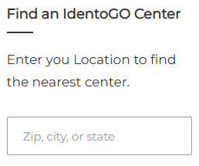
Select the location most convenient to you and select the “Schedule Appointment” button.

Scroll to the bottom of the page and click “Select” in the box labeled “Digital Fingerprinting.
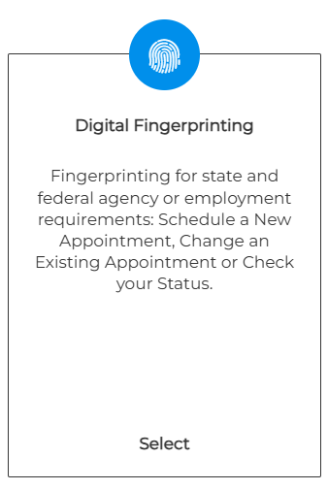
Select the green box “Schedule a New Appointment in the “For New Appointments”
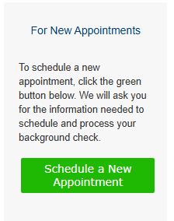
Enter Service Code 28TXZG
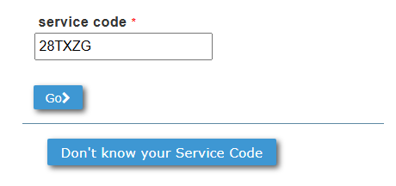
You should receive the following message – if so select continue
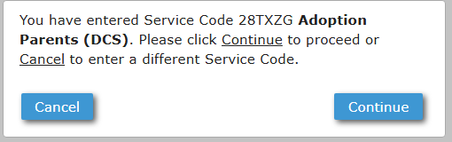
Enter OCA number: TAHSS
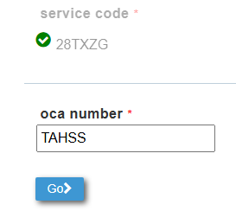
You should receive the following message – if so select “YES”
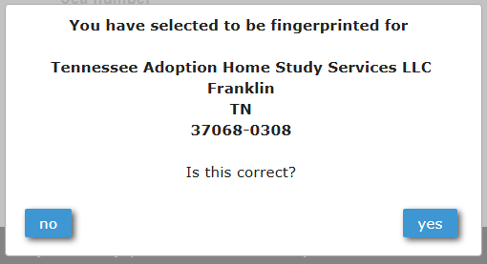

To continue, you will need to Check the box I Agree
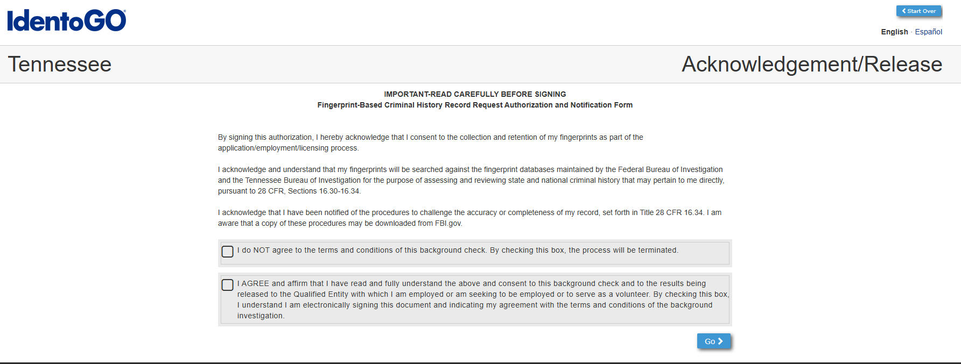
On the next screen, please verify the appointment location and select the desired date and time. Complete all required fields in the application. You will then be prompted to select a method of payment.
As of March 2026, the fee for this service is $37.15.
- Applicants who elect to utilize Tennessee Adoption Home Study Services’ optional background check package (at a cost of $100 per adult household member) will be issued a coupon code to cover this fee.
- Applicants who choose to use an alternative service or independently complete the background check will be required to provide payment by credit card.
- Coupon codes are issued individually, may be used only once, and are non-refundable once applied.
Applicants are responsible for ensuring that the appointment location, date, and time are correct prior to confirmation. Missed or incorrect appointments will result in additional out-of-pocket expenses to reschedule.

